Beginners Guide to Filecoin

只看减法之后的内容

* **拷贝所有内容，注明来源(不要有自己的内容和自己的发挥)**
* **画出思维导图**

Prequel

# Chapter 1 DOUBLE - SPENDING PROBLEM

<https://www.topcoder.com/thrive/articles/double-spending-and-how-its-prevented-by-blockchain>

There are only two ways to process any transaction –

* Online: A transaction that uses virtual/digital currency is referred to as an online transaction.
* Offline: A transaction that uses actual cash or money is referred to as an offline transaction.

Spending money more than once results in double spending. The double spending issue is never possible with physical currency. However, double spending can occur with digital currency like bitcoin.

To understand the double-spending problem, let’s take a small example

You visit a restaurant and order a pot of coffee worth $5 and you pay with cash. When you pay for your coffee in a restaurant, the cashier immediately acknowledges your payment and gives you your coffee. It is now impossible to use the same $5 elsewhere to make a different transaction. But what if you can spend that $5 again to make another purchase? It indicates that a single individual can utilize the same funds several times. The term “double spending problem” refers to this sort of issue.

## 

## WHY IS DOUBLE SPENDING PROBLEMATIC FOR DIGITAL CURRENCY?

* Digital money is far different from physical money.
* When you use digital money to make a transaction, the transaction is broadcast to all of the nodes within the network.
* Nodes must wait for the transaction to be received and confirmed, which takes time.

Consequently, this is a problem:

* What prevents someone from duplicating a transaction and retransmitting it before the confirmation of the transaction from the network?
* The network would not be able to tell which transaction was authentic.

## BITCOIN DOES NOT HAVE A CENTRAL BANK TO RESOLVE CONFLICTS

* Digital currency circulated on the internet before bitcoin was created. Banks and other financial organizations were in charge of overseeing and regulating it all, as they still do for the most part today.
* Banks serving as mediators in banking conflicts have the drawback that transactions can be undone if a conflict arises.
* This results in increased costs and extended transaction delays. By developing a system that is fully reliant on cryptographic evidence rather than trust, Bitcoin attempts to address these constraints. In essence, it provides a mechanism to do financial business devoid of banks.

## EVERY BITCOIN DISPLAYS THE OWNERSHIP HISTORY

* It’s crucial to comprehend what a bitcoin is in order to begin comprehending how this method of cryptographic evidence functions.
* A sequence of digital signatures is how a bitcoin is described in the bitcoin white paper.
* It may be transferred between owners via digital wallets. Both a private key (a password that only the owner knows) and a public key (an address) is stored in each wallet.
* When a bitcoin owner transfers a coin to another, they sign the public key of the new owner and a hash of the prior transaction.
* The bitcoin is then completed by appending this hash. As a result, each bitcoin is similar to a car’s logbook in that it contains a list of all prior owners.

## THE BLOCKCHAIN OF BITCOIN CONTAINS A UNIVERSAL LEDGER

* Bitcoin uses a global ledger known as a blockchain to address the double-spending issue.
* The blockchain offers a mechanism for all nodes to be knowledgeable of every transaction, demonstrating that no efforts to double spend have been made.
* All bitcoin transactions are formally broadcast to every node. The sequence in which they were acquired can then be agreed upon as a unified history.
* Double spending efforts made after that point are ineffective in bitcoin since most nodes will concur on which transaction was the first to be received.

## BITCOIN HAS A TIMESTAMP SERVER

A timestamp server was suggested as a solution to the double spending issue in Satoshi Nakamoto’s white paper. A block of transactions is hashed by this server, which then broadcasts the hash to every node in the bitcoin network. This timestamp demonstrates that none of the information in the hash could have been produced following the publication of the hash. This creates an immutable (unchangeable) log of the sequence in which transactions occurred since each timestamp contains the preceding timestamp in its hash. Each timestamp builds on the ones that came before it.

## EVERY BITCOIN TRANSACTION EVER PERFORMED IS RECORDED

You must be aware that since the first bitcoin client was delivered in 2009, the blockchain of bitcoin has preserved an exhaustive record of all transactions ever done in order to properly comprehend how the blockchain avoids double spending. You cannot just alter the record since every transaction is cryptographically hashed to the preceding blocks. This database is referred to as a blockchain because a fresh batch of transactions, known as a block, is added to it every ten minutes.

## 51% ATTACK

When a group of miners controls over 50% of the network’s hash rate, they launch a 51% attack against a cryptocurrency blockchain. Having control of 51% of the network’s nodes provides the governing parties with the ability to change the blockchain.

Payments between a few or all users might be stopped if the attackers were able to stop fresh transactions from receiving confirmations. The ability to undo decisions taken when they were in charge would likewise be available to them. One of the problems that consensus systems like proof-of-work were designed to avoid is that by reversing transactions, users might double spend coins.

On a coin with a high participation rate, a 51% assault is an extremely demanding and difficult undertaking. The majority of the time, the group of attackers would have to be able to command the required 51% and have a backup blockchain ready to be injected when the opportunity arises. The main network would then have to be out-hashed. One of the biggest obstacles against a 51% attack is the expense of doing so.

For instance, the Bitmain S19 XP Hydro is the most sophisticated Application Specific Integrated Circuit (ASIC) miner. It boasts 255 TH/s (tera hashes per second) of hash rate and costs more than $19,800.

FoundryUSA, with 54.42 EH/s (exahashes per second), accounts for 23.75% of the entire Bitcoin network hash rate, followed by AntPool at 41.49 EH/s, 18.12%, and Binance Pool at 34.48 EH/s, 15.06%.



The above data as per by July 2020 is of 51% attack on Ethereum Blockchain.

## CONCLUSION

In conclusion, the blockchain stops double spending by broadcasting groups of transactions to all nodes in the bitcoin network and timestamping them. Transactions are irreversible and hard to tamper with since they are timestamped on the blockchain and quantitatively tied to earlier ones.

# Chapter 2：Byzantine Generals' Problem

How does blockchain solve the Byzantine generals problem?

<https://cointelegraph.com/learn/how-does-blockchain-solve-the-byzantine-generals-problem>



## **Byzantine generals problem explained**

A reliable computer system must be able to function even if one or more of its components fails. A failing component may display a frequently overlooked behavior: delivering contradicting data to different sections of the system. So, what is the Byzantine generals problem? The Byzantine generals problem is an abstract expression of the problem of dealing with this type of failure.

[The Byzantine generals problem](https://cointelegraph.com/news/crypto-mining-needs-to-be-redefined-before-simply-casting-it-away) is a game theory problem that describes how difficult it is for dispersed parties to reach a consensus without the help of a trusted central party. How can members of a network agree on a specific reality when no one can verify the identities of other members?

Game theory is a framework for thinking about social events with competing actors. In a strategic environment, game theory conceives social circumstances among competing participants and produces optimal decision-making of autonomous and competing agents.

The Byzantine generals are based on a game theory analogy. The problem is that multiple generals besiege Byzantium. They've encircled the city, but they must decide when to assault as a group. They will win if all generals assault simultaneously; however, they will lose if they attack.

Because any letters they transmit or receive could have been intercepted or deceptively sent by Byzantium's defenders, the generals have no secure communication channels with one another. How can the generals coordinate simultaneous attacks?

*This article aims to explain what a Byzantine fault in blockchain is and how to solve the Byzantine generals problem.*

## **The research paper**

"[The Byzantine Generals Problem](https://www.microsoft.com/en-us/research/uploads/prod/2016/12/The-Byzantine-Generals-Problem.pdf)," a research article by Leslie Lamport, Robert Shostak and Marshall Pease, was published in 1982. The importance of this problem is evident from the opening page, which notes that the National Aeronautics and Space Administration (NASA), the Ballistic Missile Defense Systems Command and the Army Research Office all financed their research.

Although the Byzantine generals problem had been studied in computer science before 1982, this was one of the first attempts to translate it into parallel and proposed solutions. The following analogy illustrates the Byzantine generals problem. Several divisions of the Byzantine army are stationed just outside of an enemy’s city, prepared for war. The only way for various generals to connect is through a messenger. They must agree on a course of action.

However, we must presume that certain generals, intent on keeping loyal generals from deciding on a single course of action, are traitors. To ensure that a tiny group of traitors cannot interrupt communications, an algorithm is required.

To address the problem of the Byzantine generals, loyal generals need a safe means to agree on a plan (known as consensus) and carry it out (known as coordination). While solving the Byzantine generals problem is a difficult task, we now better understand the fundamental problem. It's critical to note that, as the example suggests, the concept can be applied to military communications.

However, this issue affects all types of computer systems, not only those used in military applications. The Byzantine generals problem must be solved if a dispersed group of nodes (e.g., computers or other physical devices) needs to achieve reliable communications.

## **Understanding Byzantine fault tolerance (BFT)**

There are several reasons why a distributed computer system could fail. In the military scenario above, Byzantine failures are essentially traitors attempting to interrupt communications between loyal generals.

This could be a software defect, a hardware malfunction, or a malicious attack when applied to real-world computer systems. To put it another way, Byzantine failures don't always have to be the result of a well-coordinated effort by a bad actor. There can be difficulties that hinder nodes from reaching consensus on distributed networks.

Any system failure that exhibits diverse symptoms to different observers is referred to as a Byzantine fault. It contains no constraints and assumptions about the type of behavior that a node can exhibit (e.g., a node can generate arbitrary data while posing as an honest actor).

In every distributed computer system, Byzantine failures are virtually unavoidable.

Let's imagine there's a power outage and all of the nodes go offline simultaneously. Now, the question arises if the network is still operational and capable of sustaining reliable communication? Or does the system as a whole stop working or become open to attacks all of a sudden?

In a reasonably secure network, anything as minor as a few offline nodes has no discernible effect on the network. Byzantine fault tolerance is the ability to defend against these conditions. Networks that can endure more Byzantine failures are said to have a higher tolerance, implying that they are more secure than those that can't.

The actual incidence and taxonomy of Byzantine faults in various systems is a vast and challenging subject. It can, however, be specified in such a way that a formal definition of Byzantine fault tolerance emerges.

It's worth noting that Byzantine flaws are the most serious and difficult to correct. Byzantine fault tolerance is required in nuclear power plants, aviation engine systems and pretty much any system whose actions are dependent on the results of a large number of sensors.

## **Byzantine generals problem in a distributed system**

Only decentralized systems are susceptible to the Byzantine generals problem, as they lack a dependable source of information and have no way of confirming the information they get from other network users. In centralized systems, an authority is trusted to disseminate accurate information while preventing the spread of erroneous or fraudulent information across the network.

For example, in the traditional financial system, banks are trusted to provide clients with accurate balances and transaction histories. If a bank tries to deceive or mislead its consumers, the central bank or government is authorized to restore faith.

The Byzantine generals dilemma, which inconsistently necessitates the establishment of truth, is not solved by centralized systems. Instead, they choose not to confront the problem at all, opting for efficiency over trustworthiness. Centralized systems, on the other hand, are prone to central authority corruption.

## **Byzantine generals problem example**

The Byzantine generals problem is exemplified by money. How could a society build a monetary system that all members can trust and agree on? Societies have used precious metals or other rare items, such as shells or glass beads, as currency for most of history. Gold addressed the Byzantine generals problem because it was trusted and recognized across decentralized systems like international trade.

Gold's weight and purity, on the other hand, remained untrustworthy until now. The failure of gold to completely address the Byzantine generals problem led to the establishment and issuance of money being taken over by trusted central bodies, mainly governments. Governments monopolized mints to instill confidence in the currency's weight and purity. Therefore, Byzantine failure was not solved by centralized systems.

Moreover, the trusted central authorities for money, governments, have betrayed that confidence by seizing, debasing or modifying it. To solve the Byzantine generals problem, a currency must be verifiable, counterfeit-resistant and untrustworthy. This accomplishment was not accomplished until the advent of Bitcoin ([BTC](https://cointelegraph.com/bitcoin-price)).

## **How do you solve Byzantine generals problem?**

The problem can be solved by implementing a protocol that employs fault-tolerant mechanisms. When faced with uncertainty, adopting a procedure among the generals is the best method to make choices.

As a result, it becomes probabilistic rather than deterministic because nothing can be guaranteed. That is precisely the case when there is less direct communication among peers, and each is self-contained. Because each general is in a different place, there is a physical separation between them.

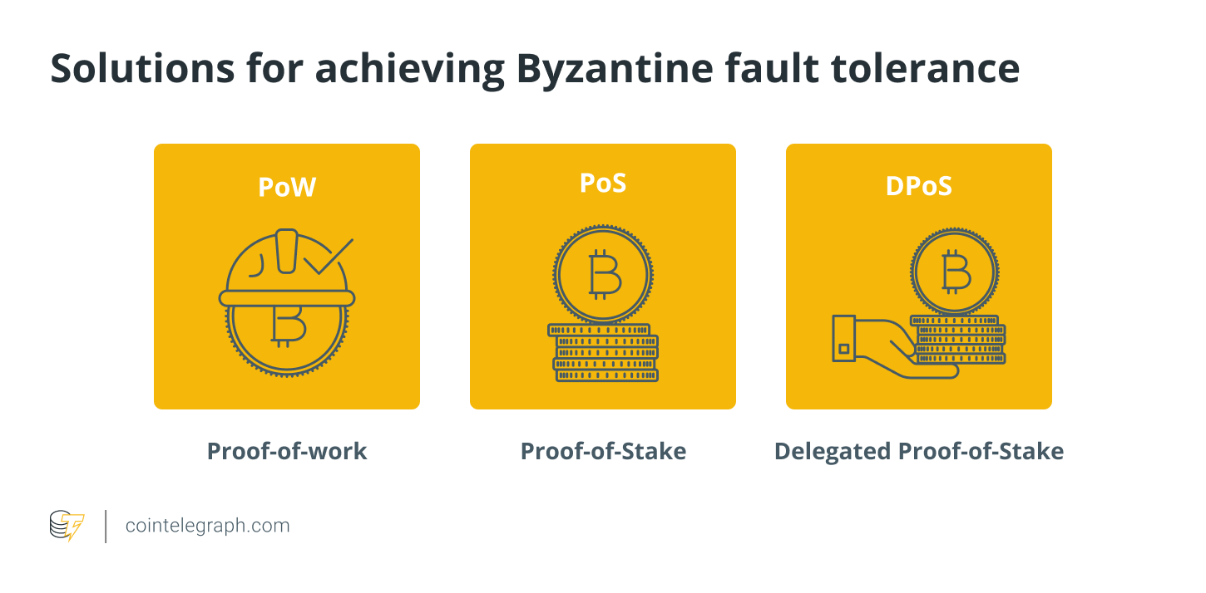

### **Blockchain: The solution for the Byzantine general problem**

The Byzantine general problem can be solved with the help of a blockchain. It's all about giving people a way to communicate safely and securely in an unpredictable world. In the actual world, most transactions occur between strangers who do not know or trust one another.

Each individual is like a general, waiting for orders to attack or defend their position. There are no middlemen to arbitrate the attack on your behalf; you are entirely on your own in making your decision.

A blockchain creates a layer that can be trusted without needing to trust every individual. This is accomplished by a network of nodes coming together to agree on the truth before it is recorded. If the general is unsure about the substance of the communication, the other generals can verify it using what they know to be true.

Once one node has recorded it, a copy is sent to all other nodes in the network, making the information redundant. The PoW consensus algorithm is designed to achieve this goal. Bad actors will still try to game the system because the information isn't always accurate.

Since the system was designed to be utilized by the general public, fault-tolerant mechanisms and security are in place in a blockchain. In this scenario, cryptography was required to ensure that the messages could not be altered.

The system provides key pairs for digitally signing a communication to verify identity as proof that it comes from the persons purported to have sent it. Once messages have been authenticated, they are recorded for transparency and historical proof of accountability.

### **How does Bitcoin solve the Byzantine generals problem?**

With regard to money, Bitcoin was the first realized solution to the Byzantine generals problem. Many plans and projects before Bitcoin attempted to create money that was independent of the government, but they all failed in some way.

Bitcoin needs the means to handle ownership and [avoid double-spending](https://cointelegraph.com/bitcoin-for-beginners/what-is-bitcoin-a-beginners-guide-to-the-worlds-first-cryptocurrency) as a monetary system. Bitcoin employs a [blockchain, or a public, distributed ledger](https://cointelegraph.com/blockchain-for-beginners/how-does-blockchain-work-everything-there-is-to-know), that stores a history of all transactions to accomplish this in a trustless manner. The blockchain, in the Byzantine generals analogy, is the truth that all parties must agree on.

If all the nodes in the Bitcoin network could agree on which transactions happened when and in what order, they could verify Bitcoin ownership and create a working, trustless monetary system without the need for a centralized authority.

### **Proof-of-Work (PoW) and the Byzantine generals problem**

[Satoshi Nakamoto released the first Bitcoin](https://cointelegraph.com/bitcoin-for-beginners/who-is-satoshi-nakamoto-the-creator-of-bitcoin) [whitepaper](https://cointelegraph.com/ico-101/what-is-a-white-paper-and-how-to-write-it%20) in October 2008. Although the name "Byzantine generals problem" isn't used in this document, Nakamoto effectively provided a solution that would be implemented in January 2009 with the introduction of the Bitcoin network.

Satoshi devised a means to use [cryptographic security and public-key encryption](https://cointelegraph.com/explained/secure-encryption-key-management-modules-explained) to answer the Byzantine general problem in a digital electronic network. To prevent data tampering, cryptographic security uses hashing, a process of encoding. The identity of a network user is verified via public key encryption.

A transaction is secured in a block that is connected to other blocks by its hash value in cryptographic security. All hashes may be tracked down to the root of all hashes, which is an initial block. The blockchain is a system that uses a [Merkle Tree to verify hashes](https://cointelegraph.com/blockchain-for-beginners/a-beginners-guide-to-understanding-the-layers-of-blockchain-technology) that come from a genesis block.

Every block in the network that comes from the first block, also known as the genesis block, is valid. Miners validate blocks, who compete with other miners to solve cryptographic puzzles to produce blocks as part of a PoW consensus method.

By employing a [proof-of-work consensus mechanism](https://cointelegraph.com/blockchain-for-beginners/proof-of-stake-vs-proof-of-work:-differences-explained), Bitcoin overcame the Byzantine generals problem and established a clear, objective rulebook for the blockchain. To add information to the blockchain, called blocks, a network member must publish proof that they put a lot of effort into making the block. This work comes at a high cost to the creator, incentivizing them to share accurate information.

There can be no disagreement or tampering with the information on the Bitcoin network because the rules are objective. The system for selecting who can mint new Bitcoin and the laws regulating which transactions are valid or invalid are both objectives. Furthermore, it is impossible to remove a block from the blockchain after it has been added, making Bitcoin's history unchangeable.

Therefore, the Byzantine generals problem is solved by miners who are similar to generals in Satoshi's version of the blockchain. Each node is responsible for validating transactions, which are similar to messages delivered to the generals. Bad actors (for example, hackers) who aim to steal messages or harm the network can be considered the enemy.

Hackers (i.e., [the man-in-the-middle](https://cointelegraph.com/news/blockchaininfo-adds-additional-tor-security-features-to-head-off-man-in-the-middle-attacks)) cannot readily attack the blockchain because messages use cryptographic security. To prevent manipulation, the messages or transactions are bundled into blocks and hashed for added protection. Satoshi makes things more probabilistic by putting miners in a competition to validate the blocks. This makes it more decentralized because no single miner can receive all of the rewards by monopolizing validation.

Instead, miners must compete to solve a riddle by using their computational power, known as the hash rate. The higher a miner's hash rate, the more likely they are to solve the puzzle. When the miner who has solved the puzzle broadcasts the solution to the network, all other miners must validate or deny the value if it is erroneous. A difficulty target is a value that must be equal to or less than the correct value.

Members of the Bitcoin network can thus agree on the status of the blockchain and all transactions in blockchain at any time. Each node verifies whether blocks are valid according to the proof-of-work criterion and whether transactions are valid according to additional criteria.

If a network member tries to broadcast misleading information, all nodes on the network will detect it as objectively invalid and ignore it. There is no need to trust other members of the Bitcoin network because each node can verify every information on the network, itself, making Bitcoin a trustless system.

The blockchain is also decentralized, which means the system should not have a single point of failure. The blocks are saved in a distributed database, which is replicated across the network. This redundancy also aids in fault tolerance, ensuring that no single malfunctioning computer may bring the entire system down. This is the equivalent of having many messengers in case one is ambushed by the enemy. The message will not be lost because it will be copied by other messengers.

## **The novel solutions: Proof-of-stake (PoS) and Delegated proof-of-stake (DPoS)**

[PoS is another blockchain consensus mechanism](https://cointelegraph.com/tags/proof-of-stake) that seeks to address the Byzantine generals problem. It was first deployed in 2012. PoS-based networks, unlike PoW-based networks, are not reliant on cryptocurrency mining. Instead, a technique called staking is performed.

Users (called validators) stake funds in this system. Validators who own more coins on a blockchain can validate more blocks and earn greater rewards. Users that attempt to validate incorrect transactions risk losing their staked cash.

Users can stake coins using normal home computers instead of needing specialized machines for mining in a PoW-based network. Several PoS-based networks have created ways to prevent double-spending attacks and other potential security vulnerabilities caused by Byzantine failures. For example, [Ethereum 2.0 (Serenity)](https://cointelegraph.com/ethereum-for-beginners/ethereum-upgrades-a-beginners-guide-to-eth-2-0) will use the Casper PoS algorithm, which requires a two-thirds majority of nodes to agree on a block before it can be created.

Delegated proof-of-stake is a blockchain consensus technique that operates similarly to proof-of-stake and was first developed in 2014. Both require users to put money on the line. Only a few users (known as delegates) can validate transactions and generate blocks in DPoS-based networks.

In general, any user can stake a blockchain's coins to cast a vote in support of a delegate candidate. Block rewards are usually distributed proportionally to the amount of monies staked in delegate elections by elected nodes to their voters.

Nodes can reach consensus considerably faster using DPoS than they can with PoW or PoS. At scale, this means transactions can be handled significantly quicker. Maintaining a high level of Byzantine fault tolerance with DPoS may become problematic in some cases due to the tradeoff.

Because fewer nodes are accountable for keeping the network safe, it is potentially easier for nodes to conspire against the majority's best interests. DPoS-based networks, on the other hand, try to avoid this scenario by holding delegate elections regularly to ensure that delegates are held accountable for their decisions.

## **Conclusion**

For blockchains, solving the Byzantine Generals Problem means reaching network consensus in spite of many bad actors trying to steal from you, as well as the potential for various parts of the network to be down or malfunction. Managing this task even for a short period of time is challenging, but achieving such a feat perpetually is a much more difficult undertaking.

Success is likely to depend on the fundamental vulnerabilities present in the consensus algorithms being tested, their ability to scale as transaction volumes increase, as well as their ability to integrate with other technologies like DeFi platforms or even [legacy networks](https://supraoracles.com/academy/stateless-money-lessons-from-the-free-banking-era-and-wildcat-bankers).

Overall, [the future of Web3](https://supraoracles.com/academy/web1-web2-web3-whats-the-difference/) will likely be shaped by the needs of early-to-adopt industries and organizations, as well as breakthroughs in our ability to solve the Byzantine Generals Problem at a massively large scale, but without sacrificing on network availability via consensus algorithm limitations.

That is, can we solve the problem *at scale* and maintain the sort of speeds needed to [power the future of finance](https://supraoracles.com/academy/verifiable-random-functions-fair-play-in-a-decentralized-world/); and can we keep it self-sustainable in perpetuity? To such questions, only the test of time can truly reveal the answers.

# 

# 

# 

# 

# **Chapter 3 Bitcoin's Academic Pedigree**

### **Blockchain: Bitcoin’s Academic Pedigree**

<https://queue.acm.org/detail.cfm?id=3136559>

The concept of cryptocurrencies is built from forgotten ideas in research literature.

Arvind Narayanan and Jeremy Clark

If you've read about bitcoin in the press and have some familiarity with academic research in the field of cryptography, you might reasonably come away with the following impression: Several decades' worth of research on digital cash, beginning with David Chaum,10,12 did not lead to commercial success because it required a centralized, banklike server controlling the system, and no banks wanted to sign on. Along came bitcoin, a radically different proposal for a decentralized cryptocurrency that didn't need the banks, and digital cash finally succeeded. Its inventor, the mysterious Satoshi Nakamoto, was an academic outsider, and bitcoin bears no resemblance to earlier academic proposals.

This article challenges that view by showing that nearly all of the technical components of bitcoin originated in the academic literature of the 1980s and '90s (see figure 1). This is not to diminish Nakamoto's achievement but to point out that he stood on the shoulders of giants. Indeed, by tracing the origins of the ideas in bitcoin, we can zero in on Nakamoto's true leap of insight—the specific, complex way in which the underlying components are put together. This helps explain why bitcoin took so long to be invented. Readers already familiar with how bitcoin works may gain a deeper understanding from this historical presentation. (For an introduction, see *Bitcoin and Cryptocurrency Technologies* by Arvind Narayanan et al.36) Bitcoin's intellectual history also serves as a case study demonstrating the relationships among academia, outside researchers, and practitioners, and offers lessons on how these groups can benefit from one another.

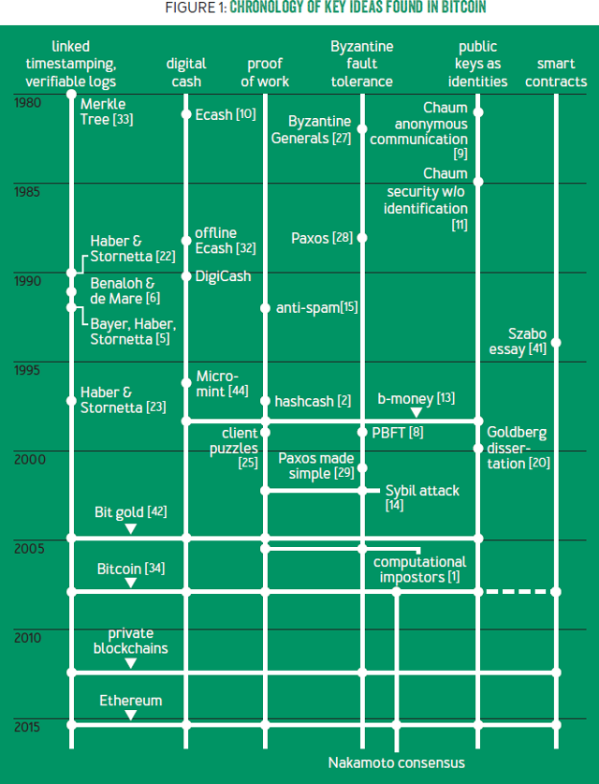

### 

### 

### 

### **The Ledger**

If you have a secure ledger, the process to leverage it into a digital payment system is straightforward. For example, if Alice sends Bob $100 by PayPal, then PayPal debits $100 from Alice's account and credits $100 to Bob's account. This is also roughly what happens in traditional banking, although the absence of a single ledger shared between banks complicates things.

This idea of a ledger is the starting point for understanding bitcoin. It is a place to record all transactions that happen in the system, and it is open to and trusted by all system participants. Bitcoin converts this system for recording payments into a currency. Whereas in banking, an account balance represents cash that can be demanded from the bank, what does a unit of bitcoin represent? For now, assume that what is being transacted holds value inherently.

How can you build a ledger for use in an environment like the Internet where participants may not trust each other? Let's start with the easy part: the choice of data structure. There are a few desirable properties. The ledger should be immutable or, more precisely, *append only*: you should be able to add new transactions but not remove, modify, or reorder existing ones. There should also be a way to obtain a succinct *cryptographic digest* of the state of the ledger at any time. A digest is a short string that makes it possible to avoid storing the entire ledger, knowing that if the ledger were tampered with in any way, the resulting digest would change, and thus the tampering would be detected. The reason for these properties is that unlike a regular data structure that's stored on a single machine, the ledger is a *global* data structure collectively maintained by a mutually untrusting set of participants. This contrasts with another approach to decentralizing digital ledgers,7,13,21 in which many participants maintain local ledgers and it is up to the user querying this set of ledgers to resolve any conflicts.

#### **Linked timestamping**

Bitcoin's ledger data structure is borrowed, with minimal modifications, from a series of papers by Stuart Haber and Scott Stornetta written between 1990 and 1997 (their 1991 paper had another co-author, Dave Bayer).5,22,23 We know this because Nakamoto says so in his bitcoin white paper.34 Haber and Stornetta's work addressed the problem of document timestamping—they aimed to build a "digital notary" service. For patents, business contracts, and other documents, one may want to establish that the document was created at a certain point in time, and no later. Their notion of document is quite general and could be any type of data. They do mention, in passing, financial transactions as a potential application, but it wasn't their focus.

In a simplified version of Haber and Stornetta's proposal, documents are constantly being created and broadcast. The creator of each document asserts a time of creation and signs the document, its timestamp, and the previously broadcast document. This previous document has signed its own predecessor, so the documents form a long chain with pointers backwards in time. An outside user cannot alter a timestamped message since it is signed by the creator, and the creator cannot alter the message without also altering the entire chain of messages that follows. Thus, if you are given a single item in the chain by a trusted source (e.g., another user or a specialized timestamping service), the entire chain up to that point is locked in, immutable, and temporally ordered. Further, if you assume that the system rejects documents with incorrect creation times, you can be reasonably assured that documents are at least as old as they claim to be. At any rate, bitcoin borrows only the data structure from Haber and Stornetta's work and reengineers its security properties with the addition of the proof-of-work scheme described later in this article.

In their follow-up papers, Haber and Stornetta introduced other ideas that make this data structure more effective and efficient (some of which were hinted at in their first paper). First, links between documents can be created using hashes rather than signatures; hashes are simpler and faster to compute. Such links are called hash pointers. Second, instead of threading documents individually—which might be inefficient if many documents are created at approximately the same time—they can be grouped into batches or blocks, with documents in each block having essentially the same timestamp. Third, within each block, documents can be linked together with a binary tree of hash pointers, called a Merkle tree, rather than a linear chain. Incidentally, Josh Benaloh and Michael de Mare independently introduced all three of these ideas in 1991,6 soon after Haber and Stornetta's first paper.

#### **Merkle trees**

Bitcoin uses essentially the data structure in Haber and Stornetta's 1991 and 1997 papers, shown in simplified form in figure 2 (Nakamoto was presumably unaware of Benaloh and de Mare's work). Of course, in bitcoin, transactions take the place of documents. In each block's Merkle tree, the leaf nodes are transactions, and each internal node essentially consists of two pointers. This data structure has two important properties. First, the hash of the latest block acts as a digest. A change to any of the transactions (leaf nodes) will necessitate changes propagating all the way to the root of the block, and the roots of all following blocks. Thus, if you know the latest hash, you can download the rest of the ledger from an untrusted source and verify that it hasn't changed. A similar argument establishes another important property of the data structure—that is, someone can efficiently prove to you that a particular transaction is included in the ledger. This user would have to send you only a small number of nodes in that transaction's block (this is the point of the Merkle tree), as well as a small amount of information for every following block. The ability to efficiently prove inclusion of transactions is highly desirable for performance and scalability.

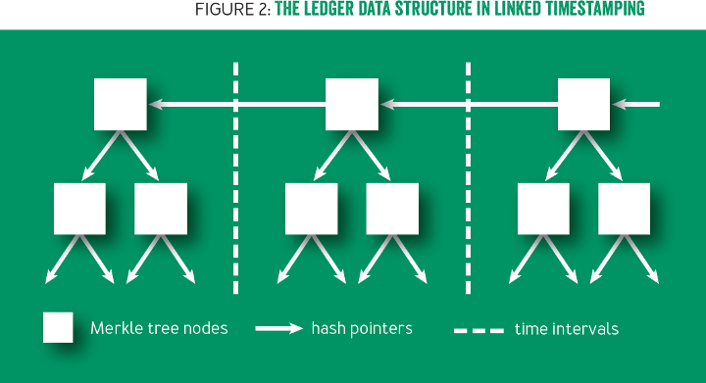

Merkle trees, by the way, are named for Ralph Merkle, a pioneer of asymmetric cryptography who proposed the idea in his 1980 paper.33 His intended application was to produce a digest for a public directory of digital certificates. When a website, for example, presents you with a certificate, it could also present a short proof that the certificate appears in the global directory. You could efficiently verify the proof as long as you know the root hash of the Merkle tree of the certificates in the directory. This idea is ancient by cryptographic standards, but its power has been appreciated only of late. It is at the core of the recently implemented Certificate Transparency system.30 A 2015 paper proposes CONIKS, which applies the idea to directories of public keys for end-to-end encrypted emails.32 Efficient verification of parts of the global state is one of the key functionalities provided by the ledger in Ethereum, a new cryptocurrency.

Bitcoin may be the most well-known real-world instantiation of Haber and Stornetta's data structures, but it is not the first. At least two companies—Surety starting in the mid-'90s and Guardtime starting in 2007—offer document timestamping services. An interesting twist present in both of these services is an idea mentioned by Bayer, Haber, and Stornetta,5 which is to publish Merkle roots periodically in a newspaper by taking out an ad. Figure 3 shows a Merkle root published by Guardtime.



#### **Byzantine fault tolerance**

Of course, the requirements for an Internet currency without a central authority are more stringent. A distributed ledger will inevitably have forks, which means that some nodes will think block A is the latest block, while other nodes will think it is block B. This could be because of an adversary trying to disrupt the ledger's operation or simply because of network latency, resulting in blocks occasionally being generated near-simultaneously by different nodes unaware of each other's blocks. Linked timestamping alone is not enough to resolve forks, as was shown by Mike Just in 1998.26

A different research field, fault-tolerant distributed computing, has studied this problem, where it goes by different names, including *state replication*. A solution to this problem is one that enables a set of nodes to apply the same state transitions in the same order—typically, the precise order does not matter, only that all nodes are consistent. For a digital currency, the state to be replicated is the set of balances, and transactions are state transitions. Early solutions, including Paxos, proposed by Turing Award winner Leslie Lamport in 1989,28,29 consider state replication when communication channels are unreliable and when a minority of nodes may exhibit certain "realistic" faults, such as going offline forever or rebooting and sending outdated messages from when it first went offline. A prolific literature followed with more adverse settings and efficiency tradeoffs.

A related line of work studied the situation where the network is mostly reliable (messages are delivered with bounded delay), but where the definition of "fault" was expanded to handle *any* deviation from the protocol. Such Byzantine faults include both naturally occurring faults as well as maliciously crafted behaviors. They were first studied in a paper also by Lamport, cowritten with Robert Shostak and Marshall Pease, as early as 1982.27 Much later, in 1999, a landmark paper by Miguel Castro and Barbara Liskov introduced PBFT (practical Byzantine fault tolerance), which accommodated both Byzantine faults and an unreliable network.8 Compared with linked timestamping, the fault-tolerance literature is enormous and includes hundreds of variants and optimizations of Paxos, PBFT, and other seminal protocols.

In his original white paper, Nakamoto does not cite this literature or use its language. He uses some concepts, referring to his protocol as a consensus mechanism and considering faults both in the form of attackers, as well as nodes joining and leaving the network. This is in contrast to his explicit reliance on the literature in linked timestamping (and proof of work, discussed next). When asked in a mailing-list discussion about bitcoin's relation to the Byzantine Generals' Problem (a thought experiment requiring BFT to solve), Nakamoto asserts that the proof-of-work chain solves this problem.35

In the following years, other academics have studied Nakamoto consensus from the perspective of distributed systems. This is still a work in progress. Some show that bitcoin's properties are quite weak,43 while others argue that the BFT perspective doesn't do justice to bitcoin's consistency properties.40 Another approach is to define variants of well-studied properties and prove that bitcoin satisfies them.19 Recently these definitions were substantially sharpened to provide a more standard consistency definition that holds under more realistic assumptions about message delivery.37 All of this work, however, makes assumptions about "honest," i.e., procotol-compliant, behavior among a subset of participants, whereas Nakamoto suggests that honest behavior need not be blindly assumed, because it is incentivized. A richer analysis of Nakamoto consensus accounting for the role of incentives doesn't fit cleanly into past models of fault-tolerant systems.

### **Proof of Work**

Virtually all fault-tolerant systems assume that a strict majority or supermajority (e.g., more than half or two-thirds) of nodes in the system are both honest and reliable. In an open peer-to-peer network, there is no registration of nodes, and they freely join and leave. Thus an adversary can create enough *Sybils*, or sockpuppet nodes, to overcome the consensus guarantees of the system. The Sybil attack was formalized in 2002 by John Douceur,14 who turned to a cryptographic construction called *proof of work* to mitigate it.

#### **The origins**

To understand proof of work, let's turn to its origins. The first proposal that would be called proof of work today was created in 1992 by Cynthia Dwork and Moni Naor.15 Their goal was to deter spam. Note that spam, Sybil attacks, and denial of service are all roughly similar problems in which the adversary amplifies its influence in the network compared to regular users; proof of work is applicable as a defense against all three. In Dwork and Naor's design, email recipients would process only those emails that were accompanied by proof that the sender had performed a moderate amount of computational work—hence, "proof of work." Computing the proof would take perhaps a few seconds on a regular computer. Thus, it would pose no difficulty for regular users, but a spammer wishing to send a million emails would require several weeks, using equivalent hardware.

Note that the proof-of-work *instance* (also called a *puzzle*) has to be specific to the email, as well as to the recipient. Otherwise, a spammer would be able to send multiple messages to the same recipient (or the same message to multiple recipients) for the cost of one message to one recipient. The second crucial property is that it should pose minimal computational burden on the recipient; puzzle solutions should be trivial to verify*,* regardless of how hard they are to compute. Additionally, Dwork and Naor considered functions with a *trapdoor*, a secret known to a central authority that would allow the authority to solve the puzzles without doing the work. One possible application of a trapdoor would be for the authority to approve posting to mailing lists without incurring a cost. Dwork and Naor's proposal consisted of three candidate puzzles meeting their properties, and it kicked off a whole research field, to which we'll return.

#### **Hashcash**

A very similar idea called hashcash was independently invented in 1997 by Adam Back, a postdoctoral researcher at the time who was part of the cypherpunk community. Cypherpunks were activists who opposed the power of governments and centralized institutions, and sought to create social and political change through cryptography. Back was practically oriented: he released hashcash first as software,2 and five years later in 2002 released an Internet draft (a standardization document) and a paper.4

Hashcash is much simpler than Dwork and Naor's idea: it has no trapdoor and no central authority, and it uses only hash functions instead of digital signatures. It is based on a simple principle: a hash function behaves as a random function for some practical purposes, which means that the only way to find an input that hashes to a particular output is to try various inputs until one produces the desired output. Further, the only way to find an input that hashes into an arbitrary *set* of outputs is again to try hashing different inputs one by one. So, if I challenged you to find an input whose (binary) hash value begins with 10 zeros, you would have to try numerous inputs, and you would find that each output had a 1/210 chance of beginning with 10 zeros, which means that you would have to try on the order of 210 inputs, or approximately 1,000 hash computations.

As the name suggests, in hashcash Back viewed proof of work as a form of cash. On his web page he positioned it as an alternative to David Chaum's DigiCash, which was a system that issued untraceable digital cash from a bank to a user.3 He even made compromises to the technical design to make it appear more cashlike. Later, Back made comments suggesting that bitcoin was a straightforward extension of hashcash. Hashcash is simply not cash, however, because it has no protection against double spending. Hashcash tokens cannot be exchanged among peers.

Meanwhile, in the academic scene, researchers found many applications for proof of work besides spam, such as preventing denial-of-service attacks,25 ensuring the integrity of web analytics,17 and rate-limiting password guessing online.38 Incidentally, the term *proof of work* was coined only in 1999 in a paper by Markus Jakobsson and Ari Juels, which also includes a nice survey of the work up until that point.24 It is worth noting that these researchers seem to have been unaware of hashcash but independently started to converge on hash-based proof of work, which was introduced in papers by Eran Gabber et al.18 and by Juels and Brainard.25 (Many of the terms used throughout this paragraph didn't become standard terminology until long after the papers in question were published.)

#### **Proof of work and digital cash: A catch-22**

You may know that proof of work did not succeed in its original application as an anti-spam measure. One possible reason is the dramatic difference in the puzzle-solving speed of different devices. That means spammers will be able to make a small investment in custom hardware to increase their spam rate by orders of magnitude. In economics, the natural response to an asymmetry in the cost of production is trade—that is, a market for proof-of-work solutions. But this presents a catch-22, because that would require a working digital currency. Indeed, the lack of such a currency is a major part of the motivation for proof of work in the first place. One crude solution to this problem is to declare puzzle solutions to *be* cash, as hashcash tries to do.

More coherent approaches to treating puzzle solutions as cash are found in two essays that preceded bitcoin, describing ideas called b-money13 and bit gold42 respectively. These proposals offer timestamping services that sign off on the creation (through proof of work) of money, and once money is created, they sign off on transfers. If disagreement about the ledger occurs among the servers or nodes, however, there isn't a clear way to resolve it. Letting the majority decide seems to be implicit in both authors' writings, but because of the Sybil problem, these mechanisms aren't very secure, unless there is a gatekeeper who controls entry into the network or Sybil resistance is itself achieved with proof of work.

### **Putting it all together**

Understanding all these predecessors that contain pieces of bitcoin's design leads to an appreciation of the true genius of Nakamoto's innovation. In bitcoin, for the first time, puzzle solutions don't constitute cash by themselves. Instead, they are merely used to secure the ledger. Solving proof of work is performed by specialized entities called *miners* (although Nakamoto underestimated just how specialized mining would become).

Miners are constantly in a race with each other to find the next puzzle solution; each miner solves a slightly different variant of the puzzle so that the chance of success is proportional to the fraction of global mining power that the miner controls. A miner who solves a puzzle gets to contribute the next batch, or block, of transactions to the ledger, which is based on linked timestamping. In exchange for the service of maintaining the ledger, a miner who contributes a block is rewarded with newly minted units of the currency. With high likelihood, if a miner contributes an invalid transaction or block, it will be rejected by the majority of other miners who contribute the following blocks, and this will also invalidate the block reward for the bad block. In this way, because of the monetary incentives, miners ensure each other's compliance with the protocol.

Bitcoin neatly avoids the double-spending problem plaguing proof-of-work-as-cash schemes because it eschews puzzle solutions themselves having value. In fact, puzzle solutions are *twice* decoupled from economic value: the amount of work required to produce a block is a floating parameter (proportional to the global mining power), and further, the number of bitcoins issued per block is not fixed either. The block reward (which is how new bitcoins are minted) is set to halve every four years (in 2017, the reward is 12.5 bitcoins/block, down from 50 bitcoins/block). Bitcoin incorporates an additional reward scheme—namely, senders of transactions paying miners for the service of including the transaction in their blocks. It is expected that the market will determine transaction fees and miners' rewards.

Nakamoto's genius, then, wasn't any of the individual components of bitcoin, but rather the intricate way in which they fit together to breathe life into the system. The timestamping and Byzantine agreement researchers didn't hit upon the idea of incentivizing nodes to be honest, nor, until 2005, of using proof of work to do away with identities. Conversely, the authors of hashcash, b-money, and bit gold didn't incorporate the idea of a consensus algorithm to prevent double spending. In bitcoin, a secure ledger is necessary to prevent double spending and thus ensure that the currency has value. A valuable currency is necessary to reward miners. In turn, strength of mining power is necessary to secure the ledger. Without it, an adversary could amass more than 50 percent of the global mining power and thereby be able to generate blocks faster than the rest of the network, double-spend transactions, and effectively rewrite history, overrunning the system. Thus, bitcoin is bootstrapped, with a circular dependence among these three components. Nakamoto's challenge was not just the design, but also convincing the initial community of users and miners to take a leap together into the unknown—back when a pizza cost 10,000 bitcoins and the network's mining power was less than a trillionth of what it is today.

#### **Public keys as identities**

This article began with the understanding that a secure ledger makes creating digital currency straightforward. Let's revisit this claim. When Alice wishes to pay Bob, she broadcasts the transaction to all bitcoin nodes. A transaction is simply a string: a statement encoding Alice's wish to pay Bob some value, signed by her. The eventual inclusion of this signed statement into the ledger by miners is what makes the transaction real. Note that this doesn't require Bob's participation in any way. But let's focus on what's *not* in the transaction: conspicuously absent are Alice and Bob's identities; instead, the transaction contains only their respective public keys. This is an important concept in bitcoin: public keys are the only kinds of identities in the system. Transactions transfer value from and to public keys, which are called *addresses*.

In order to "speak for" an identity, you must know the corresponding secret key. You can create a new identity at any time by generating a new key pair, with no central authority or registry. You don't need to obtain a user name or inform others that you have picked a particular name. This is the notion of decentralized identity management. Bitcoin doesn't specify how Alice tells Bob what her pseudonym is—that is external to the system.

Although radically different from most other payment systems today, these ideas are quite old, dating back to David Chaum, the father of digital cash. In fact, Chaum also made seminal contributions to anonymity networks, and it is in this context that he invented this idea. In his 1981 paper, "Untraceable Electronic Mail, Return Addresses, and Digital Pseudonyms,"9 he states: "A digital pseudonym' is a public key used to verify signatures made by the anonymous holder of the corresponding private key."

Now, having message recipients be known only by a public key presents an obvious problem: there is no way to route the message to the right computer. This leads to a massive inefficiency in Chaum's proposal, which can be traded off against the level of anonymity but not eliminated. Bitcoin is similarly exceedingly inefficient compared with centralized payment systems: the ledger containing every transaction is maintained by every node in the system. Bitcoin incurs this inefficiency for security reasons anyway, and thus achieves pseudonymity (i.e, public keys as identities) "for free." Chaum took these ideas much further in a 1985 paper,11 where he presents a vision of privacy-preserving e-commerce based on pervasive pseudonyms, as well as "blind signatures," the key technical idea behind his digital cash.

The public-keys-as-identities idea is also seen in b-money and bit gold, the two precursor essays to bitcoin discussed earlier. However, much of the work that built on Chaum's foundation, as well as Chaum's own later work on ecash, moved away from this idea. The cypherpunks were keenly interested in privacy-preserving communication and commerce, and they embraced pseudonyms, which they called *nyms*. But to them, nyms weren't mere cryptographic identities (i.e., public keys), but rather, usually email addresses that were linked to public keys. Similarly, Ian Goldberg's dissertation, which became the basis of much future work on anonymous communication, recognizes Chaum's idea but suggests that nyms should be human-memorable nicknames with certificates to bind them.20 Thus Bitcoin proved to be the most successful instantiation of Chaum's idea.

### **The Blockchain**

So far, this article has not addressed the blockchain, which, if you believe the hype, is bitcoin's main invention. It might come as a surprise to you that Nakamoto doesn't mention that term at all. In fact, the term *blockchain* has no standard technical definition but is a loose umbrella term used by various parties to refer to systems that bear varying levels of resemblance to bitcoin and its ledger.

Discussing example applications that benefit from a blockchain will help clarify the different uses of the term. First, consider a database backend for transactions among a consortium of banks, where transactions are netted at the end of each day and accounts are settled by the central bank. Such a system has a small number of well-identified parties, so Nakamoto consensus would be overkill. An on-blockchain currency is not needed either, as the accounts are denominated in traditional currency. Linked timestamping, on the other hand, would clearly be useful, at least to ensure a consistent global ordering of transactions in the face of network latency. State replication would also be useful: a bank would know that its local copy of the data is identical to what the central bank will use to settle its account. This frees banks from the expensive reconciliation process they must currently perform.

Second, consider an asset-management application such as a registry of documents that tracks ownership of financial securities, or real estate, or any other asset. Using a blockchain would increase interoperability and decrease barriers to entry. We want a secure, global registry of documents, and ideally one that allows public participation. This is essentially what the timestamping services of the 1990s and 2000s sought to provide. Public blockchains offer a particularly effective way to achieve this today (the data itself may be stored off-chain, with only the metadata stored on-chain). Other applications also benefit from a timestamping or "public bulletin board" abstraction, most notably electronic voting.

Let's build on the asset-management example. Suppose you want to execute trades of assets via the blockchain, and not merely record them there. This is possible if the asset is issued digitally on the blockchain itself, and if the blockchain supports smart contracts. In this instance, smart contracts solve the "fair exchange" problem of ensuring that payment is made if and only if the asset is transferred. More generally, smart contracts can encode complex business logic, provided that all necessary input data (assets, their prices, and so on) are represented on the blockchain.

This mapping of blockchain properties to applications allows us not only to appreciate their potential, but also to inject a much-needed dose of skepticism. First, many proposed applications of blockchains, especially in banking, don't use Nakamoto consensus. Rather, they use the ledger data structure and Byzantine agreement, which, as shown, date to the '90s. This belies the claim that blockchains are a new and revolutionary technology. Instead, the buzz around blockchains has helped banks initiate collective action to deploy shared-ledger technology, like the parable of "stone soup." Bitcoin has also served as a highly visible proof of concept that the decentralized ledger works, and the Bitcoin Core project has provided a convenient code base that can be adapted as necessary.

Second, blockchains are frequently presented as more secure than traditional registries—a misleading claim. To see why, the overall stability of the system or platform must be separated from endpoint security—that is, the security of users and devices. True, the systemic risk of blockchains may be lower than that of many centralized institutions, but the endpoint-security risk of blockchains is far worse than the corresponding risk of traditional institutions. Blockchain transactions are near-instant, irreversible, and, in public blockchains, anonymous by design. With a blockchain-based stock registry, if a user (or broker or agent) loses control of his or her private keys—which takes nothing more than losing a phone or getting malware on a computer—the user loses his or her assets. The extraordinary history of bitcoin hacks, thefts, and scams doesn't inspire much confidence—according to one estimate, at least six percent of bitcoins in circulation have been stolen at least once.39

### **Concluding Lessons**

The history described here offers rich (and complementary) lessons for practitioners and academics. Practitioners should be skeptical of claims of revolutionary technology. As shown here, most of the ideas in bitcoin that have generated excitement in the enterprise, such as distributed ledgers and Byzantine agreement, actually date back 20 years or more. Recognize that your problem may not require any breakthroughs—there may be long-forgotten solutions in research papers.

Academia seems to have the opposite problem, at least in this instance: a resistance to radical, extrinsic ideas. The bitcoin white paper, despite the pedigree of many of its ideas, was more novel than most academic research. Moreover, Nakamoto didn't care for academic peer review and didn't fully connect it to its history. As a result, academics essentially ignored bitcoin for several years. Many academic communities informally argued that Bitcoin couldn't work, based on theoretical models or experiences with past systems, despite the fact that it *was* working in practice.

We've seen repeatedly that ideas in the research literature can be gradually forgotten or lie unappreciated, especially if they are ahead of their time, even in popular areas of research. Both practitioners and academics would do well to revisit old ideas to glean insights for present systems. Bitcoin was unusual and successful not because it was on the cutting edge of research on any of its components, but because it combined old ideas from many previously unrelated fields. This is not easy to do, as it requires bridging disparate terminology, assumptions, etc., but it is a valuable blueprint for innovation.

Practitioners would benefit from being able to identify overhyped technology. Some indicators of hype: difficulty identifying the technical innovation; difficulty pinning down the meaning of supposedly technical terms, because of companies eager to attach their own products to the bandwagon; difficulty identifying the problem that is being solved; and finally, claims of technology solving social problems or creating economic/political upheaval.

In contrast, academia has difficulty selling its inventions. For example, it's unfortunate that the original proof-of-work researchers get no credit for bitcoin, possibly because the work wasn't well known outside academic circles. Activities such as releasing code and working with practitioners are not adequately rewarded in academia. In fact, the original branch of the academic proof-of-work literature continues today without acknowledging the existence of bitcoin! Engaging with the real world not only helps get credit, but will also reduce reinvention and is a source of fresh ideas.

### **Sidebars**

#### **Sybil-resistant networks**

In his paper on Sybil attacks, John Douceur proposed that all nodes participating in a BFT protocol be required to solve hashcash puzzles. If a node were masquerading as N nodes, it would be unable to solve N puzzles in time, and the fake identities would be purged. A malicious node, however, could still obtain a moderate advantage over an honest node that claimed only a single identity. A follow-up paper in 20051 suggested that honest nodes should instead mimic the behavior of malicious nodes and claim as many virtual identities as they computationally can afford to claim. With these virtual identities executing a BFT protocol, the assumption, "At most a fraction *f* of nodes are faulty" can be replaced with the assumption "The fraction of total computational power controlled by faulty nodes is at most *f*." Thus, it is no longer necessary to validate identities, and open peer-to-peer networks can run a BFT protocol. Bitcoin uses exactly this idea. But Nakamoto asks a further question: What motivates nodes to perform computationally expensive proof of work? The answer requires a further leap: digital currency.

#### **Smart contracts**

A smart contract takes the idea of putting *data* in a secure ledger and extends it to *computation*. In other words, it is a consensus protocol for the correct execution of a publicly specified program. Users can invoke functions in these smart-contract programs, subject to any restrictions specified by the program, and the function code is executed in tandem by the miners. Users can trust the output without having to redo the computation and can write their own programs to act on the output of other programs. Smart contracts are especially powerful when combined with a cryptocurrency platform, because the programs in question can handle money—own it, transfer it, destroy it, and, in some cases, even print it.

Bitcoin implements a restrictive programming language for smart contracts. A "standard" transaction (i.e., one that moves currency from one address to another) is specified as a short script in this language. Ethereum offers a more permissive and powerful language.

The idea of smart contracts was proposed by Nick Szabo in 199441 and so named because he saw them as analogs of legal contracts, but with automated enforcement. (This view has been critiqued by Karen Levy31 and Ed Felten.16) Presciently, Szabo presented smart contracts as extensions of digital-cash protocols and recognized that Byzantine agreement and digital signatures (among others) could be used as building blocks. The success of cryptocurrencies has made smart contracts practical, and research on the topic has bloomed as well. For example, programming languages researchers have adapted their methods and tools to automatically discover bugs in smart contracts and to write verifiably correct ones.

#### **Permissioned blockchains**

While this article has emphasized that private or permissioned blockchains omit most of bitcoin's innovations, this isn't meant to diminish the interesting work happening in this space. A permissioned blockchain places restrictions on who can join the network, write transactions, or mine blocks. In particular, if miners are restricted to a list of trustworthy participants, the proof of work can be dropped in favor of a more traditional BFT approach. Thus, much of the research is a rebirth of BFT that asks questions such as: Can we use hash trees to simplify consensus algorithms? What if the network can fail only in certain ways?

Further, there are important considerations around identity and public-key infrastructure, access control, and confidentiality of the data stored on the blockchain. These issues largely don't arise in public blockchain settings, nor are they studied in the traditional BFT literature.

Finally, there is also the engineering work of scaling blockchains for high throughput and adapting them to various applications such as supply-chain management and financial technology.

## References

1. Aspnes, J., et al. 2005. Exposing computationally challenged Byzantine imposters. Yale University Department of Computer Science; <http://cs.yale.edu/publications/techreports/tr1332.pdf>.

2. Back, A. 1997. A partial hash collision based postage scheme; <http://www.hashcash.org/papers/announce.txt>.

3. Back, A. 2001. Hash cash; <https://web.archive.org/web/20010614013848/http://cypherspace.org/hashcash/>.

4. Back, A. 2002. Hashcash—a denial of service counter measure; <http://www.hashcash.org/papers/hashcash.pdf>.

5. Bayer, D., Haber, S., Stornetta, W. S. Improving the efficiency and reliability of digital time-stamping. *Proceedings of Sequences* 1991; <https://link.springer.com/chapter/10.1007/978-1-4613-9323-8_24>.

6. Benaloh, J., de Mare, M. 1991. Efficient broadcast timestamping; <http://citeseerx.ist.psu.edu/viewdoc/summary?doi=10.1.1.38.9199>.

7. Boyle, T. F. 1997. GLT and GLR: Component architecture for general ledgers; <https://linas.org/mirrors/www.gldialtone.com/2001.07.14/GLT-GLR.htm>.

8. Castro, M., Liskov, B. 1999. Practical Byzantine fault tolerance. *Proceedings of the Third Symposium on Operating Systems Design and Implementation;* <http://pmg.csail.mit.edu/papers/osdi99.pdf>.

9. Chaum, D. 1981. Untraceable electronic mail, return addresses, and digital pseudonyms. *Communications of the ACM* 24(2): 84-90; <https://dl.acm.org/citation.cfm?id=358563>.

10. Chaum, D. 1983. Blind signatures for untraceable payments. *Advances in Cryptology*: 199-203.

11. Chaum, D. 1985. Security without identification: transaction systems to make Big Brother obsolete. *Communications of the ACM* 28(10): 1030-1044; <https://dl.acm.org/citation.cfm?id=4373>.

12. Chaum, D., et al. 1988. Untraceable electronic cash. *Advances in Cryptology*: 319-327; <https://dl.acm.org/citation.cfm?id=88969>.

13. Dai, W. 1998; <http://www.weidai.com/bmoney.txt>.

14. Douceur, J. R. 2002. The Sybil attack; <https://dl.acm.org/citation.cfm?id=687813>.

15. Dwork, C., Naor, M. 1992. Pricing via processing or combatting junk mail; <https://dl.acm.org/citation.cfm?id=705669>.

16. Felten, E. 2017. Smart contracts: neither smart nor contracts? Freedom to Tinker; <https://freedom-to-tinker.com/2017/02/20/smart-contracts-neither-smart-not-contracts/>.

17. Franklin, M. K., Malkhi, D. 1997. Auditable metering and lightweight security; <http://www.hashcash.org/papers/auditable-metering.pdf>.

18. Gabber, E., et al. 1998. Curbing Junk E-Mail via Secure Classiffication. <http://www.hashcash.org/papers/secure-classification.pdf>.

19. Garay, J. A., et al. 2015. The bitcoin backbone protocol: analysis and applications. *Advances in Cryptology*: 281-310; <https://eprint.iacr.org/2014/765.pdf>.

20. Goldberg, I. 2000. A pseudonymous communications infrastructure for the Internet. Ph.D. dissertation, University of California Berkeley; <http://moria.freehaven.net/anonbib/cache/ian-thesis.pdf>.

21. Grigg, I. 2005. Triple entry accounting; <http://iang.org/papers/triple_entry.html>.

22. Haber, S., Stornetta, W. S. 1991. How to timestamp a digital document. *Journal of Cryptology* 3(2): 99-111; <https://link.springer.com/chapter/10.1007/3-540-38424-3_32>.

23. Haber, S., Stornetta, W. S. 1997. Secure names for bit-strings. In *Proceedings of the 4th ACM Conference on Computer and Communications Security*: 28-35; <http://dl.acm.org/citation.cfm?id=266430>.

24. Jakobsson, M., Juels, A. 1999. Proofs of work and bread pudding protocols; <http://www.hashcash.org/papers/bread-pudding.pdf>.

25. Juels, A., Brainard, J. 1999. Client puzzles: a cryptographic countermeasure against connection completion attacks. *Proceedings of Networks and Distributed Security Systems*: 151-165; <https://www.isoc.org/isoc/conferences/ndss/99/proceedings/papers/juels.pdf>.

26. Just, M. 1998. Some timestamping protocol failures; <http://www.isoc.org/isoc/conferences/ndss/98/just.pdf>.

27. Lamport, L., et al. 1982. The Byzantine Generals Problem. *ACM Transactions on Programming Languages and Systems* 4(3): 382-401; <https://dl.acm.org/citation.cfm?id=357176> .

28. Lamport, L. 1989. The part-time parliament. Digital Equipment Corporation; <https://computerarchive.org/files/mirror/www.bitsavers.org/pdf/dec/tech_reports/SRC-RR-49.pdf>.

29. Lamport, L. 2001. Paxos made simple; <http://lamport.azurewebsites.net/pubs/paxos-simple.pdf>.

30. Laurie, B. 2014. Certificate Transparency. *acmqueue* 12(8); <https://queue.acm.org/detail.cfm?id=2668154>.

31. Levy, K. E. C. 2017. Book-smart, not street-smart: blockchain-based smart contracts and the social workings of law. *Engaging Science, Technology, and Society* 3: 1-15; <http://estsjournal.org/article/view/107>.

32. Melara, M., et al. 2015. CONIKS: bringing key transparency to end users. *Proceedings of the 24th Usenix Security Symposium*; <https://www.usenix.org/system/files/conference/usenixsecurity15/sec15-paper-melara.pdf>.

33. Merkle, R. C. 1980. Protocols for public key cryptosystems. IEEE Symposium on Security and Privacy; <http://www.merkle.com/papers/Protocols.pdf>.

34. Nakamoto, S. 2008. Bitcoin: a peer-to-peer electronic cash system; <https://bitcoin.org/bitcoin.pdf>.

35. Nakamoto, S. 2008. Re: Bitcoin P2P e-cash paper; <http://satoshi.nakamotoinstitute.org/emails/cryptography/11/>.

36. Narayanan, A., et al. 2016. *Bitcoin and Cryptocurrency Technologies: A Comprehensive Introduction*. Princeton University Press; <http://bitcoinbook.cs.princeton.edu/>.

37. Pass, R., et al. 2017. Analysis of the blockchain protocol in asynchronous networks. *Annual International Conference on the Theory and Applications of Cryptographic Techniques*; <https://link.springer.com/chapter/10.1007/978-3-319-56614-6_22>.

38. Pinkas, B., Sander, T. 2002. Securing passwords against dictionary attacks. *Proceedings of the Ninth ACM Conference on Computer and Communications Security*: 161-170; <https://dl.acm.org/citation.cfm?id=586133>.

39. Reuters. 2014. Mind your wallet: why the underworld loves bitcoin; <http://www.cnbc.com/2014/03/14/mind-your-wallet-why-the-underworld-loves-bitcoin.html>.

40. Sirer, E. G. 2016. Bitcoin guarantees strong, not eventual, consistency. Hacking, Distributed; <http://hackingdistributed.com/2016/03/01/bitcoin-guarantees-strong-not-eventual-consistency/>.

41. Szabo, N. 1994. Smart contracts; <http://www.fon.hum.uva.nl/rob/Courses/InformationInSpeech/CDROM/Literature/LOTwinterschool2006/szabo.best.vwh.net/smart.contracts.html>.

42. Szabo, N. 2008. Bit gold. Unenumerated; <https://unenumerated.blogspot.com/2005/12/bit-gold.html>.

43. Wattenhofer, R. 2016. *The Science of the Blockchain*. Inverted Forest Publishing.

44. Rivest, R. L., Shamir, A. 1996. PayWord and MicroMint: Two simple micropayment schemes. *International Workshop on Security Protocols.*

**Arvind Narayanan** is an assistant professor of computer science at Princeton. He leads the Princeton Web Transparency and Accountability Project to uncover how companies collect and use our personal information. Narayanan also leads a research team investigating the security, anonymity, and stability of cryptocurrencies, as well as novel applications of blockchains. He co-created a massive open online course, and a textbook on bitcoin and cryptocurrency technologies. His doctoral research showed the fundamental limits of de-identification, for which he received the Privacy Enhancing Technologies Award. Narayanan is an affiliated faculty member at the Center for Information Technology Policy at Princeton and an affiliate scholar at Stanford Law School's Center for Internet and Society. You can follow him on Twitter at @random_walker.

**Jeremy Clark** is an assistant professor at the Concordia Institute for Information Systems Engineering. He obtained his Ph.D. from the University of Waterloo, where his gold medal dissertation was on designing and deploying secure voting systems, including Scantegrity—the first cryptographically verifiable system used in a public-sector election. He wrote one of the earliest academic papers on bitcoin, completed several research projects in the area, and contributed to the first textbook. Beyond research, he has worked with several municipalities on voting technology and testified to the Canadian Senate on bitcoin. You can follow him on Twitter at @PulpSpy.

# Chapter 4 Finance: Ethereum - HandWiki

<https://handwiki.org/wiki/Finance:Ethereum>

**Ethereum** is a decentralized, [open-source](https://handwiki.org/wiki/Open-source_software) [blockchain](https://handwiki.org/wiki/Finance:Blockchain) with [smart contract](https://handwiki.org/wiki/Finance:Smart_contract) functionality. **Ether** ([Abbreviation](https://handwiki.org/wiki/ISO_4217#Cryptocurrencies): **ETH**;[[lower-alpha 1]](https://handwiki.org/wiki/Finance:Ethereum#cite_note-3) [sign](https://handwiki.org/wiki/Finance:Currency_symbol): **Ξ**) is the native [cryptocurrency](https://handwiki.org/wiki/Finance:Cryptocurrency) of the platform. Among cryptocurrencies, ether is second only to [bitcoin](https://handwiki.org/wiki/Software:Bitcoin) in [market capitalization](https://handwiki.org/wiki/Social:Market_capitalization).[[3]](https://handwiki.org/wiki/Finance:Ethereum#cite_note-ft20210528-4)[[4]](https://handwiki.org/wiki/Finance:Ethereum#cite_note-wsj20210603-5)

Ethereum was conceived in 2013 by [programmer](https://handwiki.org/wiki/Computer_programming) Vitalik Buterin.[[5]](https://handwiki.org/wiki/Finance:Ethereum#cite_note-FOOTNOTETapscottTapscott201687-6) Additional founders of Ethereum included Gavin Wood, Charles Hoskinson, Anthony Di Iorio and Joseph Lubin.[[6]](https://handwiki.org/wiki/Finance:Ethereum#cite_note-paumgarten-7) In 2014, [development](https://handwiki.org/wiki/Software_development) work began and was [crowdfunded](https://handwiki.org/wiki/Crowdfunding), and the network went live on 30 July 2015.[[7]](https://handwiki.org/wiki/Finance:Ethereum#cite_note-8) Ethereum allows anyone to deploy permanent and immutable [decentralized applications](https://handwiki.org/wiki/Finance:Decentralized_application) onto it, with which users can interact.[[8]](https://handwiki.org/wiki/Finance:Ethereum#cite_note-9) [Decentralized finance](https://handwiki.org/wiki/Finance:Decentralized_finance) (DeFi) applications provide a broad array of financial services without the need for typical [financial intermediaries](https://handwiki.org/wiki/Finance:Financial_intermediary) like brokerages, [exchanges](https://handwiki.org/wiki/Finance:Exchange_(organized_market)), or [banks](https://handwiki.org/wiki/Social:Bank), such as allowing cryptocurrency users to borrow against their holdings or lend them out for [interest](https://handwiki.org/wiki/Finance:Interest).[[9]](https://handwiki.org/wiki/Finance:Ethereum#cite_note-10)[[10]](https://handwiki.org/wiki/Finance:Ethereum#cite_note-fortune20210506-11) Ethereum also allows users to create and exchange NFTs, which are unique tokens representing ownership of an associated asset or privilege, as recognized by any number of institutions. Additionally, many other cryptocurrencies utilize the ERC-20 token standard on top of the Ethereum blockchain and have utilized the platform for [initial coin offerings](https://handwiki.org/wiki/Finance:Initial_coin_offering).

On 15 September 2022, Ethereum transitioned its [consensus mechanism](https://handwiki.org/wiki/Consensus_(computer_science)) from [proof-of-work](https://handwiki.org/wiki/Finance:Proof_of_work) (PoW) to [proof-of-stake](https://handwiki.org/wiki/Finance:Proof_of_stake) (PoS) in an upgrade process known as "the Merge". This has cut Ethereum's energy usage by 99%.[[11]](https://handwiki.org/wiki/Finance:Ethereum#cite_note-EnergyRevamp-12)

## History

### Founding (2013–2014)

Ethereum co-founder Vitalik Buterin in 2015

Ethereum was initially described in late 2013 in a [white paper](https://handwiki.org/wiki/White_paper) by Vitalik Buterin,[[5]](https://handwiki.org/wiki/Finance:Ethereum#cite_note-FOOTNOTETapscottTapscott201687-6)[[12]](https://handwiki.org/wiki/Finance:Ethereum#cite_note-13) a programmer and co-founder of [*Bitcoin Magazine*](https://handwiki.org/wiki/Finance:Bitcoin_Magazine), that described a way to build decentralized applications.[[13]](https://handwiki.org/wiki/Finance:Ethereum#cite_note-Finley-27-Jan-2014-14)[[14]](https://handwiki.org/wiki/Finance:Ethereum#cite_note-Schneider-2014-04-07-15) Buterin argued to the [Bitcoin Core](https://handwiki.org/wiki/Finance:Bitcoin_Core) developers that Bitcoin and blockchain technology could benefit from other applications besides money and that it needed a more robust language for application development[[15]](https://handwiki.org/wiki/Finance:Ethereum#cite_note-tapscott2016-16):88 that could lead to attaching[[*clarification needed*](https://en.wikipedia.org/wiki/Please_clarify)] real-world assets, such as stocks and property, to the blockchain.[[16]](https://handwiki.org/wiki/Finance:Ethereum#cite_note-Russo2020-17) In 2013, Buterin briefly worked with [eToro](https://handwiki.org/wiki/Company:EToro) CEO Yoni Assia on the [Colored Coins](https://handwiki.org/wiki/Software:Colored_Coins) project and drafted its white paper outlining additional use cases for blockchain technology.[[17]](https://handwiki.org/wiki/Finance:Ethereum#cite_note-FOOTNOTERusso202044-18) However, after failing to gain agreement on how the project should proceed, he proposed the development of a new platform with a more robust scripting language—a Turing-complete programming language[[18]](https://handwiki.org/wiki/Finance:Ethereum#cite_note-FOOTNOTETapscottTapscott2016278-19)—that would eventually become Ethereum.[[15]](https://handwiki.org/wiki/Finance:Ethereum#cite_note-tapscott2016-16)

Ethereum was announced at the North American Bitcoin Conference in Miami, in January 2014.[[19]](https://handwiki.org/wiki/Finance:Ethereum#cite_note-Paumgarten-20) During the conference, Gavin Wood, Charles Hoskinson, and Anthony Di Iorio (who financed the project) rented a house in Miami with Buterin at which they could develop a fuller sense of what Ethereum might become.[[19]](https://handwiki.org/wiki/Finance:Ethereum#cite_note-Paumgarten-20) Di Iorio invited friend Joseph Lubin, who invited reporter Morgen Peck, to bear witness.[[19]](https://handwiki.org/wiki/Finance:Ethereum#cite_note-Paumgarten-20) Peck subsequently wrote about the experience in *Wired*.[[20]](https://handwiki.org/wiki/Finance:Ethereum#cite_note-21) Six months later the founders met again in [Zug](https://handwiki.org/wiki/Place:Zug), Switzerland, where Buterin told the founders that the project would proceed as a non-profit. Hoskinson left the project at that time and soon after founded IOHK, a blockchain company responsible for [Cardano](https://handwiki.org/wiki/Cardano_(blockchain_platform)).[[19]](https://handwiki.org/wiki/Finance:Ethereum#cite_note-Paumgarten-20)

Ethereum has an unusually long list of founders.[[21]](https://handwiki.org/wiki/Finance:Ethereum#cite_note-entrepreneur20210817-22) Anthony Di Iorio wrote: "Ethereum was founded by Vitalik Buterin, Myself, Charles Hoskinson, Mihai Alisie & Amir Chetrit (the initial 5) in December 2013. Joseph Lubin, Gavin Wood, & Jeffrey Wilcke were added in early 2014 as founders." Buterin chose the name Ethereum after browsing a list of elements from science fiction on [Wikipedia](https://handwiki.org/wiki/Wikipedia). He stated, "I immediately realized that I liked it better than all of the other alternatives that I had seen; I suppose it was the fact that [it] sounded nice and it had the word '[ether](https://handwiki.org/wiki/Physics:Luminiferous_aether)', referring to the hypothetical invisible medium that permeates the universe and allows light to travel."[[19]](https://handwiki.org/wiki/Finance:Ethereum#cite_note-Paumgarten-20) Buterin wanted his platform to be the underlying and imperceptible medium for the applications running on top of it.[[22]](https://handwiki.org/wiki/Finance:Ethereum#cite_note-FOOTNOTERusso202056-23)

### Development (2014)

Formal development of the software underlying Ethereum began in early 2014 through a Swiss company, Ethereum Switzerland GmbH (*EthSuisse*).[[23]](https://handwiki.org/wiki/Finance:Ethereum#cite_note-bloomberg20160820-24) The idea of putting executable [smart contracts](https://handwiki.org/wiki/Finance:Smart_contract) in the blockchain needed to be specified before it could be implemented in software. This work was done by Gavin Wood, then the [chief technology officer](https://handwiki.org/wiki/Engineering:Chief_technology_officer), in the Ethereum Yellow Paper that specified the Ethereum Virtual Machine.[[24]](https://handwiki.org/wiki/Finance:Ethereum#cite_note-Dannen2018-25)[[25]](https://handwiki.org/wiki/Finance:Ethereum#cite_note-eip150-26) Subsequently, a Swiss non-profit foundation, the **Ethereum Foundation** (*Stiftung Ethereum*), was founded. Development was funded by an online public crowd sale from July to August 2014, in which participants bought the Ethereum value token (ether) with another digital currency, bitcoin. While there was early praise for the technical innovations of Ethereum, questions were also raised about its security and scalability.[[13]](https://handwiki.org/wiki/Finance:Ethereum#cite_note-Finley-27-Jan-2014-14)

### Launch and the DAO event (2014–2016)

| **Protocol layer** | **Code name** | **Release date** | **Block no. or**  **Beacon Chain epoch** |
| --- | --- | --- | --- |
| Frontier | 30 July 2015[[26]](https://handwiki.org/wiki/Finance:Ethereum#cite_note-WSJFRONTIER-27)[[5]](https://handwiki.org/wiki/Finance:Ethereum#cite_note-FOOTNOTETapscottTapscott201687-6) | 0 |  |
| Execution | Ice Age | 8 September 2015 | 200,000 |
| Execution | Homestead | 15 March 2016 | 1,150,000 |
| Execution | DAO fork | 20 July 2016 | 1,920,000 |
| Execution | Tangerine Whistle | 18 October 2016 | 2,463,000 |
| Execution | Spurious Dragon | 23 November 2016 | 2,675,000 |
| Execution | Byzantium | 16 October 2017 | 4,370,000 |
| Execution | Constantinople | 28 February 2019 | 7,280,000 |
| Execution | St. Petersburg | 28 February 2019 | 7,280,000 |
| Execution | Istanbul | 8 December 2019 | 9,069,000 |
| Phase 0 | 1 December 2020 | 0 (epoch) |  |
| Execution | Muir Glacier | 2 January 2020 | 9,200,000 |
| Execution | Berlin | 15 April 2021[[27]](https://handwiki.org/wiki/Finance:Ethereum#cite_note-bi20210413-28) | 12,244,000 |
| Execution | London | 5 August 2021[[28]](https://handwiki.org/wiki/Finance:Ethereum#cite_note-cnbc20210805-29) | 12,965,000 |
| Consensus | Altair | 27 October 2021 | 74,240 (epoch) |
| Execution | Arrow Glacier | 8 December 2021 | 13,773,000 |
| Execution | Gray Glacier | 30 June 2022 | 15,050,000 |
| Consensus | Bellatrix | 6 September 2022 | 144,896 (epoch) |
| Execution | Paris | 15 September 2022 | 15,537,394[[29]](https://handwiki.org/wiki/Finance:Ethereum#cite_note-30) |
| Execution | Shanghai | TBD | TBD |
| Consensus | Capella[[30]](https://handwiki.org/wiki/Finance:Ethereum#cite_note-31) | TBD | TBD |

Several codenamed prototypes of Ethereum were developed over 18 months in 2014 and 2015 by the Ethereum Foundation as part of their [proof-of-concept](https://handwiki.org/wiki/Proof_of_concept#Software_development) series.[[5]](https://handwiki.org/wiki/Finance:Ethereum#cite_note-FOOTNOTETapscottTapscott201687-6) "Olympic" was the last prototype and public beta pre-release. The Olympic network gave users a bug bounty of 25,000 ether for stress-testing the Ethereum blockchain. On 30 July 2015, "Frontier" marked the official launch of the Ethereum platform, and Ethereum created its "genesis block".[[5]](https://handwiki.org/wiki/Finance:Ethereum#cite_note-FOOTNOTETapscottTapscott201687-6)[[26]](https://handwiki.org/wiki/Finance:Ethereum#cite_note-WSJFRONTIER-27) The genesis block contained 8,893 transactions allocating various amounts of ether to different addresses, and a block reward of 5 ETH.

Since the initial launch, Ethereum has undergone a number of planned protocol upgrades, which are important changes affecting the underlying functionality and/or [incentive structures](https://handwiki.org/wiki/Incentive_compatibility) of the platform.[[31]](https://handwiki.org/wiki/Finance:Ethereum#cite_note-EFPROCESS-32)[[32]](https://handwiki.org/wiki/Finance:Ethereum#cite_note-33) Protocol upgrades are accomplished by means of a hard fork.

In 2016, a [decentralized autonomous organization](https://handwiki.org/wiki/Decentralized_autonomous_organization) called [The DAO](https://handwiki.org/wiki/Organization:The_DAO)—a set of smart contracts developed on the platform—raised a record US$150 million in a crowd sale to fund the project.[[33]](https://handwiki.org/wiki/Finance:Ethereum#cite_note-WSJDAOCC-34) The DAO was exploited in June 2016 when US$50 million of DAO tokens were stolen by an unknown hacker.[[34]](https://handwiki.org/wiki/Finance:Ethereum#cite_note-NYTDAOHACK-35)[[35]](https://handwiki.org/wiki/Finance:Ethereum#cite_note-BIDAOHACK-36) The event sparked a debate in the crypto-community about whether Ethereum should perform a contentious "hard fork" to reappropriate the affected funds.[[36]](https://handwiki.org/wiki/Finance:Ethereum#cite_note-IEEEDAOHK-37) The fork resulted in the network splitting into two blockchains: Ethereum with the theft reversed, and [Ethereum Classic](https://handwiki.org/wiki/Finance:Ethereum_Classic) which continued on the original chain.[[37]](https://handwiki.org/wiki/Finance:Ethereum#cite_note-bloomberg20170613-38) The hard fork created a rivalry between the two networks. After the hard fork, Ethereum subsequently forked twice in the fourth quarter of 2016 to deal with other attacks.

### Continued development and milestones (2017–present)

In March 2017, various [blockchain](https://handwiki.org/wiki/Finance:Blockchain) startups, research groups, and [*Fortune 500*](https://www.wikipedia.org/wiki/Fortune%20500) companies announced the creation of the Enterprise Ethereum Alliance (EEA) with 30 founding members.[[38]](https://handwiki.org/wiki/Finance:Ethereum#cite_note-NYTEEA-39) By May 2017, the nonprofit organization had 116 enterprise members, including [ConsenSys](https://handwiki.org/wiki/Company:ConsenSys), [CME Group](https://handwiki.org/wiki/Company:CME_Group), [Cornell University's research group](https://handwiki.org/wiki/Organization:Cornell_University#Research), Toyota Research Institute, Samsung SDS, [Microsoft](https://handwiki.org/wiki/Company:Microsoft), [Intel](https://handwiki.org/wiki/Company:Intel), [J. P. Morgan](https://handwiki.org/wiki/Company:JPMorgan_Chase), Cooley LLP, Merck KGaA, DTCC, [Deloitte](https://handwiki.org/wiki/Company:Deloitte), [Accenture](https://handwiki.org/wiki/Company:Accenture), [Banco Santander](https://handwiki.org/wiki/Company:Banco_Santander), [BNY Mellon](https://handwiki.org/wiki/Company:BNY_Mellon), [ING](https://handwiki.org/wiki/Company:ING_Group), and National Bank of Canada.[[39]](https://handwiki.org/wiki/Finance:Ethereum#cite_note-IEEEEEA-40)[[40]](https://handwiki.org/wiki/Finance:Ethereum#cite_note-EEA022217-41) By July 2017, there were over 150 members in the alliance, including MasterCard, [Cisco Systems](https://handwiki.org/wiki/Company:Cisco_Systems), Sberbank, and [Scotiabank](https://handwiki.org/wiki/Company:Scotiabank).[[41]](https://handwiki.org/wiki/Finance:Ethereum#cite_note-42)

By January 2018, ether was the second-largest cryptocurrency in terms of market capitalization, behind bitcoin.[[42]](https://handwiki.org/wiki/Finance:Ethereum#cite_note-fortune20180108-43) (As of 2021), it maintained that relative position.[[3]](https://handwiki.org/wiki/Finance:Ethereum#cite_note-ft20210528-4)[[4]](https://handwiki.org/wiki/Finance:Ethereum#cite_note-wsj20210603-5)

After the Constantinople upgrade on 28 February 2019, there were two network upgrades made within a month late in the year: Istanbul on 8 December 2019 and Muir Glacier on 2 January 2020.

In 2019, Ethereum Foundation employee Virgil Griffith was arrested by the US government for presenting at a blockchain conference in North Korea.[[43]](https://handwiki.org/wiki/Finance:Ethereum#cite_note-44) He would later plead guilty to one count of conspiring to violate the International Emergency Economic Powers Act in 2021.[[44]](https://handwiki.org/wiki/Finance:Ethereum#cite_note-45)

In March 2021, [Visa Inc.](https://handwiki.org/wiki/Company:Visa_Inc.) announced that it began settling [stablecoin](https://handwiki.org/wiki/Finance:Stablecoin) transactions using Ethereum.[[45]](https://handwiki.org/wiki/Finance:Ethereum#cite_note-fortune20210329-46) In April 2021, JP Morgan Chase, [UBS](https://handwiki.org/wiki/Company:UBS), and MasterCard announced that they were investing US$65 million into [ConsenSys](https://handwiki.org/wiki/Company:ConsenSys), a software development firm that builds Ethereum-related infrastructure.[[46]](https://handwiki.org/wiki/Finance:Ethereum#cite_note-fortune20210413-47)

There were two network upgrades in 2021. The first was "Berlin", implemented on 14 April 2021.[[27]](https://handwiki.org/wiki/Finance:Ethereum#cite_note-bi20210413-28) The second was "London", which took effect on 5 August.[[28]](https://handwiki.org/wiki/Finance:Ethereum#cite_note-cnbc20210805-29) The London upgrade included Ethereum Improvement Proposal ("EIP") 1559, a mechanism for reducing transaction fee volatility. The mechanism causes a portion of the ether paid in transaction fees for each block to be destroyed rather than given to the miner, reducing the inflation rate of ether and potentially resulting in periods of deflation.[[47]](https://handwiki.org/wiki/Finance:Ethereum#cite_note-bloomberg20210307-48)

On 27 August 2021, the blockchain experienced a brief [fork](https://handwiki.org/wiki/Fork_(blockchain)) that was the result of clients running different incompatible software versions.[[48]](https://handwiki.org/wiki/Finance:Ethereum#cite_note-bloom20210827-49)

### Ethereum 2.0



Ethereum enthusiasts gather for a Merge party in San Francisco in 2022

Ethereum 2.0 (Eth2) was a set of three or more upgrades, also known as "phases", meant to transition the network's consensus mechanism to proof-of-stake, and to scale the network's transaction throughput with execution sharding and an improved EVM architecture.[[49]](https://handwiki.org/wiki/Finance:Ethereum#cite_note-50) The first of these three upgrades, also known as "phase 0", launched the proof-of-stake Beacon Chain on the 1st of December, 2020.

Following the realisation that the Beacon Chain would be delivered much earlier than the later phases of the Eth2 roadmap, proposals were made for an "early Merge", expediting the delivery of proof-of-stake to Ethereum. Most importantly, the early Merge would not require any migration from Ethereum’s applications or its users, and would continue using the heavily battle-tested mainnet Ethereum clients in conjunction with the new proof-of-stake consensus clients.

In early 2022, the “Ethereum 2.0” terminology was deprecated in an effort to highlight the existence of only one Ethereum network and one ether cryptocurrency. As a result of the effort, the Eth1 blockchain was renamed to the “execution layer”, and its associated Eth1 clients were reclassified as execution clients. Similarly, the Eth2 blockchain was renamed to the "consensus layer", and its associated Eth2 clients were reclassified as consensus clients.

The switch from proof-of-work to proof-of-stake has cut Ethereum's energy usage by 99%. However, the impact this has on global energy consumption and climate change may be limited since the computers previously used for mining ether may be used to mine other cryptocurrencies that are energy-intensive.[[11]](https://handwiki.org/wiki/Finance:Ethereum#cite_note-EnergyRevamp-12)

## Design

Ethereum is a permissionless,[[lower-alpha 2]](https://handwiki.org/wiki/Finance:Ethereum#cite_note-51) non-hierarchical [network of computers](https://handwiki.org/wiki/Computer_network) (nodes) that maintains a [database](https://handwiki.org/wiki/Database) containing the ETH balances and other storage values of all Ethereum accounts, known as the "state", and processes state-altering transactions. Approximately every 12 seconds, a batch of new transactions, known as a "block", is processed by the network. Each block contains a [cryptographic hash](https://handwiki.org/wiki/Cryptographic_hash_function) identifying the series of blocks that must precede it if the block is to be considered valid. This series of blocks, from the genesis (first) block to the most recent one, is known as the [blockchain](https://handwiki.org/wiki/Finance:Blockchain).

Each node connects with a relatively small subset of the network—its "peers". It offers blocks and unvalidated transactions (i.e. transactions not yet in the blockchain) to its peers for download, and it downloads any of these from its peers that it doesn't already have. Its list of unvalidated transactions is known as a "mempool".

A node may choose to create a copy of the state for itself. It does this by starting with the genesis state and executing every transaction in the blockchain, in the proper order of blocks and in the order they are listed within each block.

Any Ethereum account may "stake" (deposit) 32 ETH to become a validator. At the end of each "epoch" (32 block slots, each lasting 12 seconds), each validator is [pseudorandomly](https://handwiki.org/wiki/Pseudorandomness) assigned to one of the slots of the epoch after the next, either as the block proposer or as an attester. The block proposer creates a block that is intended to become the new "head" (latest block) of the blockchain, and the attesters attest to which block is at the head of the chain. If a validator makes self-contradicting proposals or attestations, or if it is inactive, it loses a portion of its stake. It may add to its stake at any time. A validator's attestation is given a weight equal to its stake or 32, whichever is less. According to the Ethereum protocol, the blockchain with the highest accumulated weight of attestations is the canonical chain. Validators are rewarded for proposing and attesting to blocks that become part of the canonical chain.

### Ether

Ether (ETH) is the cryptocurrency generated in accordance with the Ethereum protocol as a reward to validators in a [proof-of-stake](https://handwiki.org/wiki/Finance:Proof_of_stake) system for adding blocks to the blockchain. Ether is represented in the state as an [unsigned](https://handwiki.org/wiki/Signedness) [integer](https://handwiki.org/wiki/Integer_(computer_science)) associated with each account, this being the account's ETH balance denominated in wei (1018 wei = 1 ether).[[50]](https://handwiki.org/wiki/Finance:Ethereum#cite_note-52) At the end of each epoch, new ETH is generated by the addition of protocol-specified amounts to the balances of all validators for that epoch, with the block proposers receiving the largest portion. Additionally, ether is the only currency accepted by the protocol as payment for the transaction fee. The transaction fee is composed of two parts: the base fee and the tip. The base fee is "burned" (deleted from existence) and the tip goes to the block proposer. The validator reward together with the tips provide the incentive to validators to keep the blockchain growing (i.e. to keep processing new transactions). Therefore, ETH is fundamental to the operation of the network. Ether may be "sent" from one account to another via a transaction, which simply entails subtracting the *amount to be sent* from the sender's balance and adding the same amount to the recipient's balance.[[51]](https://handwiki.org/wiki/Finance:Ethereum#cite_note-NYTEVCRB-53)

Ether is often erroneously referred to as "Ethereum".[[52]](https://handwiki.org/wiki/Finance:Ethereum#cite_note-54)

Ether is listed on exchanges under the abbreviation ETH. The Greek uppercase Xi character (Ξ) is sometimes used for its currency symbol.

### Accounts

There are two types of accounts on Ethereum: user accounts (also known as externally-owned accounts) and contracts. Both types have an ETH balance, may send ETH to any account, may call any public [function](https://handwiki.org/wiki/Subroutine) of a contract or create a new contract, and are identified on the blockchain and in the state by an account address.[[53]](https://handwiki.org/wiki/Finance:Ethereum#cite_note-bloomberg20201125-55)

User accounts are the only type of account that may create transactions. For a transaction to be valid, it must be signed using the sending account's private key, the 64-character [hexadecimal](https://handwiki.org/wiki/Hexadecimal) [string](https://handwiki.org/wiki/String_(computer_science)) from which the account's address is derived. The [algorithm](https://handwiki.org/wiki/Algorithm) used to produce the signature is ECDSA. Importantly, this algorithm allows one to derive the signer's address from the signature without knowing the private key.

Contracts are the only type of account that has associated [code](https://handwiki.org/wiki/Computer_code) (a set of functions and [variable](https://handwiki.org/wiki/Variable_(computer_science)) [declarations](https://handwiki.org/wiki/Declaration_(computer_programming))) and contract storage (the values of the variables at any given time). A contract function may take [arguments](https://handwiki.org/wiki/Parameter_(computer_programming)) and may have [return values](https://handwiki.org/wiki/Return_statement). In addition to [control flow](https://handwiki.org/wiki/Control_flow) statements, the body of a function may include instructions to send ETH, read from and write to the contract's storage, create temporary storage ([memory](https://handwiki.org/wiki/Volatile_memory)) that vanishes at the end of the function, perform [arithmetic](https://handwiki.org/wiki/Arithmetic) and hashing operations, call the contract's own functions or public functions of other contracts, create new contracts, and query information about the current transaction or the blockchain.[[54]](https://handwiki.org/wiki/Finance:Ethereum#cite_note-56)

#### Addresses

Ethereum addresses are composed of the prefix "0x" (a common identifier for [hexadecimal](https://handwiki.org/wiki/Hexadecimal)) concatenated with the rightmost 20 bytes of the [Keccak-256](https://handwiki.org/wiki/SHA-3) hash of the ECDSA [public key](https://handwiki.org/wiki/Public-key_cryptography) (the curve used is the so-called *secp256k1*). In hexadecimal, two digits represent a byte, and so addresses contain 40 hexadecimal digits, e.g. 0xb794f5ea0ba39494ce839613fffba74279579268. Contract addresses are in the same format, however, they are determined by sender and creation transaction [nonce](https://handwiki.org/wiki/Cryptographic_nonce).[[25]](https://handwiki.org/wiki/Finance:Ethereum#cite_note-eip150-26)

### Virtual machine

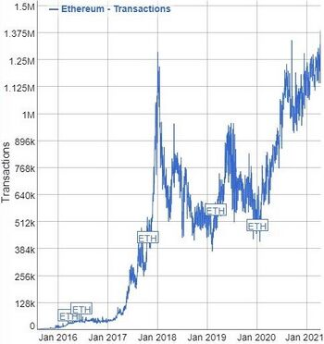

The number of daily confirmed Ethereum transactions as of April 2021

The Ethereum Virtual Machine (EVM) is the [runtime](https://handwiki.org/wiki/Runtime_(program_lifecycle_phase)) environment for transaction execution in Ethereum. It includes a [stack](https://handwiki.org/wiki/Stack_(abstract_data_type)), memory, and the persistent storage for all Ethereum accounts (including contract code). The EVM is stack-based, in that most instructions pop [operands](https://handwiki.org/wiki/Operand) from the stack and push the result to the stack. The EVM is designed to be [deterministic](https://handwiki.org/wiki/Deterministic_algorithm) on a wide variety of [hardware](https://handwiki.org/wiki/Computer_hardware) and [operating systems](https://handwiki.org/wiki/Operating_system), so that given a pre-transaction state and a transaction, each node produces the same post-transaction state, thereby enabling network consensus. The formal definition of the EVM is specified in the Ethereum Yellow Paper.[[25]](https://handwiki.org/wiki/Finance:Ethereum#cite_note-eip150-26)[[55]](https://handwiki.org/wiki/Finance:Ethereum#cite_note-DEBA20-57) EVMs have been implemented in [C++](https://handwiki.org/wiki/C%2B%2B), [C#](https://handwiki.org/wiki/C_Sharp_(programming_language)), [Go](https://handwiki.org/wiki/Go_(programming_language)), [Haskell](https://handwiki.org/wiki/Haskell_(programming_language)), [Java](https://handwiki.org/wiki/Java_(programming_language)), [JavaScript](https://handwiki.org/wiki/JavaScript), [Python](https://handwiki.org/wiki/Python_(programming_language)), [Ruby](https://handwiki.org/wiki/Ruby_(programming_language)), [Rust](https://handwiki.org/wiki/Rust_(programming_language)), [Elixir](https://handwiki.org/wiki/Elixir_(programming_language)), [Erlang](https://handwiki.org/wiki/Erlang_(programming_language)), and soon [WebAssembly](https://handwiki.org/wiki/WebAssembly).

### Gas

Gas is a [unit of account](https://handwiki.org/wiki/Finance:Unit_of_account) within the EVM used in the calculation of the transaction fee, which is the amount of ETH a transaction's sender must pay to the network to have the transaction included in the blockchain. Each type of operation which may be performed by the EVM is hardcoded with a certain gas cost, which is intended to be roughly [proportional](https://handwiki.org/wiki/Proportionality_(mathematics)) to the monetary value of the resources (e.g. [computation](https://handwiki.org/wiki/Computation) and [storage](https://handwiki.org/wiki/Computer_data_storage)) a node must expend or dedicate to perform that operation.

When a sender is creating a transaction, the sender must specify a *gas limit* and *gas price*. The *gas limit* is the maximum amount of gas the sender is willing to use in the transaction, and the *gas price* is the amount of ETH the sender wishes to pay to the network per unit of gas used. A transaction may only be included in the blockchain at a block slot that has a *base gas price* less than or equal to the transaction's *gas price*. The portion of the *gas price* that is in excess of the *base gas price* is known as the tip and goes to the block proposer; the higher the tip, the more incentive a block proposer has to include the transaction in their block, and thus the quicker the transaction will be included in the blockchain. The sender buys the full amount of gas (i.e. their ETH balance is debited the amount: *gas limit* × *gas price*) up-front, at the start of the execution of the transaction, and is refunded at the end for any unused gas. If at any point the transaction does not have enough gas to perform the next operation, the transaction is reverted but the sender is still only refunded for the unused gas. In [user interfaces](https://handwiki.org/wiki/User_interface), gas prices are typically denominated in gigawei (gwei), a subunit of ETH equal to 10−9 ETH.[[56]](https://handwiki.org/wiki/Finance:Ethereum#cite_note-58)

This fee mechanism is designed to mitigate transaction spam, prevent infinite loops during contract execution, and provide for a market-based allocation of network resources.

## Applications

The EVM's instruction set is [Turing-complete](https://handwiki.org/wiki/Turing_completeness).[[25]](https://handwiki.org/wiki/Finance:Ethereum#cite_note-eip150-26) Popular uses of Ethereum have included the creation of fungible (ERC-20) and non-fungible (ERC-721) tokens with a variety of properties, [crowdfunding](https://handwiki.org/wiki/Crowdfunding) (e.g. initial coin offerings), [decentralized finance](https://handwiki.org/wiki/Finance:Decentralized_finance), [decentralized exchanges](https://handwiki.org/wiki/Finance:Decentralized_exchange), [decentralized autonomous organizations](https://handwiki.org/wiki/Decentralized_autonomous_organization) (DAOs), games, [prediction markets](https://handwiki.org/wiki/Finance:Prediction_market), and gambling.

### Contract source code

Ethereum's smart contracts are written in [high-level](https://handwiki.org/wiki/High-level_programming_language) programming languages and then [compiled](https://handwiki.org/wiki/Compiler) down to EVM [bytecode](https://handwiki.org/wiki/Software:Bytecode) and deployed to the Ethereum blockchain. They can be written in [Solidity](https://handwiki.org/wiki/Solidity) (a language library with similarities to [C](https://handwiki.org/wiki/C_(programming_language)) and [JavaScript](https://handwiki.org/wiki/JavaScript)), Serpent (similar to [Python](https://handwiki.org/wiki/Python_(programming_language)), but deprecated), Yul (an intermediate language that can compile to various different backends—EVM 1.0, EVM 1.5, and eWASM are planned), LLL (a [low-level](https://handwiki.org/wiki/Low-level_programming_language) [Lisp](https://handwiki.org/wiki/Lisp_(programming_language))-like language), and Mutan ([Go](https://handwiki.org/wiki/Go_(programming_language))-based, but deprecated). There was also a research-oriented language under development called Vyper (a [strongly-typed](https://handwiki.org/wiki/Strong_and_weak_typing) [Python](https://handwiki.org/wiki/Python_(programming_language))-derived [decidable language](https://handwiki.org/wiki/Recursive_language)). Source code and compiler information are usually published along with the launch of the contract so that users can see the code and verify that it compiles to the bytecode that is on-chain.

One issue related to using smart contracts on a public blockchain is that bugs, including security holes, are visible to all but cannot be fixed quickly.[[57]](https://handwiki.org/wiki/Finance:Ethereum#cite_note-Peck20160528-59) One example of this is the 2016 attack on [The DAO](https://handwiki.org/wiki/Organization:The_DAO), which could not be quickly stopped or reversed.[[34]](https://handwiki.org/wiki/Finance:Ethereum#cite_note-NYTDAOHACK-35)

### ERC-20 tokens

The ERC-20 (Ethereum Request-for-Comments #20) Token Standard allows for fungible tokens on the Ethereum [blockchain](https://handwiki.org/wiki/Finance:Blockchain). The standard, proposed by Fabian Vogelsteller in November 2015, implements an [API](https://handwiki.org/wiki/API) for tokens within [smart contracts](https://handwiki.org/wiki/Finance:Smart_contract). The standard provides functions that include the transfer of tokens from one account to another, getting the current token balance of an account, and getting the total supply of the token available on the network. Smart contracts that correctly implement ERC-20 processes are called ERC-20 Token Contracts, and they keep track of created tokens on Ethereum. Numerous cryptocurrencies have launched as ERC-20 tokens and have been distributed through initial coin offerings.[[58]](https://handwiki.org/wiki/Finance:Ethereum#cite_note-forbes20200728-60) Fees to send ERC-20 tokens must be paid with ether.

### Non-fungible tokens (NFTs)

Ethereum also allows for the creation of unique and indivisible tokens, called non-fungible tokens (NFTs).[[59]](https://handwiki.org/wiki/Finance:Ethereum#cite_note-61) Since tokens of this type are unique, they have been used to represent such things as collectibles, digital art, sports memorabilia, virtual real estate, and items within games.[[60]](https://handwiki.org/wiki/Finance:Ethereum#cite_note-62) The first NFT project, Etheria, a 3D map of tradable and customizable hexagonal tiles, was deployed to the network in October 2015 and demonstrated live at DEVCON1 in November of that year.[[61]](https://handwiki.org/wiki/Finance:Ethereum#cite_note-63) In 2021, Christie's sold a digital image with an NFT by Beeple for US$69.3 million, making him the third-most-valuable living artist in terms of auction prices at the time, although observers have noted that both the buyer and seller had a vested interest in driving demand for the artist's work.[[62]](https://handwiki.org/wiki/Finance:Ethereum#cite_note-64)[[63]](https://handwiki.org/wiki/Finance:Ethereum#cite_note-65) Land, buildings, and avatars in blockchain-based virtual worlds can also be bought and sold as NFTs, sometimes for hundreds of thousands of dollars.[[64]](https://handwiki.org/wiki/Finance:Ethereum#cite_note-66)

### Decentralized finance

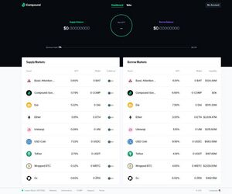

The web interface to Compound Finance's decentralized application where users can lend and borrow cryptocurrencies for interest

*Main page:* [*Finance:Decentralized finance*](https://handwiki.org/wiki/Finance:Decentralized_finance)

Decentralized finance (DeFi) offers traditional [financial instruments](https://handwiki.org/wiki/Finance:Financial_instrument) in a decentralized architecture, outside of companies' and governments' control, such as money market funds which let users earn interest.[[65]](https://handwiki.org/wiki/Finance:Ethereum#cite_note-forbes20190426-67) DeFi applications are typically accessed through a [Web3](https://handwiki.org/wiki/Web3)-enabled browser extension or application, such as [MetaMask](https://handwiki.org/wiki/Software:MetaMask), which allows users to directly interact with the Ethereum blockchain through a website.[[66]](https://handwiki.org/wiki/Finance:Ethereum#cite_note-bloomberg20200902-68) Many of these DApps can connect and work together to create complex financial services.[[67]](https://handwiki.org/wiki/Finance:Ethereum#cite_note-bloomberg20200826-69)

Examples of DeFi platforms include MakerDAO and Compound.[[68]](https://handwiki.org/wiki/Finance:Ethereum#cite_note-fortune20200825-70) [Uniswap](https://handwiki.org/wiki/Software:Uniswap), a [decentralized exchange](https://handwiki.org/wiki/Finance:Decentralized_exchange) for tokens on Ethereum grew from US$20 million in liquidity to US$2.9 billion in 2020.[[69]](https://handwiki.org/wiki/Finance:Ethereum#cite_note-forbes20201018-71) As of October 2020, over US$11 billion was invested in various DeFi protocols.[[70]](https://handwiki.org/wiki/Finance:Ethereum#cite_note-Zcash-72) Additionally, through a process called "wrapping", certain DeFi protocols allow synthetic versions of various assets (such as bitcoin, gold, and oil) to be tradeable on Ethereum and also compatible with all of Ethereum's major wallets and applications.[[70]](https://handwiki.org/wiki/Finance:Ethereum#cite_note-Zcash-72)

### Enterprise software

Ethereum-based software and networks, independent from the public Ethereum [chain](https://handwiki.org/wiki/Engineering:Chain), are being tested by [enterprise software](https://handwiki.org/wiki/Software:Enterprise_software) companies.[[71]](https://handwiki.org/wiki/Finance:Ethereum#cite_note-renamed_from_20170228_on_20210805181819-73) Interested parties include [Microsoft](https://handwiki.org/wiki/Company:Microsoft), [IBM](https://handwiki.org/wiki/Company:IBM), [JPMorgan Chase](https://handwiki.org/wiki/Company:JPMorgan_Chase),[[51]](https://handwiki.org/wiki/Finance:Ethereum#cite_note-NYTEVCRB-53) [Deloitte](https://handwiki.org/wiki/Company:Deloitte), R3, and [Innovate UK](https://handwiki.org/wiki/Organization:Innovate_UK) (cross-border payments prototype).[[72]](https://handwiki.org/wiki/Finance:Ethereum#cite_note-74) [Barclays](https://handwiki.org/wiki/Company:Barclays), [UBS](https://handwiki.org/wiki/Company:UBS), [Credit Suisse](https://handwiki.org/wiki/Company:Credit_Suisse), [Amazon](https://handwiki.org/wiki/Company:Amazon), [Visa](https://handwiki.org/wiki/Company:Visa_Inc.), and other companies are also experimenting with Ethereum.[[73]](https://handwiki.org/wiki/Finance:Ethereum#cite_note-renamed_from_20200219_on_20210805181819-75)[[74]](https://handwiki.org/wiki/Finance:Ethereum#cite_note-bloomberg20201203-76)

### Permissioned ledgers

Ethereum-based permissioned blockchain variants are used and being investigated for various projects:

* In 2017, [JPMorgan Chase](https://handwiki.org/wiki/Company:JPMorgan_Chase) proposed developing [JPM Coin](https://handwiki.org/wiki/Finance:JPM_Coin) on a permissioned-variant of Ethereum blockchain dubbed "Quorum".[[75]](https://handwiki.org/wiki/Finance:Ethereum#cite_note-77) It is "designed to toe the line between private and public in the realm of shuffling derivatives and payments. The idea is to satisfy regulators who need seamless access to financial goings-on while protecting the privacy of parties that don't wish to reveal their identities nor the details of their transactions to the general public."[[76]](https://handwiki.org/wiki/Finance:Ethereum#cite_note-fortune20161014-78)
* The Royal Bank of Scotland announced that it built a Clearing and Settlement Mechanism (CSM) based on the Ethereum distributed ledger and smart contract platform.

### Performance

The downside is that performance issues arise because every node calculates all the smart contracts in real-time. (As of January 2016), the Ethereum protocol could process about 25 transactions per second; this didn't change after the proof-of-stake implementation. In comparison, the [Visa](https://handwiki.org/wiki/Company:Visa_Inc.) payment platform processes 45,000 payments per second. This has led some to question the scalability of Ethereum.[[77]](https://handwiki.org/wiki/Finance:Ethereum#cite_note-79) On 19 December 2016, Ethereum exceeded one million transactions in a single day for the first time.[[78]](https://handwiki.org/wiki/Finance:Ethereum#cite_note-80) Visa has also signaled interest in processing NFT and Ethereum transactions.[[79]](https://handwiki.org/wiki/Finance:Ethereum#cite_note-81)

Ethereum engineers have been working on [sharding](https://handwiki.org/wiki/Shard_(database_architecture)) the calculations, and the next step (Ethereum 2) was presented at Ethereum's Devcon 3 in November 2017.[[80]](https://handwiki.org/wiki/Finance:Ethereum#cite_note-82)

Ethereum's blockchain uses [Merkle trees](https://handwiki.org/wiki/Merkle_tree) for security reasons, to improve scalability, and to optimize transaction hashing.[[81]](https://handwiki.org/wiki/Finance:Ethereum#cite_note-83) As with any Merkle tree implementation, this allows for storage savings, set membership proofs (called "Merkle proofs"), and light client synchronization. The network has faced congestion problems, such as in 2017 in relation to [*CryptoKitties*](https://handwiki.org/wiki/Software:CryptoKitties).[[82]](https://handwiki.org/wiki/Finance:Ethereum#cite_note-84)

## Regulation

In the [*United States*](https://www.wikipedia.org/wiki/United%20States) , the proposed Digital Commodities Consumer Protection Act would treat Ethereum and other cryptocurrencies as [commodities](https://handwiki.org/wiki/Finance:Commodity), which could then be regulated by the Commodity Futures Trading Commission (CFTC).[[83]](https://handwiki.org/wiki/Finance:Ethereum#cite_note-85)[[84]](https://handwiki.org/wiki/Finance:Ethereum#cite_note-86)

## Notes

* [↑](https://handwiki.org/wiki/Finance:Ethereum#cite_ref-3) Cryptocurrency do not have a formal [ISO 4217](https://handwiki.org/wiki/ISO_4217) alpha-3 code. "ETH" is informal only
* [↑](https://handwiki.org/wiki/Finance:Ethereum#cite_ref-51) A permissionless network allows any party to participate in the network (e.g., conduct transactions) and contribute to its upkeep (e.g., consensus process) without any requirement to validate/approve its identity from a central authority.

## References

* [↑](https://handwiki.org/wiki/Finance:Ethereum#cite_ref-1) Sigalos, MacKenzie. ["Ethereum's massive software upgrade just went live — here's what it does"](https://www.cnbc.com/2022/09/15/ethereums-massive-software-upgrade-just-went-live-heres-what-it-does.html) (in en).
* [↑](https://handwiki.org/wiki/Finance:Ethereum#cite_ref-2) ["Clients"](https://ethernodes.org/). 10 September 2022.
* ↑
* [Jump up to:](https://handwiki.org/wiki/Finance:Ethereum#cite_ref-ft20210528_4-0)
* [3.0](https://handwiki.org/wiki/Finance:Ethereum#cite_ref-ft20210528_4-0) [3.1](https://handwiki.org/wiki/Finance:Ethereum#cite_ref-ft20210528_4-1) Szalay, Eva; Venkataramakrishnan, Siddharth (28 May 2021). ["What are cryptocurrencies and stablecoins and how do they work?"](https://www.ft.com/content/424b29c4-07bf-4612-b7d6-76aecf8e1528). *Financial Times*.
* ↑
* [Jump up to:](https://handwiki.org/wiki/Finance:Ethereum#cite_ref-wsj20210603_5-0)
* [4.0](https://handwiki.org/wiki/Finance:Ethereum#cite_ref-wsj20210603_5-0) [4.1](https://handwiki.org/wiki/Finance:Ethereum#cite_ref-wsj20210603_5-1) Vigna, Paul (3 June 2021). ["DeFi Is Helping to Fuel the Crypto Market Boom—and Its Recent Volatility"](https://www.wsj.com/articles/defi-is-helping-to-fuel-the-crypto-market-boomand-its-recent-volatility-11622712602). *The Wall Street Journal*.
* ↑
* [Jump up to:](https://handwiki.org/wiki/Finance:Ethereum#cite_ref-FOOTNOTETapscottTapscott201687_6-0)
* [5.0](https://handwiki.org/wiki/Finance:Ethereum#cite_ref-FOOTNOTETapscottTapscott201687_6-0) [5.1](https://handwiki.org/wiki/Finance:Ethereum#cite_ref-FOOTNOTETapscottTapscott201687_6-1) [5.2](https://handwiki.org/wiki/Finance:Ethereum#cite_ref-FOOTNOTETapscottTapscott201687_6-2) [5.3](https://handwiki.org/wiki/Finance:Ethereum#cite_ref-FOOTNOTETapscottTapscott201687_6-3) [5.4](https://handwiki.org/wiki/Finance:Ethereum#cite_ref-FOOTNOTETapscottTapscott201687_6-4) [Tapscott & Tapscott 2016](https://handwiki.org/wiki/Finance:Ethereum#CITEREFTapscottTapscott2016), pp. 87.
* [↑](https://handwiki.org/wiki/Finance:Ethereum#cite_ref-paumgarten_7-0) Paumgarten, Nick (15 October 2018). ["The Prophets of Cryptocurrency Survey the Boom and Bust"](https://newyorker.com/magazine/2018/10/22/the-prophets-of-cryptocurrency-survey-the-boom-and-bust). *The New Yorker*. Retrieved 7 December 2021.
* [↑](https://handwiki.org/wiki/Finance:Ethereum#cite_ref-8) Foundation, Ethereum (30 July 2015). ["Ethereum Launches"](https://blog.ethereum.org/2015/07/30/ethereum-launches/) (in en).
* [↑](https://handwiki.org/wiki/Finance:Ethereum#cite_ref-9) Popper, Nathaniel (19 June 2017). ["Move Over, Bitcoin. Ether Is the Digital Currency of the Moment. (Published 2017)"](https://www.nytimes.com/2017/06/19/business/dealbook/ethereum-bitcoin-digital-currency.html).
  + ["Vapor No More: Ethereum Has Launched"](https://techcrunch.com/2015/08/01/vapor-no-more-ethereum-has-launched/). August 2015.
* [↑](https://handwiki.org/wiki/Finance:Ethereum#cite_ref-10) Vigna, Paul (3 May 2021). ["Ethereum Is Booming in the NFT Frenzy—So Is Network Congestion"](https://www.wsj.com/articles/ethereum-is-booming-in-the-nft-frenzyso-is-network-congestion-11620050853) (in en-US). *The Wall Street Journal*. [ISSN](https://en.wikipedia.org/wiki/International_Standard_Serial_Number) [0099-9660](http://www.worldcat.org/issn/0099-9660).
* [↑](https://handwiki.org/wiki/Finance:Ethereum#cite_ref-fortune20210506_11-0) ["There are two very real reasons Ethereum is taking off"](https://fortune.com/2021/05/06/ethereum-price-ether-predictions-why-it-is-rising-usd-bitcoin). *Fortune*. 6 May 2021.
* ↑
* [Jump up to:](https://handwiki.org/wiki/Finance:Ethereum#cite_ref-EnergyRevamp_12-0)
* [11.0](https://handwiki.org/wiki/Finance:Ethereum#cite_ref-EnergyRevamp_12-0) [11.1](https://handwiki.org/wiki/Finance:Ethereum#cite_ref-EnergyRevamp_12-1) Clark, Aaron (6 December 2022). ["Ethereum’s Energy Revamp Is No Guarantee of Global Climate Gains"](https://www.bloomberg.com/news/articles/2022-12-06/ethereum-cut-its-energy-use-99-but-climate-gains-may-be-curbed) (in en). *Bloomberg.com*.
* [↑](https://handwiki.org/wiki/Finance:Ethereum#cite_ref-13) ["White Paper· ethereum/wiki Wiki · GitHub"](https://github.com/ethereum/wiki/wiki/White-Paper).
* ↑
* [Jump up to:](https://handwiki.org/wiki/Finance:Ethereum#cite_ref-Finley-27-Jan-2014_14-0)
* [13.0](https://handwiki.org/wiki/Finance:Ethereum#cite_ref-Finley-27-Jan-2014_14-0) [13.1](https://handwiki.org/wiki/Finance:Ethereum#cite_ref-Finley-27-Jan-2014_14-1) Finley, Klint (27 January 2014). ["Out in the Open: Teenage Hacker Transforms Web into One Giant Bitcoin Network"](https://www.wired.com/2014/01/ethereum/). *Wired*. Retrieved 21 March 2016.
* [↑](https://handwiki.org/wiki/Finance:Ethereum#cite_ref-Schneider-2014-04-07_15-0) Schneider, Nathan (7 April 2014). ["Code your own utopia: Meet Ethereum, bitcoin's most ambitious successor"](http://america.aljazeera.com/articles/2014/4/7/code-your-own-utopiameetethereumbitcoinasmostambitioussuccessor.html). Al Jazeera.
* ↑
* [Jump up to:](https://handwiki.org/wiki/Finance:Ethereum#cite_ref-tapscott2016_16-0)
* [15.0](https://handwiki.org/wiki/Finance:Ethereum#cite_ref-tapscott2016_16-0) [15.1](https://handwiki.org/wiki/Finance:Ethereum#cite_ref-tapscott2016_16-1) Tapscott, Don; Tapscott, Alex (2016). *The Blockchain Revolution: How the Technology Behind Bitcoin is Changing Money, Business, and the World*. Portfolio. [ISBN](https://en.wikipedia.org/wiki/International_Standard_Book_Number) [978-0670069972](https://handwiki.org/wiki/Special:BookSources/978-0670069972).
* [↑](https://handwiki.org/wiki/Finance:Ethereum#cite_ref-Russo2020_17-0) Russo, Camila (14 July 2020). *The infinite machine : how an army of crypto-hackers is building the next internet with Ethereum* (First ed.). New York, NY. pp. 40–44. [ISBN](https://en.wikipedia.org/wiki/International_Standard_Book_Number) [9780062886149](https://handwiki.org/wiki/Special:BookSources/9780062886149).
* [↑](https://handwiki.org/wiki/Finance:Ethereum#cite_ref-FOOTNOTERusso202044_18-0) [Russo 2020](https://handwiki.org/wiki/Finance:Ethereum#CITEREFRusso2020), pp. 44.
* [↑](https://handwiki.org/wiki/Finance:Ethereum#cite_ref-FOOTNOTETapscottTapscott2016278_19-0) [Tapscott & Tapscott 2016](https://handwiki.org/wiki/Finance:Ethereum#CITEREFTapscottTapscott2016), pp. 278.
* ↑
* [Jump up to:](https://handwiki.org/wiki/Finance:Ethereum#cite_ref-Paumgarten_20-0)
* [19.0](https://handwiki.org/wiki/Finance:Ethereum#cite_ref-Paumgarten_20-0) [19.1](https://handwiki.org/wiki/Finance:Ethereum#cite_ref-Paumgarten_20-1) [19.2](https://handwiki.org/wiki/Finance:Ethereum#cite_ref-Paumgarten_20-2) [19.3](https://handwiki.org/wiki/Finance:Ethereum#cite_ref-Paumgarten_20-3) [19.4](https://handwiki.org/wiki/Finance:Ethereum#cite_ref-Paumgarten_20-4) Paumgarten, Nick (22 October 2018). ["The Prophets of Cryptocurrency Survey the Boom and Bust"](https://www.newyorker.com/magazine/2018/10/22/the-prophets-of-cryptocurrency-survey-the-boom-and-bust). *The New Yorker*.
* [↑](https://handwiki.org/wiki/Finance:Ethereum#cite_ref-21) ["The Uncanny Mind That Built Ethereum"](https://www.wired.com/2016/06/the-uncanny-mind-that-built-ethereum/) (in en-US). *Wired*. [ISSN](https://en.wikipedia.org/wiki/International_Standard_Serial_Number) [1059-1028](http://www.worldcat.org/issn/1059-1028).
* [↑](https://handwiki.org/wiki/Finance:Ethereum#cite_ref-entrepreneur20210817_22-0) Jain, Aman (17 August 2021). ["Founders' Fork: The Ethereum Architects Now Locked in Battle"](https://www.entrepreneur.com/article/380431). *Entrepreneur*.
* [↑](https://handwiki.org/wiki/Finance:Ethereum#cite_ref-FOOTNOTERusso202056_23-0) [Russo 2020](https://handwiki.org/wiki/Finance:Ethereum#CITEREFRusso2020), pp. 56.
* [↑](https://handwiki.org/wiki/Finance:Ethereum#cite_ref-bloomberg20160820_24-0) ["Company Overview of Ethereum Switzerland GmbH"](https://www.bloomberg.com/Research/stocks/private/snapshot.asp?privcapId=309484729). Bloomberg. 20 August 2016. "The company was founded in 2014 and is based in Baar, Switzerland."
* [↑](https://handwiki.org/wiki/Finance:Ethereum#cite_ref-Dannen2018_25-0) Dannen, Chris (16 March 2017). [*Introducing Ethereum and Solidity: Foundations of Cryptocurrency and Blockchain Programming for Beginners*](https://books.google.com/books?id=roVkDgAAQBAJ&pg=PA30). Apress. p. 30. [ISBN](https://en.wikipedia.org/wiki/International_Standard_Book_Number) [978-1484225356](https://handwiki.org/wiki/Special:BookSources/978-1484225356). Retrieved 12 November 2018.
* ↑
* [Jump up to:](https://handwiki.org/wiki/Finance:Ethereum#cite_ref-eip150_26-0)
* [25.0](https://handwiki.org/wiki/Finance:Ethereum#cite_ref-eip150_26-0) [25.1](https://handwiki.org/wiki/Finance:Ethereum#cite_ref-eip150_26-1) [25.2](https://handwiki.org/wiki/Finance:Ethereum#cite_ref-eip150_26-2) [25.3](https://handwiki.org/wiki/Finance:Ethereum#cite_ref-eip150_26-3) Wood, Gavin (3 February 2018). ["Ethereum: A Secure Decentralized Generalised Transaction Ledger (EIP-150)"](http://yellowpaper.io/).
* ↑
* [Jump up to:](https://handwiki.org/wiki/Finance:Ethereum#cite_ref-WSJFRONTIER_27-0)
* [26.0](https://handwiki.org/wiki/Finance:Ethereum#cite_ref-WSJFRONTIER_27-0) [26.1](https://handwiki.org/wiki/Finance:Ethereum#cite_ref-WSJFRONTIER_27-1) Vigna, Paul (31 July 2015). ["BitBeat: Ethereum Opens Its 'Frontier' for Business"](https://blogs.wsj.com/moneybeat/2015/07/31/bitbeat-ethereum-opens-its-frontier-for-business/). *The Wall Street Journal*.
* ↑
* [Jump up to:](https://handwiki.org/wiki/Finance:Ethereum#cite_ref-bi20210413_28-0)
* [27.0](https://handwiki.org/wiki/Finance:Ethereum#cite_ref-bi20210413_28-0) [27.1](https://handwiki.org/wiki/Finance:Ethereum#cite_ref-bi20210413_28-1) ["Ether rallies to all-time high above $2,200 ahead of Coinbase listing, Berlin hard fork"](https://markets.businessinsider.com/currencies/news/ether-price-all-time-high-coinbase-listing-berlin-hard-fork-2021-4-1030300075). 13 April 2021.
* ↑
* [Jump up to:](https://handwiki.org/wiki/Finance:Ethereum#cite_ref-cnbc20210805_29-0)
* [28.0](https://handwiki.org/wiki/Finance:Ethereum#cite_ref-cnbc20210805_29-0) [28.1](https://handwiki.org/wiki/Finance:Ethereum#cite_ref-cnbc20210805_29-1) Sigalos, MacKenzie (5 August 2021). ["Ethereum just activated its 'London' hard fork, and it's a really big deal"](https://www.msn.com/en-us/money/markets/ethereum-just-activated-its-london-hard-fork-and-its-a-really-big-deal/ar-AAMYsaT). [*CNBC*](https://www.wikipedia.org/wiki/CNBC).
* [↑](https://handwiki.org/wiki/Finance:Ethereum#cite_ref-30) etherscan.io. ["Ethereum Blocks #15537394 | Etherscan"](http://etherscan.io/block/15537394) (in en).
* [↑](https://handwiki.org/wiki/Finance:Ethereum#cite_ref-31) [*Ethereum Proof-of-Stake Consensus Specifications*](https://github.com/ethereum/consensus-specs/blob/770a603af9263e4010c9a19c32fd2ce37631eaa0/specs/capella/beacon-chain.md), ethereum, 2022-09-15, retrieved 2022-09-15
* [↑](https://handwiki.org/wiki/Finance:Ethereum#cite_ref-EFPROCESS_32-0) Gupta, Vinay (3 March 2015). ["The Ethereum Launch Process"](https://blog.ethereum.org/2015/03/03/ethereum-launch-process/). Ethereum Foundation.
* [↑](https://handwiki.org/wiki/Finance:Ethereum#cite_ref-33) Bashir, Imran (2020). *Mastering Blockchain – Third Edition : a deep dive into distributed ledgers, consensus protocols,... smart contracts, dapps, cryptocurrencies, ethereum*. [S.l.]: Packt Publishing Limited. pp. 312. [ISBN](https://en.wikipedia.org/wiki/International_Standard_Book_Number) [978-1839213199](https://handwiki.org/wiki/Special:BookSources/978-1839213199).
* [↑](https://handwiki.org/wiki/Finance:Ethereum#cite_ref-WSJDAOCC_34-0) Vigna, Paul (16 May 2016). ["Chiefless Company Rakes in More than $100 Million"](https://www.wsj.com/articles/chiefless-company-rakes-in-more-than-100-million-1463399393). [*The Wall Street Journal*](https://www.wikipedia.org/wiki/The%20Wall%20Street%20Journal).
* ↑
* [Jump up to:](https://handwiki.org/wiki/Finance:Ethereum#cite_ref-NYTDAOHACK_35-0)
* [34.0](https://handwiki.org/wiki/Finance:Ethereum#cite_ref-NYTDAOHACK_35-0) [34.1](https://handwiki.org/wiki/Finance:Ethereum#cite_ref-NYTDAOHACK_35-1) Popper, Nathaniel (18 June 2016). ["Hacker May Have Taken $50 Million From Cybercurrency Project"](https://www.nytimes.com/2016/06/18/business/dealbook/hacker-may-have-removed-more-than-50-million-from-experimental-cybercurrency-project.html). *The New York Times*.
* [↑](https://handwiki.org/wiki/Finance:Ethereum#cite_ref-BIDAOHACK_36-0) Price, Rob (17 June 2016). ["Digital Currency Ethereum is Cratering Amid Claims of a $50 Million Hack"](http://uk.businessinsider.com/dao-hacked-ethereum-crashing-in-value-tens-of-millions-allegedly-stolen-2016-6). Business Insider.
* [↑](https://handwiki.org/wiki/Finance:Ethereum#cite_ref-IEEEDAOHK_37-0) Peck, Morgan (19 July 2016). [""Hard Fork" Coming to Restore Ethereum Funds to Investors of Hacked DAO"](https://spectrum.ieee.org/tech-talk/computing/networks/hacked-blockchain-fund-the-dao-chooses-a-hard-fork-to-redistribute-funds). IEEE.
* [↑](https://handwiki.org/wiki/Finance:Ethereum#cite_ref-bloomberg20170613_38-0) Leising, Matthew (13 June 2017). ["The Ether Thief"](https://www.bloomberg.com/features/2017-the-ether-thief/).
* [↑](https://handwiki.org/wiki/Finance:Ethereum#cite_ref-NYTEEA_39-0) Popper, Nathaniel (27 February 2017). ["Business Giants to Announce Creation of a Computing System Based on Ethereum"](https://www.nytimes.com/2017/02/27/business/dealbook/ethereum-alliance-business-banking-security.html). *The New York Times*.
* [↑](https://handwiki.org/wiki/Finance:Ethereum#cite_ref-IEEEEEA_40-0) Peck, Morgan (2 March 2017). ["Corporate Titans Unite to Build an Enterprise Version of the Ethereum Blockchain"](https://spectrum.ieee.org/tech-talk/computing/networks/enterprise-ethereum-alliance-launches). Institute of Electrical and Electronics Engineers (IEEE).
* [↑](https://handwiki.org/wiki/Finance:Ethereum#cite_ref-EEA022217_41-0) ["Enterprise Ethereum Alliance expands dramatically announcing 86 new members"](https://entethalliance.org/enterprise-ethereum-alliance-release-05-19-2017.pdf) (PDF) (Press release). Enterprise Ethereum Alliance (EEA). 19 May 2017. [Archived](https://web.archive.org/web/20170607000537/https://entethalliance.org/enterprise-ethereum-alliance-release-05-19-2017.pdf) (PDF) from the original on 7 June 2017. Retrieved 5 June 2017.
* [↑](https://handwiki.org/wiki/Finance:Ethereum#cite_ref-42) ["The Enterprise Ethereum Alliance Just Got A Whole Lot Stronger"](https://www.inc.com/brian-d-evans/the-enterprise-ethereum-alliance-just-got-a-whole-.html). 19 July 2017.
* [↑](https://handwiki.org/wiki/Finance:Ethereum#cite_ref-fortune20180108_43-0) Shen, Lucinda (8 January 2018). ["Ethereum Regains Title as Second Most Valuable Cryptocurrency Behind Bitcoin"](https://fortune.com/2018/01/08/ethereum-price-ripple-price-bitcoin-xrp/) (in en). *Fortune* (Fortune Media IP Limited).
* [↑](https://handwiki.org/wiki/Finance:Ethereum#cite_ref-44) Ransom, Jan (2 December 2019). ["He Gave a Cryptocurrency Talk in North Korea. The U.S. Arrested Him."](https://www.nytimes.com/2019/12/02/nyregion/north-korea-virgil-griffin-cyptocurrency-arrest.html). [*The New York Times*](https://www.wikipedia.org/wiki/The%20New%20York%20Times).
* [↑](https://handwiki.org/wiki/Finance:Ethereum#cite_ref-45) ["Cryptocurrency expert pleads guilty to conspiring to help North Korea dodge sanctions"](https://www.washingtonpost.com/national-security/griffith-korea-cryptocurrency-plea/2021/09/27/2da04ad2-1fc6-11ec-b3d6-8cdebe60d3e2_story.html). *Washington Post*.
* [↑](https://handwiki.org/wiki/Finance:Ethereum#cite_ref-fortune20210329_46-0) Hackett, Robert (29 March 2021). ["That settles it: Visa is making life way easier for crypto businesses"](https://fortune.com/2021/03/29/visa-crypto-business/). *Fortune*.
* [↑](https://handwiki.org/wiki/Finance:Ethereum#cite_ref-fortune20210413_47-0) Morris, David Z. (13 April 2021). ["Ethereum: Mastercard, UBS, and J.P. Morgan pour $65 million into crypto startup studio Consensys"](https://fortune.com/2021/04/13/ethereum-crypto-google-mastercard-ubs-jp-morgan-funding/). *Fortune*.
* [↑](https://handwiki.org/wiki/Finance:Ethereum#cite_ref-bloomberg20210307_48-0) ["Crypto Coin Outperforming Bitcoin Is About to See Supply Reduced"](https://www.bloomberg.com/news/articles/2021-03-07/crypto-coin-outperforming-bitcoin-is-about-to-see-supply-reduced) (in en). 7 March 2021.
* [↑](https://handwiki.org/wiki/Finance:Ethereum#cite_ref-bloom20210827_49-0) Mehrotra, Kartikay (28 August 2021). ["Most Used Blockchain Averts Crisis After Software Flaw Is Fixed"](https://www.bloomberg.com/news/articles/2021-08-27/most-used-blockchain-averts-crisis-after-software-flaw-is-fixed?srnd=technology-vp). *Bloomberg*.
* [↑](https://handwiki.org/wiki/Finance:Ethereum#cite_ref-50) ["The Roadmap to Serenity aka #Ethereum 2.0 Upgrades"](https://consensys.net/blog/blockchain-explained/the-roadmap-to-serenity-2/) (in en). 16 May 2019.
* [↑](https://handwiki.org/wiki/Finance:Ethereum#cite_ref-52) ["What Is a Wei?"](https://www.investopedia.com/terms/w/wei.asp) (in en).
* ↑
* [Jump up to:](https://handwiki.org/wiki/Finance:Ethereum#cite_ref-NYTEVCRB_53-0)
* [51.0](https://handwiki.org/wiki/Finance:Ethereum#cite_ref-NYTEVCRB_53-0) [51.1](https://handwiki.org/wiki/Finance:Ethereum#cite_ref-NYTEVCRB_53-1) Popper, Nathaniel (27 March 2016). ["Ethereum, a Virtual Currency, Enables Transactions That Rival Bitcoin's"](https://www.nytimes.com/2016/03/28/business/dealbook/ethereum-a-virtual-currency-enables-transactions-that-rival-bitcoins.html). [*The New York Times*](https://www.wikipedia.org/wiki/The%20New%20York%20Times).
* [↑](https://handwiki.org/wiki/Finance:Ethereum#cite_ref-54) Chavez-Dreyfuss, Gertrude (5 February 2021). ["Ether seeks to escape bitcoin's shadow with CME futures launch"](https://www.reuters.com/article/us-crypto-currency-ethereum/ether-seeks-to-escape-bitcoins-shadow-with-cme-futures-launch-idUKKBN2A52BC) (in en).
* [↑](https://handwiki.org/wiki/Finance:Ethereum#cite_ref-bloomberg20201125_55-0) ["Ethereum Upgrade Adds to Crypto Mania Sparked by Bitcoin's Surge"](https://www.bloomberg.com/news/articles/2020-11-25/ethereum-upgrade-adds-to-crypto-mania-sparked-by-bitcoin-s-surge). *Bloomberg.com*. 25 November 2020.
* [↑](https://handwiki.org/wiki/Finance:Ethereum#cite_ref-56) ["Introduction to Smart Contracts"](https://docs.soliditylang.org/en/v0.4.24/introduction-to-smart-contracts.html) (in en).
* [↑](https://handwiki.org/wiki/Finance:Ethereum#cite_ref-DEBA20_57-0) Triantafyllidis, Nikolaos Petros (19 February 2016). ﻿Developing an Ethereum Blockchain Application﻿ (Report). University of Amsterdam. p. 20.
* [↑](https://handwiki.org/wiki/Finance:Ethereum#cite_ref-58) de Azevedo Sousa, José Eduardo (2020). ["An analysis of the fees and pending time correlation in Ethereum"](http://dl.ifip.org/db/conf/lanoms/lanoms2019/196411_1.pdf). *International Journal of Network Management* (e2113). Retrieved 14 October 2020.
* [↑](https://handwiki.org/wiki/Finance:Ethereum#cite_ref-Peck20160528_59-0) Peck, M. (28 May 2016). ["Ethereum's $150-Million Blockchain-Powered Fund Opens Just as Researchers Call For a Halt"](https://spectrum.ieee.org/tech-talk/computing/networks/ethereums-150-million-dollar-dao-opens-for-business-just-as-researchers-call-for-a-moratorium). [Institute of Electrical and Electronics Engineers](https://handwiki.org/wiki/Organization:Institute_of_Electrical_and_Electronics_Engineers).
* [↑](https://handwiki.org/wiki/Finance:Ethereum#cite_ref-forbes20200728_60-0) Castillo, Michael del. ["Ethereum's First ICO Blazes Trail To A World Without Bosses"](https://www.forbes.com/sites/michaeldelcastillo/2020/07/28/ethereums-first-ico-blazes-trail-to-a-world-without-bosses/?sh=4d6c90035a18) (in en).
* [↑](https://handwiki.org/wiki/Finance:Ethereum#cite_ref-61) Volpicelli, Gian (24 February 2021). ["The bitcoin elite are spending millions on collectable memes"](https://www.wired.co.uk/article/crypto-art-nft). *Wired UK*. Retrieved 25 February 2021.
* [↑](https://handwiki.org/wiki/Finance:Ethereum#cite_ref-62) Browne, Ryan (25 February 2021). ["Why people are buying crypto art and sports memorabilia for thousands of dollars"](https://www.cnbc.com/2021/02/25/nfts-why-digital-art-and-sports-collectibles-are-suddenly-so-popular.html) (in en).
* [↑](https://handwiki.org/wiki/Finance:Ethereum#cite_ref-63) ["The Cult of CryptoPunks"](https://social.techcrunch.com/2021/04/08/the-cult-of-cryptopunks/) (in en-US). 8 April 2021.
* [↑](https://handwiki.org/wiki/Finance:Ethereum#cite_ref-64) Gerlis, Melanie (18 February 2021). ["Christie's gets digital with the art world's non-fungible craze"](https://www.ft.com/content/d7523a73-8aa3-40eb-8b3d-bf27cd2494a0). *Financial Times*.
  + Ostroff, Kelly Crow and Caitlin (11 March 2021). ["Beeple NFT Fetches Record-Breaking $69 Million in Christie's Sale"](https://www.wsj.com/articles/beeple-nft-fetches-record-breaking-69-million-in-christies-sale-11615477732).
* [↑](https://handwiki.org/wiki/Finance:Ethereum#cite_ref-65) Ravenscraft, Eric (March 12, 2022). ["NFTs Don't Work the Way You Might Think They Do"](https://www.wired.com/story/nfts-dont-work-the-way-you-think-they-do/). Wired.
* [↑](https://handwiki.org/wiki/Finance:Ethereum#cite_ref-66) ["The 'metaverse' bet: crypto-rich investors snap up virtual real estate"](https://www.reuters.com/business/metaverse-bet-crypto-rich-investors-snap-up-virtual-real-estate-2021-04-19/). 19 April 2021.
* [↑](https://handwiki.org/wiki/Finance:Ethereum#cite_ref-forbes20190426_67-0) Kauflin, Jeff. ["Why Everyone in Crypto Is Talking About DeFi"](https://www.forbes.com/sites/jeffkauflin/2019/04/26/why-everyone-in-crypto-is-talking-about-defi/) (in en).
* [↑](https://handwiki.org/wiki/Finance:Ethereum#cite_ref-bloomberg20200902_68-0) ["MetaMask's Blockchain Mobile App Opens Doors For Next-Level Web"](https://www.bloomberg.com/news/articles/2020-09-02/metamask-s-blockchain-mobile-app-opens-doors-for-next-level-web) (in en). 2 September 2020.
* [↑](https://handwiki.org/wiki/Finance:Ethereum#cite_ref-bloomberg20200826_69-0) ["Why 'DeFi' Utopia Would Be Finance Without Financiers: QuickTake"](https://www.bloomberg.com/news/articles/2020-08-26/why-defi-utopia-would-be-finance-without-financiers-quicktake). *Bloomberg*. 26 August 2020.
* [↑](https://handwiki.org/wiki/Finance:Ethereum#cite_ref-fortune20200825_70-0) ["Crypto soars again as traders embrace 'DeFi' and 'yield farming'—but some see echoes of the 2017 bubble"](https://fortune.com/2020/08/25/crypto-defi-yield-farming-bitcoin/). *Fortune*. 25 August 2020.
* [↑](https://handwiki.org/wiki/Finance:Ethereum#cite_ref-forbes20201018_71-0) Konrad, Alex. ["These Young Investors Are Still Betting Big On Crypto – And Are Taking Harvard And Stanford Along For The Ride"](https://www.forbes.com/sites/alexkonrad/2020/10/18/these-young-investors-betting-big-on-crypto-are-taking-harvard-and-stanford-along-for-the-ride/#5642b5e04212). *Forbes*.
* ↑
* [Jump up to:](https://handwiki.org/wiki/Finance:Ethereum#cite_ref-Zcash_72-0)
* [70.0](https://handwiki.org/wiki/Finance:Ethereum#cite_ref-Zcash_72-0) [70.1](https://handwiki.org/wiki/Finance:Ethereum#cite_ref-Zcash_72-1) Ehrlich, Steven. ["Leading 'Privacy Coin' Zcash Poised For Growth Following Placement On Ethereum"](https://www.forbes.com/sites/stevenehrlich/2020/10/29/leading-privacy-coin-zcash-poised-for-growth-following-placement-on-ethereum) (in en).
* [↑](https://handwiki.org/wiki/Finance:Ethereum#cite_ref-renamed_from_20170228_on_20210805181819_73-0) ["Big Business Giants From Microsoft to J.P. Morgan Are Getting Behind Ethereum"](http://fortune.com/2017/02/28/ethereum-jpmorgan-microsoft-alliance/) (in en). *Fortune*.
* [↑](https://handwiki.org/wiki/Finance:Ethereum#cite_ref-74) ["Settlement using blockchain to Automate Foreign Exchange in a Regulated environment (SAFER)"](http://gtr.rcuk.ac.uk/projects?ref=720735).
* [↑](https://handwiki.org/wiki/Finance:Ethereum#cite_ref-renamed_from_20200219_on_20210805181819_75-0) Castillo, Michael del. ["Blockchain 50"](https://www.forbes.com/sites/michaeldelcastillo/2020/02/19/blockchain-50/?sh=219e535d7553) (in en).
* [↑](https://handwiki.org/wiki/Finance:Ethereum#cite_ref-bloomberg20201203_76-0) ["Beyond Bitcoin: These Cryptocurrencies Are Doing Even Better"](https://www.bloomberg.com/news/articles/2020-12-03/ethereum-xet-xrp-litecoin-xlc-cryptocurrency-alternative-to-bitcoin-btc) (in en). 3 December 2020.
* [↑](https://handwiki.org/wiki/Finance:Ethereum#cite_ref-77) ["JP Morgan's Quorum blockchain powers new correspondent banking network " Banking Technology"](http://www.bankingtech.com/1037032/jp-morgans-quorum-blockchain-powers-new-correspondent-banking-network/). 18 October 2017.
* [↑](https://handwiki.org/wiki/Finance:Ethereum#cite_ref-fortune20161014_78-0) Hackett, Robert (4 October 2016). ["Why J.P. Morgan Chase Is Building a Blockchain on Ethereum"](http://fortune.com/2016/10/04/jp-morgan-chase-blockchain-ethereum-quorum/). *Fortune*.
* [↑](https://handwiki.org/wiki/Finance:Ethereum#cite_ref-79) Murphy, Hannah (19 October 2018). ["The rise and fall of Ethereum"](https://www.ft.com/content/a8d2c280-d2b6-11e8-a9f2-7574db66bcd5) (in en). *Financial Times* (London: The Financial Times Ltd).
* [↑](https://handwiki.org/wiki/Finance:Ethereum#cite_ref-80) Filiba, Jack. ["Ethereum Breaks One Million Transactions in a Single Day"](https://discover.coinsquare.io/tech/ethereum-one-million-transaction-day/).
* [↑](https://handwiki.org/wiki/Finance:Ethereum#cite_ref-81) DeCambre, Mark. ["Why did Visa just buy a 'CryptoPunk' NFT for $150,000? The payments giant wants 'a seat at the table as the crypto economy evolves'"](https://www.marketwatch.com/story/why-did-visa-just-buy-a-cryptopunk-nft-for-150-000-the-payments-giant-wants-a-seat-at-the-table-as-the-crypto-economy-evolves-11629737832) (in EN-US).
* [↑](https://handwiki.org/wiki/Finance:Ethereum#cite_ref-82) Galeon, Dom. ["Ethereum's Co-Founder Just Unveiled His Plan for the Future of Cryptocurrency"](https://futurism.com/ethereums-co-founder-just-unveiled-his-plan-for-the-future-of-cryptocurrency/).
* [↑](https://handwiki.org/wiki/Finance:Ethereum#cite_ref-83) Vitalik Buterin. ["Merkling in Ethereum"](https://blog.ethereum.org/2015/11/15/merkling-in-ethereum).
* [↑](https://handwiki.org/wiki/Finance:Ethereum#cite_ref-84) Joon Ian Wong (4 December 2017). ["The Ethereum network is getting jammed up because people are rushing to buy cartoon cats on its blockchain"](https://qz.com/1145833/cryptokitties-is-causing-ethereum-network-congestion/).
* [↑](https://handwiki.org/wiki/Finance:Ethereum#cite_ref-85) ["Customer Advisory: Understand the Risks of Virtual Currency Trading"](https://www.cftc.gov/LearnAndProtect/AdvisoriesAndArticles/understand_risks_of_virtual_currency.html#:~:text=Bitcoin%20is%20a%20Commodity&text=While%20its%20regulatory%20oversight%20authority,a%20commodity%20in%20interstate%20commerce). Commodity Futures Trading Commission.
* [↑](https://handwiki.org/wiki/Finance:Ethereum#cite_ref-86) ["Bitcoin Basics"](https://www.cftc.gov/sites/default/files/2019-12/oceo_bitcoinbasics0218.pdf). Commodity Futures Trading Commission. December 2019.

# Chapter 5 Storage: A Research Perspective on Filecoin

A Research Perspective on Filecoin | Protocol Labs Research

<https://research.protocol.ai/blog/2020/a-research-perspective-on-filecoin/>

A Research Perspective on Filecoin, Part Two | Protocol Labs Research

<https://research.protocol.ai/blog/2020/a-research-perspective-on-filecoin-part-two/>

[The Filecoin network](https://filecoin.io/) is launching in the middle of a revolution in internet architecture, where vulnerable centralized services dependent on trusted parties are being replaced with resilient decentralized solutions based on verifiable computation, and internet services are being relocated from inefficient central monoliths to the far reaches of the network by peer-to-peer markets.

Filecoin represents an evolution in protocols and services adapted to the needs of the revolution in internet architecture: an open-source decentralized storage network with built-in economic incentives to ensure that files are stored reliably over time. Filecoin and other blockchain networks like Bitcoin and Ethereum are pioneering examples of Open Services: decentralized platforms where commercial service providers —from the corporation to the individual— can compete in an open market.

Filecoin is a living project, and here we trace the evolutionary trajectory of a revolutionary technology in two parts: In Part One, we describe the technological and conceptual advances leading to the creation of the first modern networks based on distributed ledger technology. In Part Two, we focus on Filecoin’s development, from inception to implementation.

## **Part One: Standing on the shoulders of giants**

It would be impossible to capture all of the advances in cryptography, distributed systems, cryptoeconomics, and related fields that have contributed to the development of Filecoin. Nevertheless, there are certain peaks in the technological landscape that stand out:

The era of modern cryptography may have begun in secret at the [British Signals Intelligence Agency](https://en.wikipedia.org/wiki/GCHQ), with the development of [public key cryptography](https://web.archive.org/web/20170216051636/https://www.gchq.gov.uk/sites/default/files/document_files/CESG_Research_Report_No_3006_0.pdf) by James Ellis in 1970 and the introduction of the factoring problem in an RSA-equivalent construction by Clifford Cocks in 1973. However, the public lineage leading to blockchain implementations like Bitcoin, Ethereum, and Filecoin began in a U.C. Berkeley undergraduate computer science class with Ralph Merkle’s 1974 [CS 244 project proposal](https://www.merkle.com/1974/FirstCS244projectProposal.pdf) for establishing secure communications over insecure communication channels, eventually published in 1978 in the [*ACM*](https://www.merkle.com/1974/PuzzlesAsPublished.pdf). Merkle’s paper described a cryptosystem based on puzzle-solving, where the puzzles take the form of an encrypted message with an unknown key — an early construction for public-key cryptography. *Merkle’s Puzzles*, as the paper is commonly known, even contained an early concept of Proof-of-Work[1](https://research.protocol.ai/blog/2020/a-research-perspective-on-filecoin/#fn:1) — the construction underlying Bitcoin, Ethereum, and most other permissionless blockchains today.

Merkle’s public-key cryptosystem, based on computations having quadratic complexity, was not secure enough for most practical implementations. In 1976, with the publication of [New Directions in Cryptography](https://ee.stanford.edu/~hellman/publications/24.pdf), Whitfield Diffie and Martin Hellman built on Merkle’s ideas to devise the famous algorithm known as the [Diffie-Hellman key exchange](https://en.wikipedia.org/wiki/Diffie-Hellman), which is based on a much more complex mathematical problem ([the discrete logarithm](https://en.wikipedia.org/wiki/Discrete_logarithm_problem)). Their seminal paper also informally lays out the idea of a *cryptographic hash function*: a non-reversible algorithm that maps data of any size to a fixed-size bit string.

Shortly thereafter, in 1977, Ronald L Rivest, Adi Shamir, and Leonard Adleman at MIT developed the [RSA cryptosystem](https://people.csail.mit.edu/rivest/Rsapaper.pdf), an asymmetric cryptographic algorithm based on the factorization of large primes. RSA became one of the first public-key encryption schemes to reach wide use, and is still used in e.g. TLS handshakes between VPN servers and clients to establish secure communications channels.

In 1979, Ralph Merkle submitted a [Stanford PhD thesis](http://www.merkle.com/papers/Thesis1979.pdf) informally sketching the idea of *collision-resistance* — a property of a hash function describing how difficult it is to find two inputs that hash to the same output — and a “recipe” for building a hash function using symmetric encryption. The invention of the cryptographic hash function and the development of the concept of collision resistance to measure the security of these one-way functions created a secure means to authenticate data without violating privacy.

By the early 1980s, cryptographers and cypherpunks were making significant progress on the problem of secure communication between trusted parties. But the problem of achieving consensus in multi-party communication including potentially faulty or corrupt parties remained unsolved. In their 1982 paper “[Reaching agreement in the presence of faults](https://citeseerx.ist.psu.edu/viewdoc/download;jsessionid=CAE9DBDC8B6AF902132B7859E38E3E06?doi=10.1.1.68.4044&rep=rep1&type=pdf)”, Leslie Lamport, Robert Shostak, and Marshall Pease formally described the [Byzantine Generals Problem](http://citeseerx.ist.psu.edu/viewdoc/download?doi=10.1.1.126.9525&rep=rep1&type=pdf), the dilemma plaguing distributed ledger implementations [since antiquity](https://ethw.org/Distributed_ledgers): how does one create a trustless mechanism for enabling coordination in a system containing unreliable or untrustworthy components?

David Chaum’s 1982 UC Berkeley dissertation “[Computer Systems Established, Maintained, and Trusted by Mutually Suspicious Groups](https://www.chaum.com/publications/research_chaum_2.pdf)” introduced the first known description of a blockchain protocol, including every element of the Bitcoin blockchain (except for proof-of-work), as well as the code necessary for its implementation[2](https://research.protocol.ai/blog/2020/a-research-perspective-on-filecoin/#fn:2). The influence of this prescient but unpublished work is [unclear](https://arxiv.org/pdf/1810.06130.pdf). Though it lacks the robust *consensus mechanism* (the algorithm that lets users in a distributed system reach agreement without the need for a central arbiter) crucial to modern blockchain implementations, it anticipates many of the important features of current distributed ledger technology.

The 1980s saw further developments in cryptographic hashing: the criterion of collision-resistance for a hash function was formalized by Ivan Damgård, in his 1987 [*EUROCRYPT'87* paper](https://www.researchgate.net/publication/226671358_Collision_Free_Hash_Functions_and_Public_Key_Signature_Schemes). A few years later, in 1989, Damgård developed a cryptographic hash function “recipe” almost identical to Merkle’s, and proved in a [*CRYPTO'89* paper](https://www.researchgate.net/publication/221354712_A_Design_Principle_for_Hash_Functions) that it satisfied his previously-specified collision-resistance criterion. The idea became known as the [Merkle-Damgård construction](https://en.wikipedia.org/wiki/Merkle%E2%80%93Damg%C3%A5rd_construction), and is part of the design of important hash functions like [MD5](https://en.wikipedia.org/wiki/MD5) (designed by Ronald Rivest in 1991), [SHA-1](https://en.wikipedia.org/wiki/SHA-1) (published as a US federal standard in 1995), and [SHA-2](https://en.wikipedia.org/wiki/SHA-2). The SHA-2 family of hash functions is a NIST standard [published in 2002](https://csrc.nist.gov/csrc/media/publications/fips/180/2/archive/2002-08-01/documents/fips180-2.pdf), and is used in security protocols like TSL, SSL, SSH, and PGP. Closer to the heart of our story, the SHA-256 member of the SHA-2 family is used by Bitcoin and other blockchain protocols to verify transactions and calculate Proof-of Work and Proof-of-Stake.

The collision-resistant hash function was integral to Stuart Haber and W. Scott Stornetta’s 1991 method of certifying the creation and modification of digital documents while maintaining user privacy, published in [“How to Time-Stamp a Digital Document”](https://www.anf.es/pdf/Haber_Stornetta.pdf) (and later expanded upon with D. Bayer in a 1993 publication and in a 1997 [*ACM* paper](https://nakamotoinstitute.org/static/docs/secure-names-bit-strings.pdf); these three publications constitute three of the eight citations in the [Bitcoin whitepaper](https://bitcoin.org/bitcoin.pdf). This method of relative timestamping — establishing the order of events in a decentralized system — was essential to the critical task of establishing transaction priority on the blockchain. Improvements in timestamping presented by H. Massias, X.S. Avila, and J.-J. Quisquater in their 1999 paper, “[Design of a secure timestamping service with minimal trust requirement](https://nakamotoinstitute.org/static/docs/secure-timestamping-service.pdf)”, were directly incorporated into the [Bitcoin](https://bitcoin.org/bitcoin.pdf) proposal.

The Proof-of-Work concept underlying consensus mechanisms in many modern distributed ledger technologies was introduced in 1992 when Cynthia Dwork and Moni Naor [published](http://www.wisdom.weizmann.ac.il/~naor/PAPERS/pvp.pdf) a pricing function based on difficult computation as a scheme for controlling access to a shared resource; the publication describes an implementation to fight junk mail. Dwork and Naor’s paper did not use the term “proof-of-work” — that was invented and formalized later in a [1999 paper](http://www.hashcash.org/papers/bread-pudding.pdf) by Markus Jakobssen and Ari Juels — but the paper establishes an asymmetrically costly defense mechanism whereby service requesters must perform work that service providers can easily check. This principle of requiring verifiable and computationally costly work as the basis of consensus later became a critical component of Bitcoin’s security assurances. The work of defending and regulating the use of un-metered internet resources continued in 1997 with Adam Back’s [hashcash](http://www.hashcash.org/papers/announce.txt) proposal to use partial SHA-1 collisions as a proof-of-work to fight spam (described in detail in his [2002 paper](http://www.hashcash.org/papers/hashcash.pdf)).

We might trace the roots of the modern cryptocurrency era to 1998, when Wei Dai published “[b-money, an anonymous, distributed electronic cash system](http://www.weidai.com/bmoney.txt)” to the cypherpunks mailing list, which described a protocol having many of the features shared by modern cryptocurrency systems, including transaction broadcast and proof-of-work. In the same year, Nick Szabo proposed a blockchain-based decentralized currency called “[bit gold](https://unenumerated.blogspot.com/2005/12/bit-gold.html)” based on public-key-linked proof-of-work chains and time-stamped block elements. When Hal Finney (later to become the first Bitcoin recipient) created the first [reusable proof-of-work system](https://nakamotoinstitute.org/finney/rpow/index.html) in 2004, he proposed the use of proof-of-work tokens as a form of bit gold.

The growth of the internet spurred further work into hardening networks against faulty node behavior. In 1999, Miguel Castro and Barbara Liskov at MIT [published](http://pmg.csail.mit.edu/papers/osdi99.pdf) an implementation of a Byzantine fault-tolerant distributed file system able to meet the performance demands of real-world asynchronous internet systems.

Work on problem specification relevant to distributed systems was also producing interesting results in the late 90s. In 1999, Henning Pagnia and Felix Gärtner formally defined the [strong fair exchange problem](https://www.cs.utexas.edu/~shmat/courses/cs395t_fall04/pagnia.pdf), arguing that it is impossible for two parties to execute a guaranteed, perfectly fair exchange of digital goods without a trusted third party. This finding would later have important implications for the structure of Filecoin’s retrieval market, motivating the need to bootstrap trust between market participants via incremental deal performance.

A few years later, in the early 2000s, we can see the emergence of ideas directly and particularly relevant to Filecoin’s design. In 2002, David Mazières and Dennis Shasha described the features of a multi-user network filesystem in “[Building secure file systems out of Byzantine storage](https://cs.nyu.edu/cs/faculty/shasha/papers/mazpodc.pdf)”, demonstrating that a trusted network file system can be implemented on an untrusted server. Also in 2002, Sean Quinlan and Sean Dorward at Bell Labs developed the data model of *content-addressable storage* — a way of referring to data by its content rather than its location — as a [Plan 9](https://en.wikipedia.org/wiki/Plan_9_from_Bell_Labs) service called [Venti](https://www.usenix.org/legacy/publications/library/proceedings/fast02/quinlan/quinlan_html/index.html), using the SHA-1 hash function. This content-addressable data model using SHA-1 was [adopted](https://github.com/git/git/commit/e83c5163316f89bfbde7d9ab23ca2e25604af290?#diff-c47c7c7383225ab55ff591cb59c41e6b) by Linus Torvalds in 2005, for the version-control system Git as a way to avoid centralized repositories, and independently by Bram Cohen at [BitTorrent](https://en.wikipedia.org/wiki/Mainline_DHT), as a way to avoid central “tracker” servers.

In 2008 Satoshi Nakamoto published [Bitcoin](https://bitcoin.org/bitcoin.pdf), which uses SHA-256 both for content-addressable transaction storage and as part of a proof-of-work consensus scheme overcoming the main hurdle for building a distributed ledger on the internet, [the Byzantine Generals Problem](https://www.youtube.com/watch?v=IP-rGJKSZ3s&t=390s).

The release of Bitcoin was a [mic drop moment](https://media.giphy.com/media/l0K42u9hCg0x6XbLa/giphy.gif): Bitcoin demonstrated that distributed ledger technology could function at scale in a modern computing environment. Stay tuned for the next installment of this series, where we’ll take a look at the novel development environment ushered in by the first Bitcoin release!

In [Part One](https://research.protocol.ai/blog/2020/a-research-perspective-on-filecoin/), we traced the intellectual and technological history of modern implementations of distributed ledger technology. Now let’s take a stroll through the technological landscape around the time of Filecoin’s release:

## **The post-Bitcoin landscape**

The arrival of Bitcoin initiated a rapid florescence in the development of distributed ledger technology, inaugurating the modern blockchain era. This period saw a number of innovations in both underlying technologies and overlaid applications.

Bitcoin’s practical breakthrough was its *proof-of-work consensus algorithm*, which created a reliable system for managing and tracking token ownership in a distributed system. This was a milestone akin to the [breaking of the four-minute-mile barrier in running](https://en.wikipedia.org/wiki/Four-minute_mile): once it was established that satisfactory solutions to the Byzantine Generals problem were realistically possible, blockchain developers immediately began to implement further innovations on the problem of consensus.

[Peercoin](https://www.peercoin.net/assets/paper/peercoin-paper.pdf), a blockchain incorporating a *proof-of-stake* consensus protocol which debuted in 2012, introducing an alternative to Bitcoin’s proof-of-work protocol. In *proof-of-stake* consensus, the miner of a new block is chosen based in part on some measure of their investment in the network — for example seniority or token holdings — rather than on the solving of computationally intensive puzzles underlying *proof-of-work* systems. Reducing the resources wasted on Bitcoin mining was another target of blockchain innovators. For example, [Primecoin](https://primecoin.io/bin/primecoin-paper.pdf), introduced in 2013 by the founder of Peercoin, was based on a proof-of-work protocol that performs (slightly) useful work: searching for prime numbers. [Permacoin](https://ieeexplore.ieee.org/abstract/document/6956582), published in May 2014, was an academic proposal for building a proof-of-work mechanism around long-term data storage rather than computation, but it had the severe limitation of requiring a fixed set of data to be used over the whole lifetime of a blockchain using that design.

Ethereum ([whitepaper](https://ethereum.org/en/whitepaper/), 2013) launched based on a proof-of-work consensus protocol ([Ethash](https://eth.wiki/en/concepts/ethash/ethash)); the network intends to shift to a proof-of-stake protocol in [Eth 2.0](https://ethereum.org/en/eth2/). Ethereum explicitly foregrounded the potential for blockchain networks to serve as a platform for decentralized applications, helping to create the market for decentralized file storage, among other novel blockchain applications. Ethreum’s blockchain-as-a-platform model has created a [vibrant ecosystem](https://www.stateofthedapps.com/rankings/platform/ethereum) of third-party [dApps](https://en.wikipedia.org/wiki/Decentralized_application) (decentralized applications) and inspired some [creative thinking](https://hackfs.com/index.html) about the [types of applications](https://filecoin.io/blog/filecoin-defi/) the decentralized web (including Filecoin) can support.

## **The 2014 Filecoin whitepaper**

The first version of [Filecoin](https://filecoin.io/filecoin-jul-2014.pdf), a cryptocurrency and file storage network enabling the outsourcing of data storage to a distributed network of service providers, was published in 2014. Filecoin’s goal was to make data widely and cheaply available and redeploy wasted computational resources to perform useful work. Enacting this vision required innovation in the protocol and service layers of the network, and one of Filecoin’s primary conceptual advances was to make the useful work performed by consensus relevant to the purpose of the network: storing and retrieving files.

In the 2014 proposal, Filecoin’s useful storage service is layered atop Bitcoin-style proof-of-work consensus: in addition to solving a cryptographic puzzle, Filecoin miners would complete a *proof-of-retrievability* establishing that they were storing a particular file. The 2014 whitepaper observes that the inclusion of proof-of-work is sub-optimal, and concludes with a proposal to remove proof-of-work consensus from the Filecoin protocol. This vision formed the basis of much of the work on the [Filecoin proof system](https://filecoin.io/blog/filecoin-proof-system/) over the next few years.

## **The 2017 Filecoin whitepaper**

In 2017, Protocol Labs announced Filecoin, the decentralized storage network and market first envisioned in the 2104 whitepaper. The [2017 Filecoin construction](https://filecoin.io/filecoin.pdf) built on the foundations laid by its 2014 predecessor to introduce several significant conceptual and technological advances:

### **Growing an ecosystem**

One of the greatest conceptual advances relevant to the Filecoin Network between the 2014 and 2017 constructions occurred via a different Protocol Labs technology: the launch of [IPFS](https://ipfs.io/) — a peer-to-peer hypermedia protocol for storing and sharing data in a distributed file system — in 2015. IPFS ([whitepaper](https://ipfs.io/ipfs/QmR7GSQM93Cx5eAg6a6yRzNde1FQv7uL6X1o4k7zrJa3LX/ipfs.draft3.pdf)) served as a proof-of-concept of the real-world utility of [*content-addressing*](https://filecoin.io/blog/why-is-decentralized-critical/): referring to data by its content (through a hash fingerprint) rather than its location in the network. Content-addressing in IPFS allows peers to exchange data locally (an essential component of the decentralization of data access central to the Filecoin storage model) without having to connect to a central hub. Working with IPFS also contributed to Filecoin developers’ data and intuitions regarding market structures and incentives, as well as privacy protection.

The existence of IPFS — and of [Ethereum](https://ethereum.org/en/), a vibrant smart-contracts platform supporting applications requiring decentralized storage — also created market demand for Filecoin. Accordingly, the 2017 whitepaper built out the crypto-economic underpinnings of the Filecoin model (later elaborated in [this report](https://research.protocol.ai/publications/engineering-filecoins-economy/)), formally describing the Filecoin network as a decentralized storage network, and introducing the concept of [verifiable storage and retrieval markets](https://filecoin.io/blog/filecoin-features-verifiable-storage/). These innovations established Filecoin as part of a community of technologies interacting in an open market.

In addition to creative thinking about Filecoin’s place in the broader economy of decentralized services, this period also saw significant re-envisioning of core Filecoin technologies. We can get a sense of the extent of the improvements made to the Filecoin protocol during this time by taking a look at the changes made to the proof system and consensus mechanism:

### **The Filecoin Proof System**

The 2017 Filecoin construction described two new proofs-of-storage: *proof-of-replication* (PoRep) and *proof-of-spacetime* (PoSt)*.* These proofs were motivated by the desire to build on work in the areas of [*provable data possession*](http://webarchiv.ethz.ch/infsec/education/fs08/secsem/ateniese-ccs07.pdf) (PDP) and *proof-of-retrievability* developed by [Juels and Kaliski](https://www.arijuels.com/wp-content/uploads/2013/09/JK07.pdf) and [Shacham and Waters](https://eprint.iacr.org/2008/073.pdf) to provide greater protection against Sybil attacks, outsourcing attacks, and generation attacks. Filecoin’s PoRep ([proof-of-replication](https://proto.school/verifying-storage-on-filecoin/03)) allows storage providers (miners on the Filecoin network) to verifiably demonstrate that they are storing data replicas in physically independent locations. Filecoin’s PoSt ([proof-of-spacetime](https://proto.school/verifying-storage-on-filecoin/04)) algorithm is used to prove that a particular data replica is being stored throughout the agreed-upon period of time. The proof-of-spacetime algorithm serves as the basis for an intrinsically useful proof-of-work, one of the goals explicitly set forth in the 2014 Filecoin whitepaper.

Work on Filecoin’s proof system also included research into optimizing the methods of storing proofs in the blockchain. Filecoin uses [zk-SNARK](https://proto.school/verifying-storage-on-filecoin/05) technology to publish PoRep and PoSt on-chain in a compact format. *Zero-knowledge Succinct Non-interactive ARguments of Knowledge* ([zk-SNARKs](https://www.iacr.org/archive/crypto2013/80420214/80420214.pdf)) are publicly-verifiable and efficient systems for proving something is true via a constant-size single message that does not expose the private part of the information in question.

### **Refactoring Consensus**

One of the core advances of the Filecoin protocol lies in its *consensus mechanism* — the way the nodes of the network agree on network state. Filecoin consensus presents two efficiency advantages over Bitcoin-style consensus: it costs less energy to run than Bitcoin; and the protocol incentivizes energy “recapture” as a side effect of providing cryptographically verified cloud storage of real data for real customers, rather than being spent directly on blockchain maintenance.

Current Filecoin consensus also represents an innovation over the system described in the 2014 Filecoin whitepaper. The 2017 Filecoin proposal introduced a [consensus protocol based on useful work](https://spec.filecoin.io/#section-algorithms.expected_consensus), where the probability that a miner is elected to create a new block is proportional to their active storage relative to the rest of the network. This new consensus protocol was designed to incentivize miners to invest in storage power, aligning their incentives with the goals of the network, and to allow the proof-of-storage computation to be re-used to participate in consensus, increasing the efficiency of the system. The proofs-of-spacetime that miners submit to the network can be used to calculate miner power, making power in Filecoin *public* and *publicly verifiable*.

The PL Technical Report [*Power Fault Tolerance*](https://filecoin.io/vintage/power-fault-tolerance.pdf) models [Byzantine fault tolerance](https://en.wikipedia.org/wiki/Byzantine_fault_tolerance) (essentially a measure of the susceptibility of a distributed system to the Byzantine Generals Problem) according to a framing more applicable to the way power works in the Filecoin network. This new understanding of power is used by Filecoin’s [Expected Consensus](https://spec.filecoin.io/algorithms/expected_consensus/), a consensus protocol using a [*secret leader election*](https://eprint.iacr.org/2020/025.pdf) to select the miners who will extend the chain by mining new blocks. Leader election in Filecoin builds on extant protocols [PoA](https://netecon.seas.harvard.edu/NetEcon14/Papers/Bentov_netecon14.pdf), [Snow White](https://eprint.iacr.org/eprint-bin/getfile.pl?entry=2016/919&version=20160922:013923&file=919.pdf), and [Algorand](https://arxiv.org/pdf/1607.01341.pdf) to choose miners based on the power committed to a candidate history.

These technological advances in consensus were powered by a great deal of conceptual work in [cryptoeconomics](https://filecoin.io/blog/filecoin-cryptoeconomic-constructions/), particularly *incentive alignment*: Filecoin’s leader elections and its [block reward system](https://filecoin.io/blog/filecoin-features-block-rewards/) based on useful work create a system of incentives aligning miners and clients, with the goal of the network: providing useful storage.

The publication of the 2017 Filecoin whitepaper accelerated Filecoin research, and this dynamism continued throughout the pre-launch period:

## Preparing the launchpad

The 2017 whitepaper and [2017 Research Roadmap](https://filecoin.io/vintage/research-roadmap-2017.pdf) outlined several areas for continued research. Although none of these identified improvements was launch-critical, work on the [Single Secret Leader Election](https://research.protocol.ai/publications/single-secret-leader-election/), improvements to the proof system such as [scaling proofs-of-replication](https://research.protocol.ai/publications/scaling-proof-of-replication-for-filecoin-mining/), and [SNARK optimization](https://filecoin.io/blog/announcing-the-snark-challenge/) to help speed up the generation of zk-SNARK proofs were active research topics in the period between publication and launch.

In addition to optimizations for the extant protocol, the whitepaper also included suggestions for extending Filecoin’s functionality: the Filecoin team proposed the creation of a payments network similar to the [Bitcoin Lightning Network](https://lightning.network/lightning-network-paper.pdf), possibly incorporating features of the [Sprites system](https://arxiv.org/pdf/1702.05812.pdf), and the implementation of a system for *smart contracts*: stateful programs that users can interact with via the blockchain ledger.

There were, of course, a number of pre-launch advances that were not anticipated by the 2017 publications: ResNetLab has made significant improvements to Filecoin’s [message propagation protocols](https://research.protocol.ai/publications/gossipsub-attack-resilient-message-propagation-in-the-filecoin-and-eth2.0-networks/) to keep nodes synchronized, avoid forks, and harden the network against the most challenging attacks. And perhaps one of the more significant improvements to the network during this period was the addition of the [drand](https://drand.love/) randomness beacon, which leverages a [decentralized network](https://www.cloudflare.com/leagueofentropy/) to generate publicly verifiable, unbiased randomness. The drand project originated in the [DEDIS](https://github.com/dedis) lab at EPFL, an outgrowth of research into [scalable bias-resistant distributed randomness](https://eprint.iacr.org/2016/1067.pdf), and is now an important part of Filecoin’s leader election.

Filecoin requires high-entropy, unbiased, publicly verifiable, unpredictable randomness to conduct the [leader elections](https://filecoin.io/blog/distributed-randomness-and-leader-elections/), which determine which miner will generate the next block on the blockchain and earn that block’s rewards, and for the generation of PoRep and PoSt. Drand provides this “good randomness”, allowing Filecoin to guarantee *liveness* — client consensus on the history of the Filecoin blockchain — and *verifiable storage*.

## Building the future

The Filecoin network exploded onto the blockchain scene in October 2020, introducing an exciting new configuration of technology and incentives to the nascent Web 3.0 space. But just because Filecoin is out there tearing it up in the real world doesn’t mean the work of building secure and efficient data storage technology is over: researchers have inaugurated a new phase in Filecoin’s development, where real-world data is integrated into the research and deployment cycle.

Predicting — and shaping — the trajectory of a new technology is a complex process. Protocol Labs researchers, including members of CryptoLab, ResNetLab, and the soon-to-be-formed ConsensusLab — along with the broader research community — have some ideas about research areas that might be interesting to watch in the future:

* [zk-SNARKs](https://research.protocol.ai/talks/good-snarks-are-here-needed/) are currently a focus of active research, including using SNARK aggregation techniques and devising new vector commitment schemes to reduce the costs of Merkle trees in Filecoin SNARKs. Research foci include devising better systems for SNARKs involving [*multiparty computation*](https://en.wikipedia.org/wiki/Secure_multi-party_computation) (MPC), a technique for allowing several nodes in a network to jointly compute a function over their inputs while keeping those inputs private.
* [VRFs](https://dash.harvard.edu/bitstream/handle/1/5028196/Vadhan_VerifRandomFunction.pdf?sequence=2&isAllowed=y) — *Verifiable Random Functions* — enable publicly verifiable deterministic precommitments. In Filecoin, VRFs are used as part of a system verifying the integrity of Miners' stored data. Each block produced in Filecoin includes values pulled from two sources of randomness, VRFs and the [drand](https://drand.love/) randomness beacon. Miners submit proofs about their stored data incorporating references to randomness added at specific epochs, ensuring that Miners generated proofs at a specific point in time. Future work on VRFs will improve the randomness-production system.
* [VDFs](https://eprint.iacr.org/2018/601.pdf) — *Verifiable Delay Functions* — guarantee a random delay given some hardware assumptions and a small set of requirements. VDFs play a role in public randomness beacons, in leader election in consensus protocols, and in proofs of replication. VDFs are not currently implemented in the Filecoin spec but are an [active](https://research.protocol.ai/talks/vdfs-and-filecoin/) [research area](https://filecoin.io/blog/collaboration-on-vdfs/).
* [Depth Robust Graphs](https://research.protocol.ai/talks/proof-of-replication-using-depth-robust-graphs/) — a form of directed acyclic graph structure — are produced in Filecoin’s proof-of-replication step as original data is encoded into a replica and committed to the blockchain. Work on DRGs is part of the ongoing research into the proof system and graph structures.
* [Vector Commitments](https://eprint.iacr.org/2011/495.pdf) — cryptographic primitives enabling secret precommitments that can be revealed later — are an important component of Filecoin’s verifiable decentralized storage model, and [new vector commitment techniques](https://research.protocol.ai/talks/vector-commitment-techniques-and-applications-to-verifiable-decentralized-storage/) are an active area of CryptoLab research.
* [BLS signatures](https://en.wikipedia.org/wiki/Boneh%E2%80%93Lynn%E2%80%93Shacham) are a form of [digital signature](https://en.wikipedia.org/wiki/Digital_signature): a scheme for validating the authenticity of digital data. The drand randomness beacon uses [threshold BLS](https://hackmd.io/@nikkolasg/HyUAgm234) to jointly compute a signature by combining individual partial signatures that are independently produced by the participants. Secure collaborative computation is an important component of un-biasability, and a topic for future research.

This is, of course, not an exhaustive list of future research directions for the Filecoin project. As cryptographer and blockchain expert [Dan Boneh](https://crypto.stanford.edu/~dabo/) noted in his Filecoin Liftoff [Fireside chat](https://youtu.be/xb9oxvequPc?t=3661), the blockchain is “an amazing testing ground for deploying cryptographic tools,” in part because “the rate of change is much faster on blockchains.”

We in the research community are excited to drive breakthroughs that will accelerate the evolution of the Filecoin network. But the real technological accelerant will be Filecoin’s ongoing widespread adoption by the broader Web 3.0 community, bringing research into contact with reality to create new technologies and applications.

# 

# Chapter 6 Harnessing Blockchain to Solve the Problem of Data Storage

Technical Barriers to Blockchain | Protocol Labs

<https://protocol.ai/blog/technical-barriers-to-blockchain/>

Every new technology faces barriers to entry, and each blockchain application has its own unique set of challenges. Protocol Labs is grappling with these challenges as we prepare to launch Filecoin, a blockchain-based system to democratize file storage.

## **Harnessing Blockchain to Solve the Problem of Data Storage**

Bitcoin aimed to solve a major problem in finance: centralized trust in currency. It offers a decentralized monetary system, showcasing alternatives to traditional organization models. But blockchains, the record-keeping technology behind Bitcoin and other cryptocurrencies and tokens, face their own challenges.



The DCS triangle, above, describes top tradeoffs that decentralized systems must consider: Decentralization, Consensus, and Scalability. The DCS theorem states that a decentralized system cannot have all three properties simultaneously. This leads to technical barriers to a decentralized system that can maintain consensus as well as the scalability often needed for blockchain adoption.

Protocol Labs is grappling with these challenges as we prepare to launch Filecoin, a blockchain-based system to democratize file storage, in the coming months. Filecoin is a **[cryptocurrency-powered storage network](https://filecoin.io/)**

**[(opens new window)](https://filecoin.io/)**

that lets anyone contribute unused storage space to store the world’s information. Its mission is to create a decentralized, efficient, and robust foundation for humanity’s information.

Let’s unpack what we mean by a robust foundation using the DCS triangle.

## ***Decentralization* of Storage**

Filecoin aims to solve a pressing problem: **[what to do with all of the data](https://medium.com/@Kyle.May/blockchain-issues-1-data-storage-40fb9812c9a2)**

**[(opens new window)](https://medium.com/@Kyle.May/blockchain-issues-1-data-storage-40fb9812c9a2)**

humanity is generating. By the end of this year, there will be **[44 zettabytes (ZB)](https://www.weforum.org/agenda/2019/04/how-much-data-is-generated-each-day-cf4bddf29f/)**

**[(opens new window)](https://www.weforum.org/agenda/2019/04/how-much-data-is-generated-each-day-cf4bddf29f/)**

of data in the world -- that’s more than **[130 million](https://www.lifewire.com/terabytes-gigabytes-amp-petabytes-how-big-are-they-4125169)**

**[(opens new window)](https://www.lifewire.com/terabytes-gigabytes-amp-petabytes-how-big-are-they-4125169)**

times the amount of data housed in the Library of Congress. By 2025, it’s estimated that we’ll create **[463 exabytes](https://www.weforum.org/agenda/2019/04/how-much-data-is-generated-each-day-cf4bddf29f/)**

**[(opens new window)](https://www.weforum.org/agenda/2019/04/how-much-data-is-generated-each-day-cf4bddf29f/)**

of data per day worldwide, the equivalent of more than **[200 million DVDs](https://www.weforum.org/agenda/2019/04/how-much-data-is-generated-each-day-cf4bddf29f/)**

**[(opens new window)](https://www.weforum.org/agenda/2019/04/how-much-data-is-generated-each-day-cf4bddf29f/)**

. The question is: Where will we store all of this information?

Storage capabilities are finite, bound by centralized data storage centers and hard drive capacity. Building new centers and more sophisticated storage space is expensive and energy-intensive. Meanwhile, **[roughly half](https://www.cisco.com/c/en/us/solutions/collateral/service-provider/global-cloud-index-gci/white-paper-c11-738085.html#_Toc503317524)**

**[(opens new window)](https://www.cisco.com/c/en/us/solutions/collateral/service-provider/global-cloud-index-gci/white-paper-c11-738085.html#_Toc503317524)**

of the world's storage capacity sits unused in data centers, and even in personal computing devices like our phones and laptops.

As discussed on this [**blog**](https://protocol.ai/blog/why-is-decentralized-critical/) in 2017, a few massive corporations own nearly all of the global cloud data storage market. This consolidation is concerning for a number of reasons:

* users must trust these large corporations to protect their data from exposure,
* the cost of switching cloud providers is especially high,
* and providers are incentivized to lock in their customers and extract a premium.

The current market for cloud storage is not nearly as competitive or efficient as it could be, and end-users suffer because of it.

There’s also a significant amount of ‘latent’ (available) storage throughout the world that sits unused. This storage is owned by all kinds of entities: from large corporations to small businesses, from individuals with huge hard-drive racks to smaller drives in our home computers. But due to the aforementioned barriers to entry it would be difficult for any one particular company or individual to monetize their extra space and start a cloud data service.

In 2015, Protocol Labs launched IPFS, a technology that decentralizes the web by addressing information based on what it is, not where it is. Addressing using a cryptographic hash of the content makes the data unalterable, can identify duplicates across the network, and enables any host to store and provide the data. This makes decentralization more efficient.

Filecoin shares many common components with IPFS including content addressing. Developers can integrate with these modular components to build in encryption and redundancy. In the future, Filecoin will also support user-defined smart contracts enabling its storage to be programmable along with easier integrations with other networks and tools.

## ***Consensus* Across Many Actors**

Every new technology faces barriers to entry, and each blockchain application has its own unique set of challenges. Some face hardware or timing requirement challenges; others are challenged by energy consumption. For example, Bitcoin’s proof-of-work consensus requires miners to compete with one another to solve a computationally expensive math problem in order to verify payments. Solving these problems requires lots of electricity. In fact, each Bitcoin transaction requires an estimated **[80,000 times more energy](https://blockchain.ieee.org/technicalbriefs/june-2019/blockchain-technology-prospects-challenges-and-opportunities)**

**[(opens new window)](https://blockchain.ieee.org/technicalbriefs/june-2019/blockchain-technology-prospects-challenges-and-opportunities)**

than a credit card transaction!

Trent McConaghy’s **[blog post](https://blog.bigchaindb.com/the-dcs-triangle-5ce0e9e0f1dc)**

**[(opens new window)](https://blog.bigchaindb.com/the-dcs-triangle-5ce0e9e0f1dc)**

on The DCS Triangle describes IPFS as a decentralized network with strong decentralization and planetary scalability but not consistency across nodes. Many blockchain networks use IPFS for decentralized storage and content integrity while complementing it with a consistent view about the state of things: ordering transactions, signatures, payments, registries, markets and much more.

Filecoin incentivizes *consensus* about the state of what has been uniquely stored in the world, including a market for this, in a way that anyone can verify. Consensus in Filecoin is achieved through an operation yielding positive social externality (data storage). At its core are two Proofs-of-Storage that provide a more useful alternative to Bitcoin’s Proof-of-Work:

* Proof-of-Replication: proof that **a unique encoding of data exists in physical storage** in the world
* Proof-of-Spacetime: proof that **a given encoding of data existed in physical storage continuously over a period of time** in the world

With these proofs, the Filecoin protocol creates a trustless (i.e., more trustworthy in a mathematical sense) market for storage resources, amassing them into a self-healing, robust storage network on which anyone in the world can rely and join. Clients can select replication parameters to protect against different threat models and developers can build additional tools to make this experience as seamless as cloud services are today.

Filecoin is an ambitious project. Until now, storage power-based consensus and its consistency and security have been at the core of our protocol research. In our research to produce the best Filecoin protocol possible, this has been the priority. We’re working to make sure that consistency and security in our proofs construction and a consensus protocol are at the forefront of our work before mainnet launch in the decentralized web space.

## ***Scalability* of the Protocol**

In December, we laid out **[hardware requirements](https://filecoin.io/blog/filecoin-testnet-mining/)**

**[(opens new window)](https://filecoin.io/blog/filecoin-testnet-mining/)**

for block mining and storage mining on the testnet, which are likely larger than that old PC you have lying around and commodity hard drives. This is because protocol security and solid proofs constructions have been paramount. But longer-term, we expect to make optimization improvements to the protocol and the growth of ecosystem tools and services that facilitate a wider spectrum of miner and other market participants to join later on. This will make work cheaper for participants while also reaching for scalability via economies of scale afforded by specialized markets and the wider range of functionality they provide to the network.

Any part of our protocol where a new market may arise opens up opportunities for community participants to leverage what they can do best: block mining, storage mining, retrieval mining, repair mining, as well as potentially offloading computation and other services.

With a strong foundation for trustless coordination in its protocol, Filecoin participants can achieve consensus around decentralization of storage and use these evolving specialized markets to achieve future scalability.

The Filecoin team is working to solve the problem of building a decentralized storage solution that can operate at the scale and speed needed to satisfy many data storage and retrieval use cases while the protocol maintains consensus across diverse actors.

Learn more about the technical barriers to blockchain adoption and how Protocol Labs is approaching these challenges in **[this video](https://youtu.be/EpJicp9Bh2g)**

**[(opens new window)](https://youtu.be/EpJicp9Bh2g)**

featuring Filecoin Co-Lead Pooja Shah from CES 2020 and in this **[ZeroKnowledge podcast](https://www.zeroknowledge.fm/106)**

**[(opens new window)](https://www.zeroknowledge.fm/106)**

with Juan Benet.

# 

# Chapter 7 Blockchain Infrastructure Landscape: A First Principles Framing

Blockchain Infrastructure Landscape: A First Principles Framing | by Trent McConaghy | Medium

<https://medium.com/@trentmc0/blockchain-infrastructure-landscape-a-first-principles-framing-92cc5549bafe>

How are Ethereum, IPFS/Filecoin, and BigchainDB complementary? What about Golem, Polkadot, or Interledger? I often get questions like this. So, I decided to write about how I answer those questions, via a first-principles framing.

The quick answer: there’s no one magic system called “blockchain” that magically does everything. Rather, there are really good building blocks of computing that can be used together to create effective decentralized applications. Ethereum can play a role, BigchainDB can play a role, and many more as well. Let’s explore…

## Background

The elements of computing are storage, compute, and communications. Mainframes, PCs, mobile, and cloud all manifest these elements in their own unique ways. Specialized building blocks emerge to reconcile tradeoffs within a given element.

For example, in the storage element we have both file systems and databases, where file systems are for storing blobs like mp3s with a hierarchy of directories and files, and databases are for storing structured metadata with a query interface like SQL [1]. In the centralized cloud, we might use Amazon S3 for blob storage, MongoDB Atlas for databases, and Amazon EC2 for processing.

This article focuses on the blockchain landscape: the blocks for each element of computing, and some examples of systems manifesting each block. For each block, I will focus on being illustrative over thorough.

## Blockchain Building Blocks

Here is each element of computing, with related decentralized building blocks:

* Storage: token storage, database, file system / blobs
* Processing: stateful business logic, stateless business logic, high performance compute
* Communications: connect networks of data, of value, and of state

## Blockchain Infrastructure Landscape

Blockchain technology is manifesting in each block, as this image shows [2]:

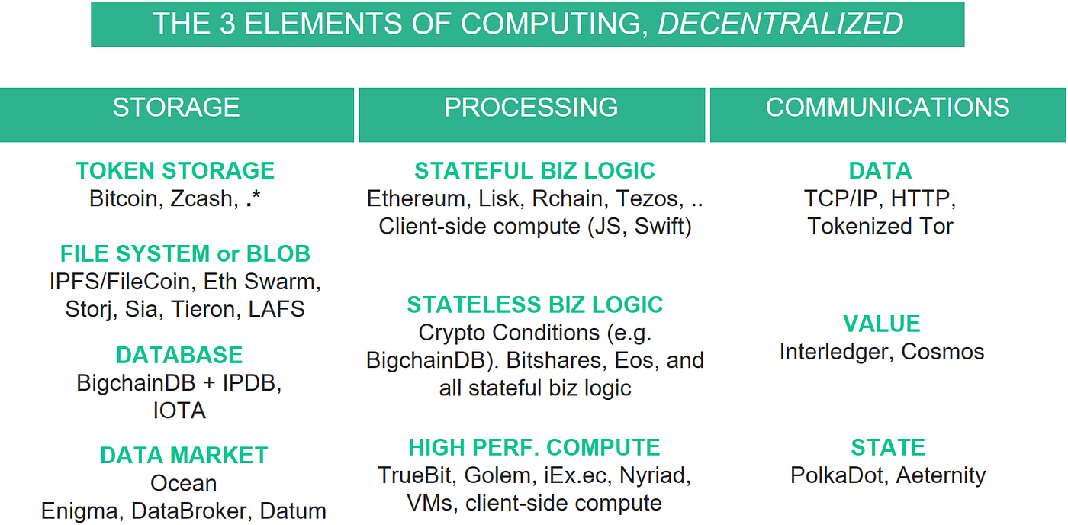

## Storage

The fundamental computing element of storage has the following building blocks.

Token storage. Tokens are stores of value (e.g. assets, securities) whether it’s Bitcoins, air miles, or digital art copyright. The main actions on a token storage system are to issue and transfer tokens (with many variants), while preventing double-spends and the like.

[Bitcoin](https://en.wikipedia.org/wiki/Bitcoin) and [Zcash](https://z.cash/) are two prominent “pure play” systems focusing solely on tokens. Ethereum happens to use tokens in service towards its mission of being a world computer. These are all examples of tokens given out as internal incentives to run the network infrastructure.

Other tokens aren’t internal to a network to power the network itself, but are used for incentives in a higher-level network where the lower-level infrastructure actually stores the tokens. One example is [ERC20](https://github.com/ethereum/eips/issues/20) tokens like Golem (GNT) running on top of the Ethereum mainnet. Another example is [Envoke’s](http://envoke.cre8tives.org/) IP licensing tokens, running on the [IPDB](https://ipdb.io/) network.

Finally, I have listed a “[.*](http://www.regular-expressions.info/dot.html)” to illustrate that most blockchain systems have a mechanism for token storage.

Database. Databases specialize in storing structured metadata, for example as tables (relational DB), document stores (e.g. JSON), key-value stores, time series, or graphs; and then rapidly retrieving that data via queries (e.g. SQL).

Traditional distributed (but centralized) databases like [MongoDB](https://www.mongodb.com/) and [Cassandra](http://cassandra.apache.org/) routinely store hundreds of Terabytes and even Petabytes of data, with throughput that can exceed 1 million writes per second, like [here](https://medium.com/netflix-techblog/benchmarking-cassandra-scalability-on-aws-over-a-million-writes-per-second-39f45f066c9e).

Query languages like [SQL](https://en.wikipedia.org/wiki/SQL) are profound because they separate implementation from specification, and are therefore not bound to any particular application. [SQL has been a standard for decades](http://modern-sql.com/standard). This is why the same database system can be used across many different industries.

Put another way: to generalize beyond Bitcoin to more applications without any application-specific code, you don’t need to go all the way to Turing completeness. You just need a database. This has corresponding benefits in simplicity and scale. There are still great reasons to have Turing completeness in some places; we discuss this further in the “decentralized processing” section.

[BigchainDB](http://www.bigchaindb.com/) is decentralized database software; specifically a document store. Being built on MongoDB (or RethinkDB), it inherits the querying and scale of Mongo. But it also has blockchain-y characteristics like decentralized control, tamper-resistance, and token support. [IPDB](http://ipdb.io/) is a public net instance of BigchainDB, with governance.

Also in the blockchain space, we can think of [IOTA](https://iota.org/) as a time-series database, if we squint a bit.

File system / data blob storage. These are systems to store large files (movies, mp3s, large datasets), organized in a hierarchy of directories and files.

[IPFS](https://ipfs.io/) and [Tahoe-LAFS](https://tahoe-lafs.org/trac/tahoe-lafs) are decentralized file systems that wrap decentralized or centralized blob storage. [FileCoin](http://filecoin.io/), [Storj](https://storj.io/), [Sia](http://sia.tech/), and [Tieron](https://tierion.com/) do decentralized blob storage. So does good old [BitTorrent](http://www.bittorrent.com/), though it uses a tit-for-tat scheme rather than tokens. [Ethereum Swarm](https://github.com/ethersphere/swarm), [Dat](https://datproject.org/), and [Swarm-JS](https://github.com/gritzko/swarm) do basically both.

Data marketplace. These systems connect the data owners (e.g. enterprises) with data consumers (e.g. AI startups). While they’re higher-level than databases and file systems, they are nonetheless core infrastructure because the countless applications that need data (e.g. anything AI) will depend on such services. [Ocean](http://www.oceanprotocol.com/) is an example protocol & network, on which data marketplaces can be built. There are also application-specific marketplaces: [Enigma Catalyst](https://www.enigma.co/) for crypto markets, [Datum](https://datum.org/) for personal data; and [DataBroker DAO](https://databrokerdao.com/) for IoT streams [2].

## Processing

Let’s discuss the fundamental computing element of processing.

“Smart contracts” systems are the popular label for systems that do processing in a decentralized fashion [3]. This actually has two subsets with very different properties: stateless (combinational) business logic and stateful (sequential) business logic. Stateless vs stateful gives radical differences in complexity, verifiability, etc. There’s a third decentralized processing building block: high-performance compute (HPC).

Stateless (combinational) business logic. This is any arbitrary logic that does not retain state internally. In electrical engineering terms, it can be framed as combinational digital logic circuits. The logic is represented as a truth table, schematic diagram, or code holding conditional statements (combining if/then, and, or, not). Because they don’t have state, it’s easy to verify large stateless smart contracts, and therefore to build large verified / secure systems. N inputs and one output requires O(2^N) computations to verify.

The [Interledger Protocol](https://interledger.org/) (ILP) contains the crypto-conditions (CC) protocol to cleanly specify combinational circuits. CC is good to know of because it’s becoming an internet standard [via the IETF](https://tools.ietf.org/html/draft-thomas-crypto-conditions-01), and because ILP is getting widespread adoption among both centralized & decentralized payments networks (e.g. [>75 banks via Ripple](https://finance.yahoo.com/news/75-banks-now-ripples-blockchain-network-162939601.html)). CC has standalone implementations in [JavaScript](https://github.com/interledgerjs/five-bells-condition), [Python](https://github.com/bigchaindb/cryptoconditions), [Java](https://github.com/interledger/java-crypto-conditions), and more. [BigchainDB](https://github.com/bigchaindb/cryptoconditions), Ripple, and other systems use CCs; and therefore support combinational business logic / smart contracts.

Bitshares and Eos also support stateless business logic.

Since stateful logic is a superset of stateless logic, then systems that support stateful logic also support stateless logic (at the expense of additional complexity and verifiability challenges).

BigchainDB, Bitshares, and Eos also support events ([example](https://github.com/bigchaindb/bigchaindb/issues/862)). This gives a level of persistence edging the functionality closer to stateful business logic (thanks to Ian Grigg for pointing this out [2]).

Stateful (sequential) business logic. This is any arbitrary logic that does retain state internally. That is, it has memory. Or, it’s a combinational logic circuit with at least one feedback loop (and a clock). For example, a microprocessor has an internal register that gets updated according to machine-code instructions that are sent to it. More generally, stateful business logic is a Turing machine that takes in a sequence of inputs, and returns a sequence of outputs. Systems that manifest (a practical approximation of) this are called Turing-complete systems [4].

[Ethereum](https://ethereum.org/) is the best-known blockchain system that manifests stateful business logic / smart contracts running directly on-chain. [Lisk](https://lisk.io/), [RChain](https://www.rchain.coop/), [DFINITY](https://dfinity.network/), [Aeternity](https://www.aeternity.com/), [Tezos](https://tezos.com/), [Fabric](https://hyperledger-fabric.readthedocs.io/en/latest/), [Sawtooth](https://intelledger.github.io/introduction.html), and many more also implement it. Running code that’s “just out there, somewhere” is a powerful concept, with many use cases. This helps explain why Ethereum took off, why its ecosystem has grown such that it’s almost a platform in its own right, and why so much competition has arisen in this building block.

Because sequential logic is a superset of combinational logic, these systems also support combinational logic.

Small mistakes in code can have grave consequences, as The DAO hack showed. Formal verification can help, just like it helped the chip industry. The Ethereum Foundation is working on this. But it has scale limitations. For combinational circuits, the number of possible mappings is 2^(number of inputs). For sequential, the number of internal states, is 2^(number of internal state variables) if your internal variables are all Boolean. For example, if you have a 3-input combinational circuit, it would have ²³ =8 possible states to verify. But if it’s a sequential circuit with a 32-bit register, then to fully verify you have to check ²³²=4.2 billion states. This restricts the complexity of sequential circuits (if you want to trust them). “Correct-by-construction” is another approach to trusting stateful smart contracts, like [Rchain](http://rchain-architecture.readthedocs.io/en/latest/introduction/introduction.html) does using rho calculus.

If you want decentralized processing, for many use cases there’s a simpler approach: simply have processing on the client side within the browser or the mobile device, running JavaScript or Swift. Here, you have to trust the processing going on in your client, but if that’s on the device in your hand it’s often acceptable. We think of this as the “[fat client](https://blog.bigchaindb.com/bigchaindb-version-1-0-released-932bee682266)” alternative to the “[fat protocols](http://joel.mn/post/148641439498/fat-protocols)” framing. This architecture is easy for mainstream web developers. For example, all that many webapps need is application state. To build this you just need JS + IPDB (using [js-bigchaindb-driver](https://www.npmjs.com/package/js-bigchaindb-driver)). Or if your app also needs have blob storage and payments, then include the JS client versions of IPFS ([ipfs.js](https://github.com/ipfs/js-ipfs)) and Ethereum ([web3.js](https://github.com/ethereum/web3.js)). Here’s an example:

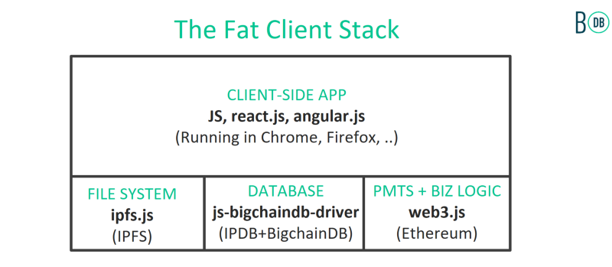

High-Performance Compute (HPC). This is processing to do “heavy lifting” compute for things like rendering, machine learning, circuit simulation, weather forecasting, protein folding, and more. A compute job here might take hours or even weeks on a cluster of machines (CPUs, GPUs, even [TPUs](https://en.wikipedia.org/wiki/Tensor_processing_unit)).

I see these approaches to decentralized HPC:

* [Golem](https://golem.network/) and [iEx.ec](http://iex.ec/) frame it as a combination of decentralized supercomputer along with associated apps.
* [Nyriad](http://www.nyriad.com/) frames it as storage processing. Basically, the processing sits next to decentralized storage (which Nyriad also has a solution to).
* [TrueBit](http://truebit.io/) lets 3rd parties compute but then doing post-compute checking (implicitly checking when possible; explicitly checking if questions get raised).
* Some folks are simply running heavy computation on VMs or [Docker](https://www.docker.com/) containers, and putting the result (final VM state, or just computed results) into blob storage with restricted access. Then, they sell access to these containers using, for example, tokenized read permissions. This approach asks more of clients to verify results, but the good thing is that all this tech is possible today. This will naturally combine with TrueBit as TrueBit matures.

### Communications

Here, we will cover the third and final fundamental computing element, of communications. There are many ways to frame communications; I will focus on connecting networks. It comes in three levels: data, value, and state.

Data. In the 60s we got the [ARPAnet](https://en.wikipedia.org/wiki/ARPANET). Its success spawned several similar networks like [NPL](https://en.wikipedia.org/wiki/NPL_network) and [CYCLADES](https://en.wikipedia.org/wiki/CYCLADES). A new problem arose: they didn’t talk to each other. Cerf and Kahn invented [TCP/IP](https://de.wikipedia.org/wiki/Transmission_Control_Protocol/Internet_Protocol) in the 70s to connect them, to create a network of networks, which we now call the internet. TCP/IP is now the de-facto standard to connect networks. [OSI](https://en.wikipedia.org/wiki/OSI_model) was a competing set of protocols, but it’s long faded; though, ironically, its model has proved useful. So, despite its age, TCP/IP is nonetheless a decentralized building block, for connecting networks of data.

[Tor Project](https://www.torproject.org/) can be seen as a TCP/IP overlay to help protect users’ privacy. However, it’s it has points of centralization, not to mention funding from the DoD which raises eyebrows. Tokenized Tor-like projects are emerging; stay tuned [2].

Value. TCP/IP only connects networks on a data level. You can double-spend packets — send the same packet to more than one destination at once — and it doesn’t care. But what about connecting networks where you can send value across the networks? For example, from Bitcoin to Ethereum, or even SWIFT payments network to say Ripple’s XRP network. You only want the token to be able to go to one destination at a time. One way to connect networks while preventing double-spends is to use an exchange. But that’s traditionally pretty heavy. However, you can strip an exchange to its essence and remove the need for a trusted middleman, by using cryptographic escrow. Alice can send money to Bob via Mallory, where Mallory is passing on the funds but cannot spend them (and there’s a timeout so that Mallory can’t stall things forever). This is the essence behind the [Interledger Protocol](http://www.interledger.org/) (ILP). It’s the same conceptual idea as two-way pegs (think sidechains) and state channels (think [Lightning](https://lightning.network/) & [Raiden](http://raiden.network/)); but the focus is 100% on connecting networks with respect to value. Besides ILP, there’s also [Cosmos](https://cosmos.network/) which adds a bit more complexity for more convenience.

State. Can we go beyond connecting networks of value? Imagine a computer virus with its own Bitcoin wallet that can hop from one network to another. Or a smart contract in Ethereum mainnet that can move its state to another Ethereum net, or another compatible net? Or, why restrict an [AI DAO](https://blog.bigchaindb.com/ai-daos-series2-3876510d6eb4) to just one net?

This where [Polkadot](http://polkadot.io/) comes in, to connect networks of state. [Aeternity](https://www.aeternity.com/) also fits somewhere between the network-of-value and network-of-state spectrum.

## Examples

We’ve now reviewed the three elements of computing (storage, processing, communications), the decentralized building blocks for each, and example projects within each building block.

People are starting to build systems that manifest combinations. There many combinations of two blocks at once, usually IPFS + Ethereum or IPFS + IPDB. But there are even folks using three or more blocks. Here are a couple leading edge examples:

* [Ujo uses](https://blog.ujomusic.com/ujo-x-rac-under-the-hood-the-future-of-licensing-d4f38e2efabd) IPFS|Swarm + IPDB + Ethereum for decentralized music, just as envisioned [here](https://medium.com/ipdb-blog/a-decentralized-content-registry-for-the-decentralized-web-99cf1335291f). IPFS or Swarm are for file system and blob storage. IPDB (with BigchainDB) is used for metadata storage and querying. Ethereum is used for token storage and stateful business logic.
* [Innogy uses](https://medium.com/@cstoecker/implementing-first-industry-4-0-use-cases-with-iota-dag-tangle-machine-tagging-for-digital-twins-baf1943c499d) IPFS + IPDB + IOTA for supply chain / IoT applications. IPFS is used for file system and blob storage. IPDB (with BigchainDB) is used for metadata storage and querying. IOTA is used for time-series data.

## Related Work

Here are related framings by others in the blockchain community; all of whom I’ve had the pleasure to have great conversations with.

Joel Monegro’s “[Fat Protocols](http://joel.mn/post/148641439498/fat-protocols)” framing emphasizes each building block as a protocol. I think this is a cool way of framing, though it constrains the building blocks to be talking to each other via a network protocol. There’s another way: blocks could simply be one “import” statement or library call away.

Reasons for using an import could be (a) lower latency: a network call takes time which could hurt or kill the usability; (b) simplicity: using a library (or even embedded code) is usually just simpler than connecting on the network, paying tokens, etc; and (c ) more mature: the protocol stack is just emerging now. We have awesome Unix libraries going back decades, even Python and JS blocks going back 15+ years.

Fred Ehrsam’s “[Dapp Developer Stack](https://medium.com/@FEhrsam/the-dapp-developer-stack-the-blockchain-industry-barometer-8d55ec1c7d4)” has an emphasis on web business models. While it’s also very helpful, it does not aim to make a fine-grained distinction among blocks for a given element of computing (e.g. file system versus database).

The [BigchainDB whitepaper](https://www.bigchaindb.com/whitepaper/bigchaindb-whitepaper.pdf) (first released Feb 2016) Figure 1 gave an earlier version of the stack of this post. For convenience, here it is:

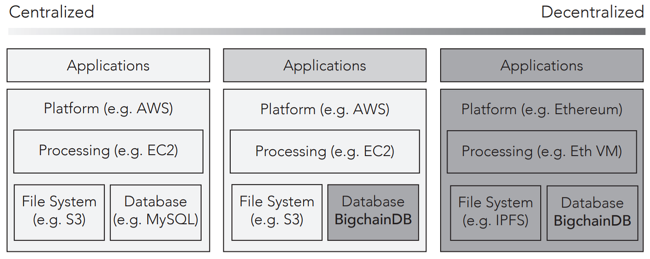

It focused on the building blocks of processing, file system, and database. It did not frame from the perspective of “elements of computing”, and did not distinguish the types of decentralized processing. What I’ve written in this post is an evolution of my thinking from that paper over the past year and a half; with continual updates in talks such as my May 22 [talk at Consensus 2017](http://trent.st/content/20170522%20blockchains%20for%20ai%20-%20consensus%202017.pdf) which is very similar to this article. (Part of my reason to write this post is that I’ve received many requests to put it in writing:)

The image also emphasized that you there’s a spectrum from fully centralized (left) to fully decentralized (right). This is helpful for updating existing software systems to be more decentralized over time, focusing on updating blocks where decentralization helps the most.

Stephan Tual’s “[Web 3.0 Revisited](https://blog.stephantual.com/web-3-0-revisited-part-one-across-chains-and-across-protocols-4282b01054c5)” stack is spiritually similar to this post, though with a bigger focus on Ethereum. It does a good service to the community by trying to make a map that groups many projects into similar building blocks. I was happily surprised by how similar the thinking was to my own. However, its layer of blocks to serve applications (blocks for messaging, storage, consensus, governance, ..) is actually mixing three things: apps, the “what”, and the “how”. To me, blocks should be the “what”. So, messaging is an app (should be at the application level); storage needs to be more fine-grained; consensus is part of the “how” (hidden within some blocks); and governance is also part of the “how” (therefore also hidden). It also has [network] protocols as a separate lower-level block, though I see those as one of the possible ways that blocks can talk to each other, alongside library calls. Nonetheless, I think this is an excellent article and stack:)

Alexander Ruppert’s [“Mapping the decentralized world”](https://medium.com/birds-view/mapping-the-decentralized-world-of-tomorrow-5bf36b973203) has about 20 groupings of organizations, with the x-axis giving four higher-level groupings from infrastructure layer to application layer, but with middleware and liquidity as intermediate levels. This is a great piece too; I’m happy to have helped Alex map it out. It has less emphasis on core infrastructure and more on broader trends; whereas this piece is all about core infrastructure from a first-principles framing.

## Future

Systems like Ujo combine many blocks together, such as IPFS or Swarm (for blobs) + Ethereum (for tokens and business logic) + IPDB & BigchainDB (for database with fast queries), and therefore leverage the benefits of all of these systems.

I expect that this trend will accelerate as folks get a better understanding of how the building blocks relate. It’s also more productive than framing everything into one monolith called “blockchain”.

I expect this stack to continually evolve, as the decentralization ecosystem evolves. AWS started out as just one service: S3 for blob storage. Then it got processing: EC2. And it kept going; [here’s the full timeline](https://en.wikipedia.org/wiki/Timeline_of_Amazon_Web_Services). AWS now has more than 50 blocks; though of course a small handful remain the most important. Below is a picture of all the AWS services.

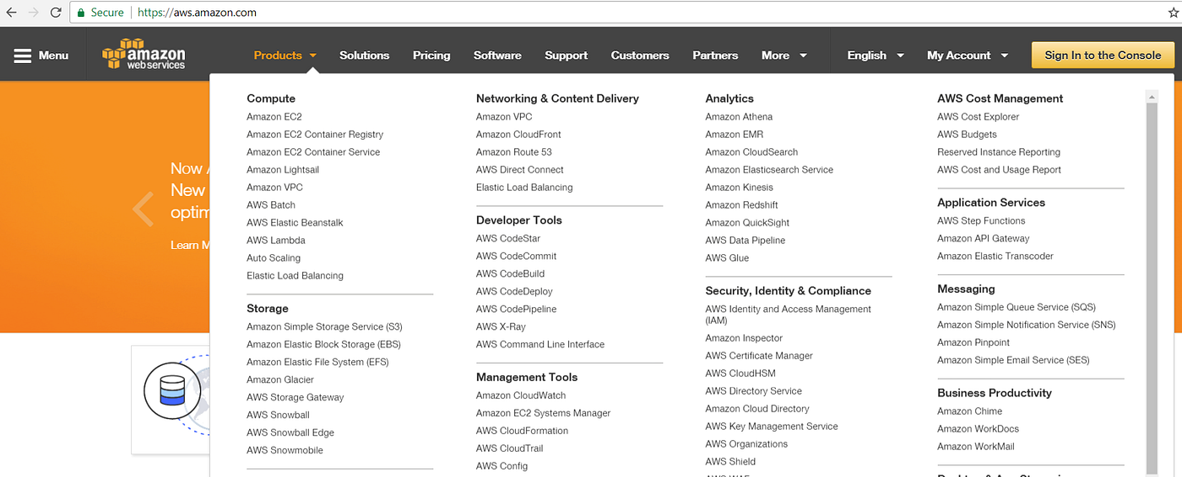

Screenshot of services from aws.amazon.com July 15, 2017.

I envision something similar happening in the decentralization space. As a first cut, one could imagine a decentralized version of every single AWS block. However, there will be differences, since each ecosystem (cloud vs mobile vs decentralized) has its own special blocks, such as token storage for decentralization. It will be a fun ride!

## Notes

[1] You can actually put further hierarchy into these building blocks. E.g. databases sit on top of file systems, which sit on raw data (blob) storage. And distributed databases involve communication. For example, most modern databases talk to the underlying storage via a file system like Ext4, XFS or GridFS. The framing I give in this article is that of an applications programmer: what’s the UX for a file system, the UX for a database, etc.

[2] I added some new content here in Sept 2017.

[3] I’ve never really liked the label “smart contracts”. They’re not really smart in any AI-ish sense of the word. And they usually have nothing to do with “contract” in any legal sense of the word. If they do include legals, they usually state so, e.g. with [Ricardian contracts](http://iang.org/papers/ricardian_contract.html). The labels “decentralized processing” and within it “decentralized business logic” make more sense. However, given “smart contract” now has widespread use, so be it. I have better things to focus on than fighting over labels:)

[4] I say “Turing complete” here in a practical sense, not in a theoretically pure sense. That is: the machine returns a string of outgoing bits as a function of the incoming bits and its current internal state; but practical in the sense of not running infinitely long or claiming to solve the “when does the machine stop” problem (halting problem).

Thanks to the countless folks who have given me feedback on this stack over the last couple years. And thanks to Carly Sheridan, Troy McConaghy, and Dimi de Jonghe for through editing. Finally, thanks to everyone in the space who continues to improve the building blocks and build ever more interesting applications:)

# Chapter 8 The challenges of our time and Protocol Labs's work

Protocol Labs: Creating New Networks | Protocol Labs

https://protocol.ai/blog/protocol-labs-creating-new-networks/

Learning Objectives - Launchpad

https://curriculum.pl-launchpad.io/curriculum/pln/objectives/

Remote-First: How We Work at Protocol Labs | Protocol Labs

https://protocol.ai/blog/how-we-work-at-protocol-labs/

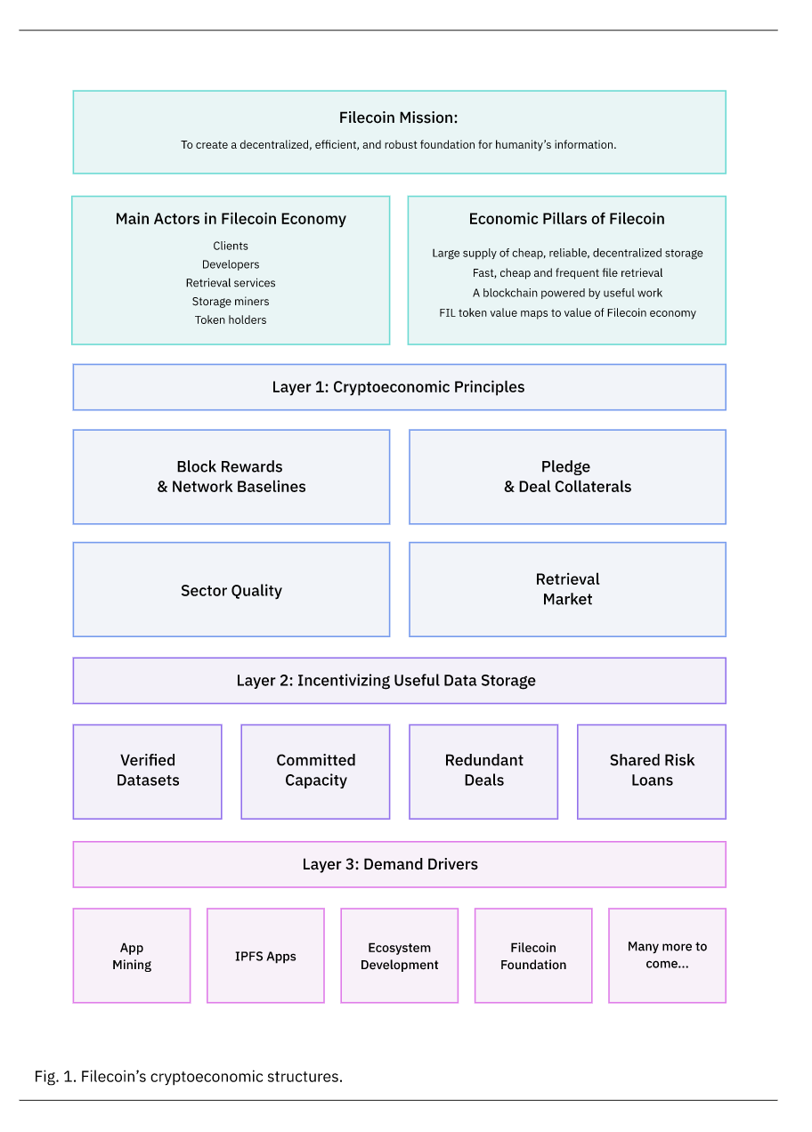

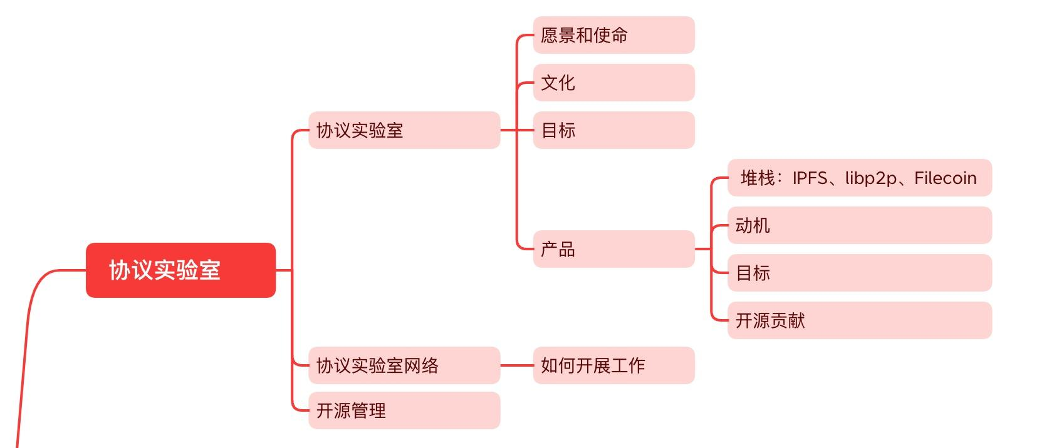

Filecoin Basic

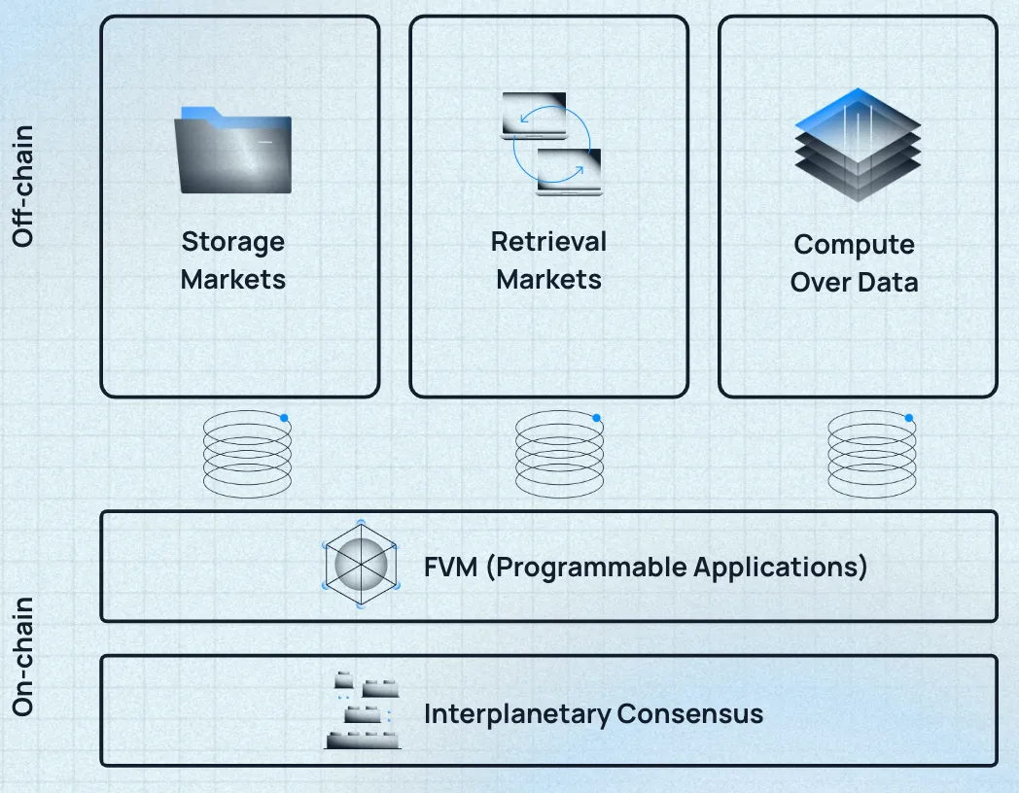

# Chapter 9 Filecoin Blockchain & Consensus

https://youtu.be/FOCC6UTgGbg

https://youtu.be/WKOzDB-4TH4

# Chapter 10 Filecoin Blockspace Market

Blockspace: An Introduction with Chris Dixon | The Generalist

<https://www.generalist.com/briefing/blockspace>

Consensus Capital Markets — Alkimiya

<https://www.aniccaresearch.tech/blog/consensus-capital-markets>

What is Blockspace and its Impacts on Blockchain Dynamics - Zerocap

<https://zerocap.com/research-lab/blockspace-impacts-blockchain-dynamics/>

# Chapter 11 FIlecoin Storage Market

How storage and retrieval deals work on Filecoin

<https://filecoin.io/blog/posts/how-storage-and-retrieval-deals-work-on-filecoin/>

Filecoin Deal Flow, or "How do I store data from my smart contract?" · filecoin-project/community · Discussion #601

<https://github.com/filecoin-project/community/discussions/601>

# Chapter 12 Filecoin Retrieval Market

State and direction of Filecoin, summarized. | by Jnthnvctr | Filecoin TL;DR | Medium

https://medium.com/tldrfilecoin/state-and-direction-of-filecoin-summarized-4b90c59e3cca

# Chapter 13 Filecoin Virtual Machine

Filecoin Virtual Machine: How It Works, What Use Cases It Unlocks, and Why It Matters | by Lukas Bresser | Filecoin TL;DR | Medium

https://medium.com/tldrfilecoin/filecoin-virtual-machine-how-it-works-what-use-cases-it-unlocks-and-why-it-matters-10dd08f471c7

Transcription: Filecoin Virtual Machine | Protocol Labs

https://protocol.ai/blog/transcription-fvm/

Request for Startups [FVM edition]

https://rfs.fvm.dev/#5f018751cf7d47ad8e029f823a5c71f2

# Chapter 14 Filecoin Tokenomics

2020-engineering-filecoins-economy-en.pdf

https://filecoin.io/2020-engineering-filecoins-economy-en.pdf

Understanding Filecoin Circulating Supply

https://filecoin.io/blog/filecoin-circulating-supply/

Filecoin Tokenomics: Understanding an Advancing Economy | by Vik Kalghatgi | Filecoin TL;DR | Medium

https://medium.com/tldrfilecoin/filecoin-tokenomics-understanding-an-advancing-economy-ef319632ffa8

Filecoin Network Crosses Baseline Sustainability Target for First Time

https://filecoin.io/blog/posts/filecoin-network-crosses-baseline-sustainability-target-for-first-time/

Filecoin Network Economics

https://filecoin.io/blog/posts/filecoin-network-economics/

Filecoin's cryptoeconomic constructions

<https://filecoin.io/blog/posts/filecoin-s-cryptoeconomic-constructions/>

protocol/filecoin-mecha-twin: Mechanistic model for the Filecoin Economy

<https://github.com/protocol/filecoin-mecha-twin/tree/main>

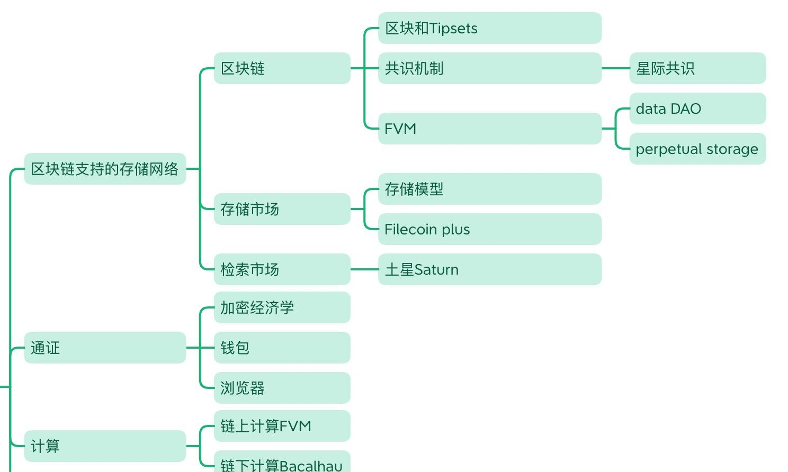

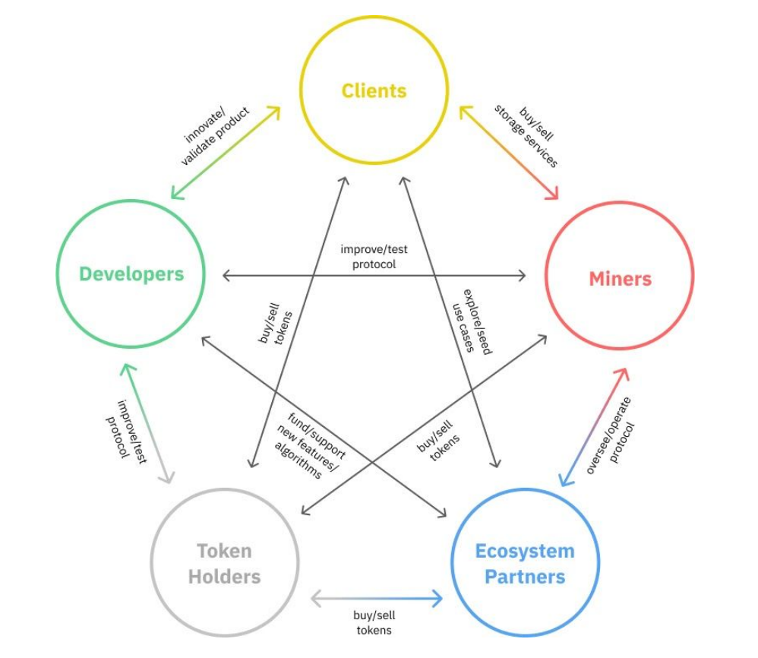

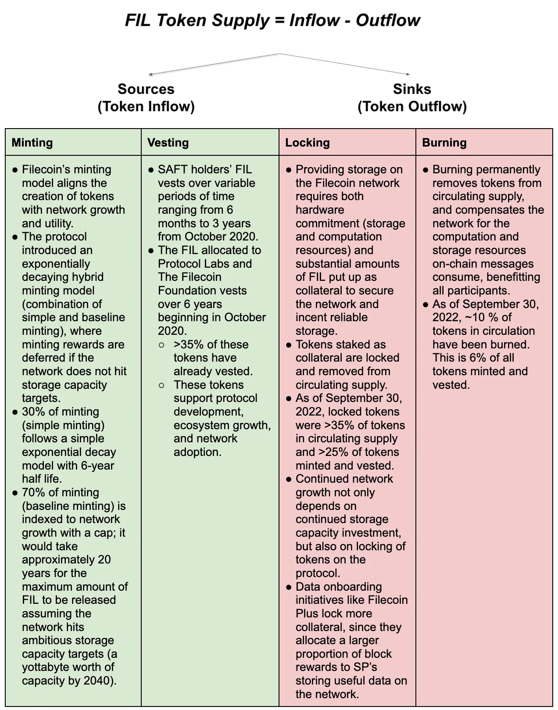

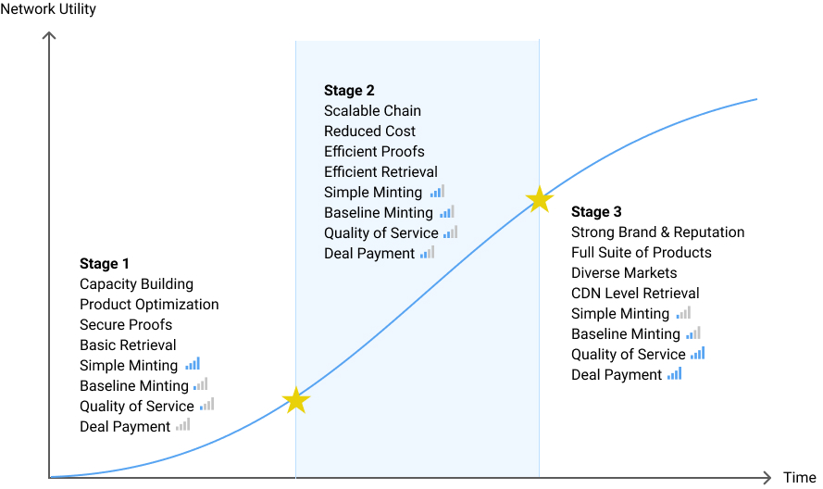

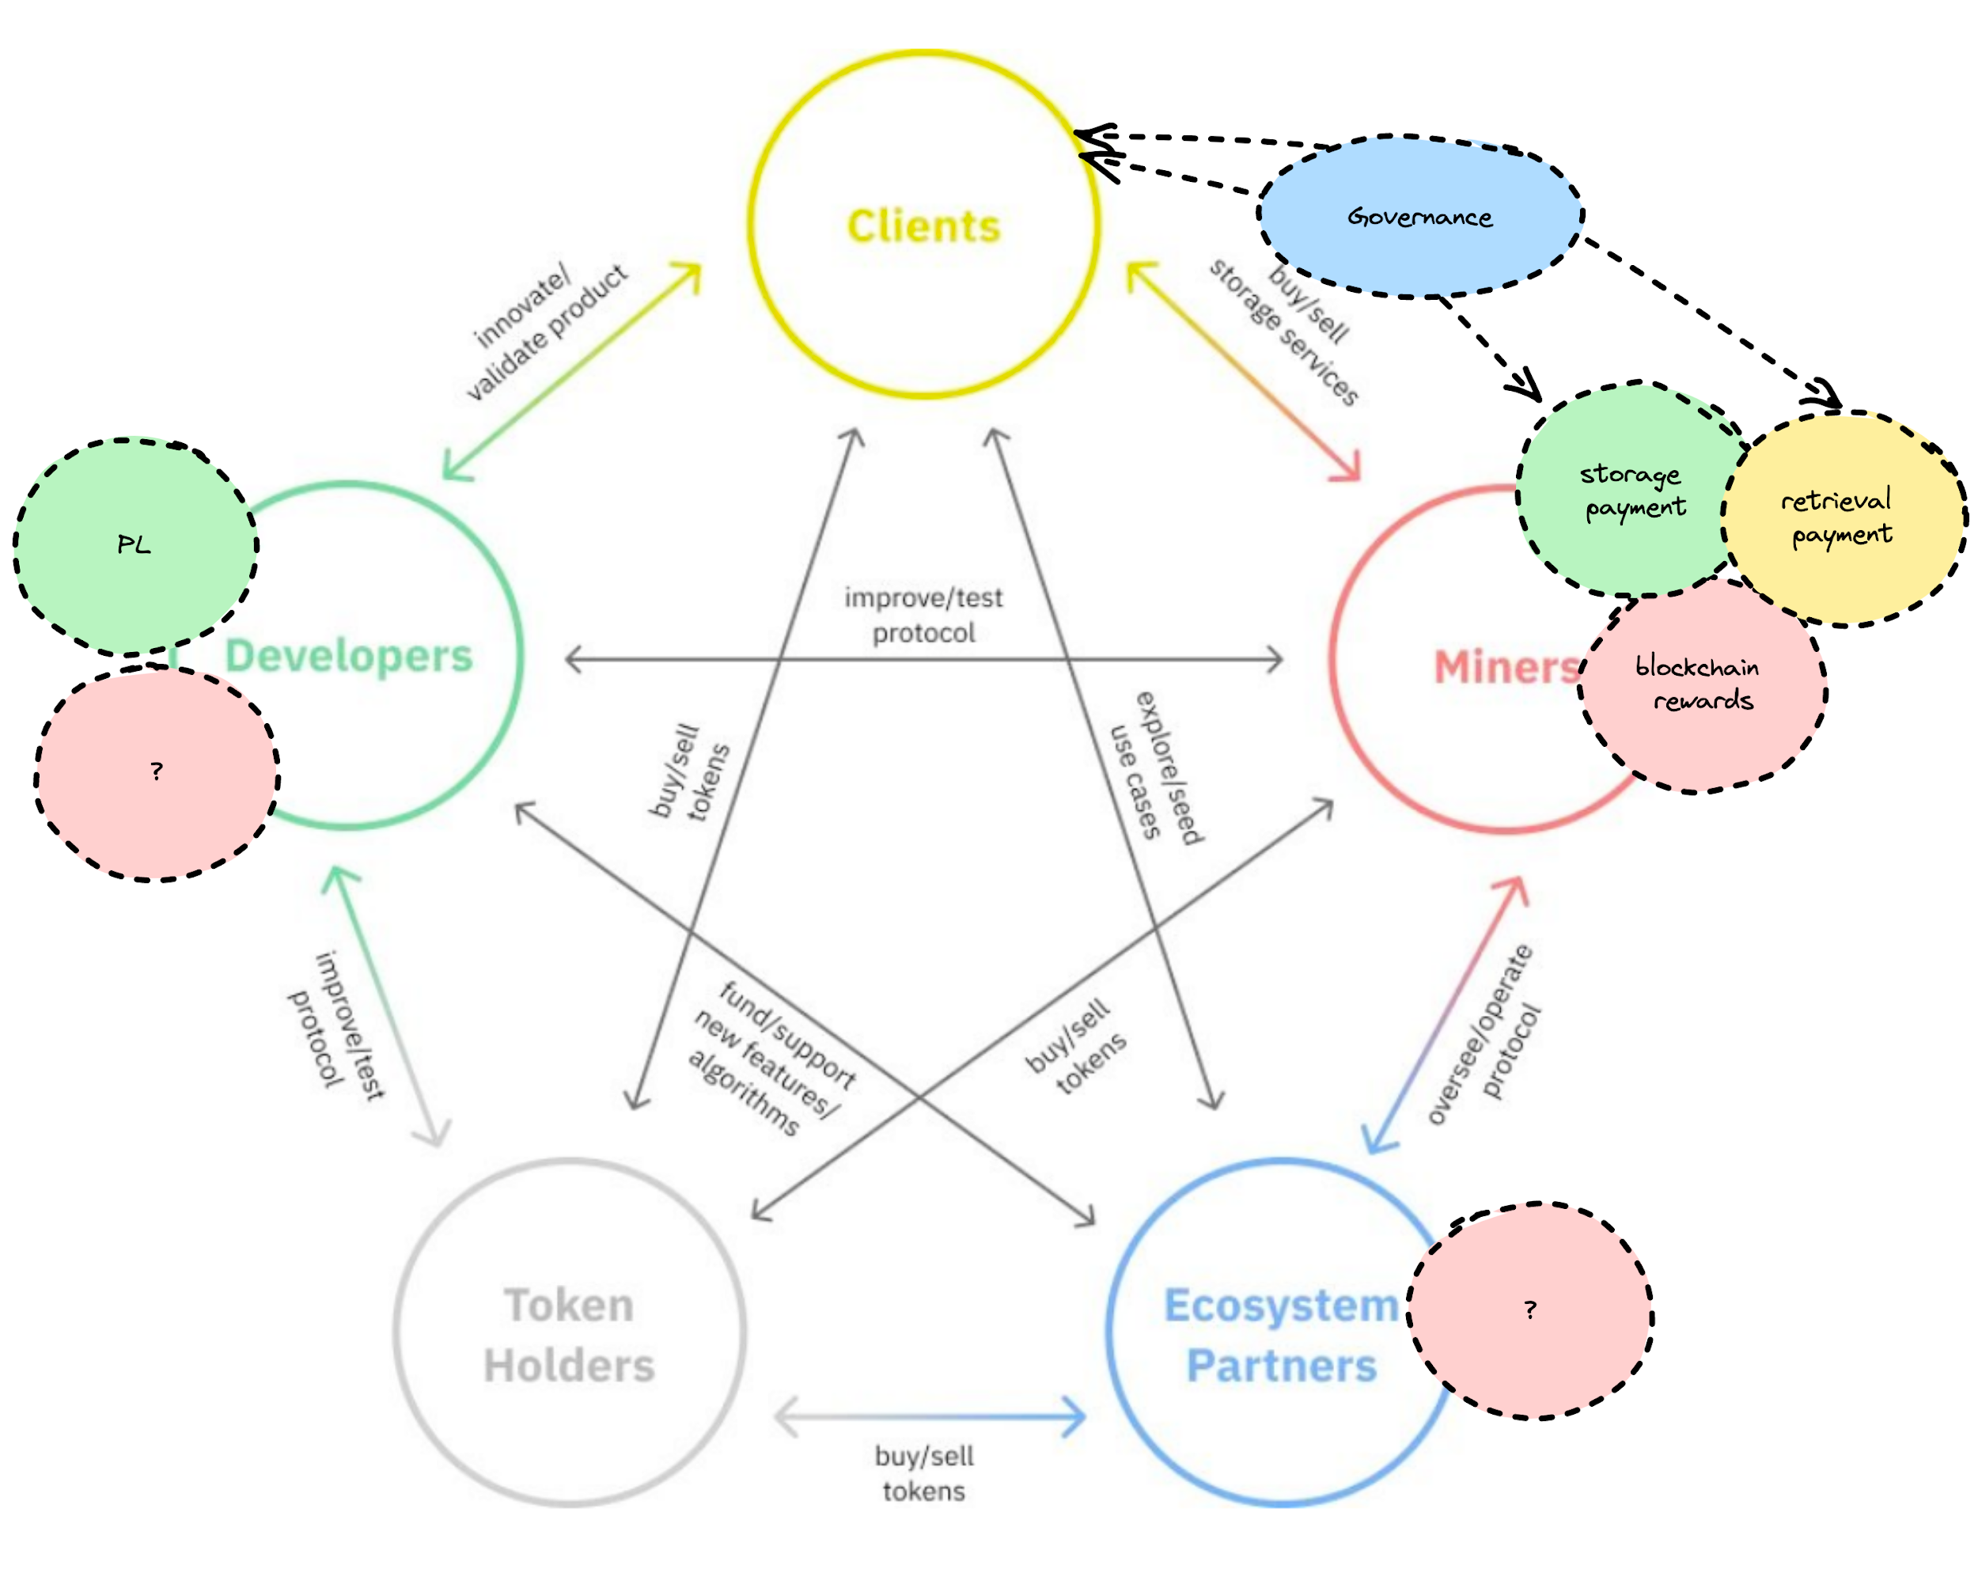

# Chapter 15 Filecoin indexer

Indexer Scalability for Ingest-heavy Workload

<https://filecoin.io/blog/posts/indexer-scalability-for-ingest-heavy-workload/>

How to be an Index Provider

<https://filecoin.io/blog/posts/how-to-be-an-index-provider/>

How does the Network Indexer work?

<https://filecoin.io/blog/posts/how-does-the-network-indexer-work/>

Introducing the Network Indexer

<https://filecoin.io/blog/posts/introducing-the-network-indexer/>

InterPlanetary Network Indexer

<https://www.notion.so/InterPlanetary-Network-Indexer-874205fce85f47a7b29b2132f584bd38>

Blog Posts

<https://www.notion.so/Blog-Posts-537393f388c14286ae9e5cfb9eccf4ff>

Indexer official website

<https://docs.cid.contact/filecoin-network-indexer/overview>

# Chapter 16 Filecoin boost

Boost (Markets v2)

https://www.notion.so/Boost-Markets-v2-19024a6a986247b98d24fcc0fc482fa2

boost official website

<https://boost.filecoin.io/>

Protecting booster-http with nginx

<https://filecoin.io/blog/posts/protecting-booster-http-with-nginx/>

Serving Files with booster-http

<https://filecoin.io/blog/posts/serving-files-with-booster-http/>

HTTP Retrieval Benchmarks with Boost

<https://filecoin.io/blog/posts/http-retrieval-benchmarks/>

Boost Monitoring Stack

<https://filecoin.io/blog/posts/boost-monitoring-stack/>

Make lightning fast storage deals with Boost v1.0

<https://filecoin.io/blog/posts/make-lightning-fast-storage-deals-with-boost-v1.0/>

Introducing Boost: New Capabilities for Markets Including HTTP transfers, Web UI, and More

<https://filecoin.io/blog/posts/introducing-boost-new-capabilities-for-markets-including-http-transfers-web-ui-and-more/>

Split-Markets - Lotus Docs

<https://lotus.filecoin.io/kb/split-markets/>

Filecoin News on Twitter: "Boost is a new replacement for the existing Lotus Markets process. Last week, Boost v1.0.0 officially went live! Get your data onto Filecoin 20x faster with Boost ⚡️💪 https://t.co/yncBIuGmmi" / Twitter

<https://twitter.com/Filecoin/status/1542859323746942976>

The Evolution of a Lotus Node

<https://filecoin.io/blog/posts/the-evolution-of-a-lotus-node/>

web3-dev-team/lotus-miner-runtime-segregation.md at main · protocol/web3-dev-team

<https://github.com/protocol/web3-dev-team/blob/main/proposals/lotus-miner-runtime-segregation.md#context>

# Chapter 17 Filecoin lassie

Basic retrieval Lassie

<https://docs.filecoin.io/basics/how-retrieval-works/basic-retrieval/>

Bedrock - Introduction to Lassie (PL EngRes Demo Day - May 2023) - YouTube

<https://www.youtube.com/watch?v=VW6gadv4h38>

filecoin-project/lassie: A minimal universal retrieval client library for IPFS and Filecoin

<https://github.com/filecoin-project/lassie>

Filecoin ecosystem

## **Filecoin master plan**

Filecoin engres Plan

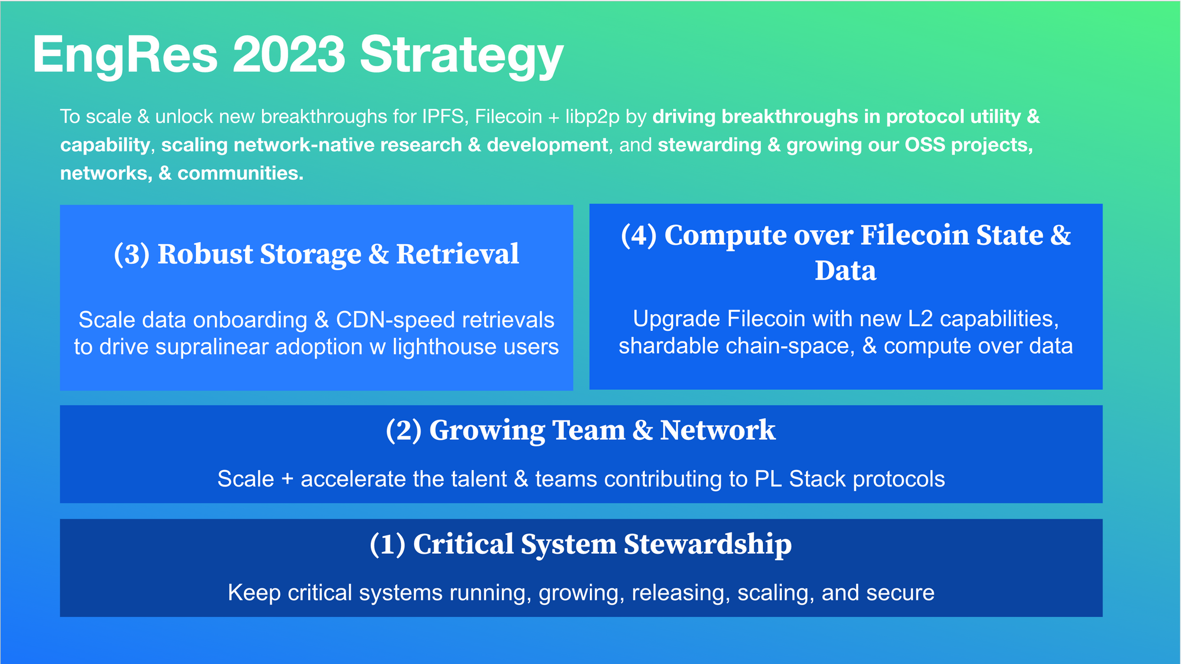

## **Filecoin Plus**

Filecoin Plus Principles · Issue #12 · filecoin-project/FIPs

https://github.com/filecoin-project/FIPs/issues/12

Filecoin Plus Principles by zixuanzh · Pull Request #13 · filecoin-project/FIPs

https://github.com/filecoin-project/FIPs/pull/13

## **Filecoin green**

## **Filecoin research**

What Are Public Goods and Commons? | Protocol Labs Research

https://research.protocol.ai/blog/2022/what-are-public-goods-and-commons/

Funding the Commons | Protocol Labs Research

https://research.protocol.ai/blog/2022/funding-the-commons/

Beginners Guide to Ethereum (ETH) | Coinware

https://coinware.co/au/beginners-guide-to-ethereum-eth/